Data Analysis

26820228

10/08/2021

# **Information**

Please refer to ‘Data Cleaning’ script prior to accessing this script.

# **Setup**

knitr::opts_chunk$set(echo = TRUE)  
require("knitr")

## Loading required package: knitr

opts_knit$set(root.dir = "~/Library/Mobile Documents/com~apple~CloudDocs/Documents/Uni/Masters/Empirical Project/Code/Empirical_Project")  
  
# turn off scientific notation  
options(scipen = 999)  
  
## colour palette  
# e7b553  
# c45150  
# a24b6f  
# 824372  
# 603863  
# 382c46  
# 403250

### *Load Libraries*

library("ggplot2") # for figures  
library("psych") # for Cronbach's alpha, for describe function

##   
## Attaching package: 'psych'

## The following objects are masked from 'package:ggplot2':  
##   
## %+%, alpha

library("ppcor") # for partial correlation p-values

## Loading required package: MASS

library("dplyr") # for mutate function

##   
## Attaching package: 'dplyr'

## The following object is masked from 'package:MASS':  
##   
## select

## The following objects are masked from 'package:stats':  
##   
## filter, lag

## The following objects are masked from 'package:base':  
##   
## intersect, setdiff, setequal, union

library("ggpubr") # for qq-plots  
library("GGally") # for scatterplot matrix

## Registered S3 method overwritten by 'GGally':  
## method from   
## +.gg ggplot2

library("effsize") # for calculation of effect size

##   
## Attaching package: 'effsize'

## The following object is masked from 'package:psych':  
##   
## cohen.d

library("pwr") # for power calculation  
library("performance") # for assessing robustness of model  
library("effsize") # for eta squared  
library("reshape2") # for transforming data from wide to long format  
library("tidyverse") # for data cleaning

## ── Attaching packages ─────────────────────────────────────── tidyverse 1.3.1 ──

## ✓ tibble 3.1.3 ✓ purrr 0.3.4  
## ✓ tidyr 1.1.3 ✓ stringr 1.4.0  
## ✓ readr 2.0.0 ✓ forcats 0.5.1

## ── Conflicts ────────────────────────────────────────── tidyverse_conflicts() ──  
## x psych::%+%() masks ggplot2::%+%()  
## x psych::alpha() masks ggplot2::alpha()  
## x dplyr::filter() masks stats::filter()  
## x dplyr::lag() masks stats::lag()  
## x dplyr::select() masks MASS::select()

library("rstatix") # for ANOVA and ANCOVA

##   
## Attaching package: 'rstatix'

## The following object is masked from 'package:MASS':  
##   
## select

## The following object is masked from 'package:stats':  
##   
## filter

library("gridExtra") # for grid.arrange function

##   
## Attaching package: 'gridExtra'

## The following object is masked from 'package:dplyr':  
##   
## combine

library("car") # for levene's test

## Loading required package: carData

##   
## Attaching package: 'car'

## The following object is masked from 'package:purrr':  
##   
## some

## The following object is masked from 'package:dplyr':  
##   
## recode

## The following object is masked from 'package:psych':  
##   
## logit

library("emmeans") # to obtain estimated marginal means

##   
## Attaching package: 'emmeans'

## The following object is masked from 'package:GGally':  
##   
## pigs

### *Set Working Directory*

# please change this to your own working directory path  
setwd("~/Library/Mobile Documents/com~apple~CloudDocs/Documents/Uni/Masters/Empirical Project/Code/Empirical_Project")

### *Read in Data and Save Data to an Object*

# please change this to however you have stored the data file   
# reading in dataframe 2, as this is the one with exclusion of n = 5  
df <- read.csv(file = "data/cleaned/dataframe_2.csv", header = TRUE, na.strings = "NA")

### *Change Variable Classifications*

# change variable classifications to meet requirements for later analyses  
# ensure IVs and categorical variables are factor variables  
# and DVs or continuous variables are numeric variables  
  
# participant id and demographics  
df$id <- factor(df$id)  
df$age <- as.numeric(df$age)  
df$sex <- factor(df$sex)  
df$ethnicity <- factor(df$ethnicity)  
df$sexual_orientation <- factor(df$sexual_orientation)  
  
# fixation count DVs  
df$acq_csp_fix_count <- as.numeric(df$acq_csp_fix_count)  
df$acq_csm_fix_count <- as.numeric(df$acq_csm_fix_count)  
df$ext_csp_fix_count <- as.numeric(df$ext_csp_fix_count)  
df$ext_csm_fix_count <- as.numeric(df$ext_csm_fix_count)  
df$e_ext_csp_fix_count <- as.numeric(df$e_ext_csp_fix_count)  
df$l_ext_csp_fix_count <- as.numeric(df$l_ext_csp_fix_count)  
df$e_ext_csm_fix_count <- as.numeric(df$e_ext_csm_fix_count)  
df$l_ext_csm_fix_count <- as.numeric(df$l_ext_csm_fix_count)  
  
# fixation duration DVs  
df$acq_csp_fix_duration <- as.numeric(df$acq_csp_fix_duration)  
df$acq_csm_fix_duration <- as.numeric(df$acq_csm_fix_duration)  
df$ext_csp_fix_duration <- as.numeric(df$ext_csp_fix_duration)  
df$ext_csm_fix_duration <- as.numeric(df$ext_csm_fix_duration)  
df$e_ext_csp_fix_duration <- as.numeric(df$e_ext_csp_fix_duration)  
df$l_ext_csp_fix_duration <- as.numeric(df$l_ext_csp_fix_duration)  
df$e_ext_csm_fix_duration <- as.numeric(df$e_ext_csm_fix_duration)  
df$l_ext_csm_fix_duration <- as.numeric(df$l_ext_csm_fix_duration)  
  
# saccade amplitude DVs  
df$acq_csp_sacc_amplitude <- as.numeric(df$acq_csp_sacc_amplitude)  
df$acq_csm_sacc_amplitude <- as.numeric(df$acq_csm_sacc_amplitude)  
df$ext_csp_sacc_amplitude <- as.numeric(df$ext_csp_sacc_amplitude)  
df$ext_csm_sacc_amplitude <- as.numeric(df$ext_csm_sacc_amplitude)  
df$e_ext_csp_sacc_amplitude <- as.numeric(df$e_ext_csp_sacc_amplitude)  
df$l_ext_csp_sacc_amplitude <- as.numeric(df$l_ext_csp_sacc_amplitude)  
df$e_ext_csm_sacc_amplitude <- as.numeric(df$e_ext_csm_sacc_amplitude)  
df$l_ext_csm_sacc_amplitude <- as.numeric(df$l_ext_csm_sacc_amplitude)

# **Internal Consistency of IUS and STICSA**

## IUS total  
# compute & extract alpha value and save as an object  
alpha_ius <- psych::alpha(df[, c("ius_1", "ius_2", "ius_3", "ius_4",  
 "ius_5", "ius_6", "ius_7", "ius_8",  
 "ius_9", "ius_10", "ius_11", "ius_12",  
 "ius_13", "ius_14", "ius_15", "ius_16",  
 "ius_17", "ius_18", "ius_19", "ius_20",   
 "ius_21", "ius_22", "ius_23", "ius_24",  
 "ius_25", "ius_26", "ius_27")])$total[1]  
  
## STICSA total  
# compute & extract alpha value and save as an object  
alpha_sticsa <- psych::alpha(df[, c("sticsa_1", "sticsa_2", "sticsa_3", "sticsa_4",  
 "sticsa_5", "sticsa_6", "sticsa_7", "sticsa_8",  
 "sticsa_9", "sticsa_10", "sticsa_11", "sticsa_12",  
 "sticsa_13", "sticsa_14", "sticsa_15", "sticsa_16",  
 "sticsa_17", "sticsa_18", "sticsa_19", "sticsa_20",   
 "sticsa_21")])$total[1]  
  
# create table of both Crobach's alpha values  
cronbachs_alpha_questionnaires <- rbind(alpha_ius, alpha_sticsa)  
  
# clean up row and column names for easier interpretation  
rownames(cronbachs_alpha_questionnaires) <- c("IUS-27", "STICSA")  
colnames(cronbachs_alpha_questionnaires) <- "Cronbach's Alpha"  
  
# obtain Cronbach's alpha table  
cronbachs_alpha_questionnaires

## Cronbach's Alpha  
## IUS-27 0.9496736  
## STICSA 0.8766597

# *Compute Questionnaire Totals*

#### IUS total  
# all items, no reverse scoring  
df$ius_total <- as.numeric(df$ius_1 + df$ius_2 + df$ius_3 + df$ius_4 + df$ius_5 + df$ius_6 +   
 df$ius_7 + df$ius_8 + df$ius_9 + df$ius_10 + df$ius_11 + df$ius_12 + df$ius_13 +   
 df$ius_14 + df$ius_15 + df$ius_16 + df$ius_17 + df$ius_18 + df$ius_19 + df$ius_20 +   
 df$ius_21 + df$ius_22 + df$ius_23 + df$ius_24 + df$ius_25 + df$ius_26 + df$ius_27)  
  
#### STICSA total  
# all items, no reverse scoring  
df$sticsa_total <- as.numeric(df$sticsa_1 + df$sticsa_2 + df$sticsa_3 +  
 df$sticsa_4 + df$sticsa_5 + df$sticsa_6 +  
 df$sticsa_7 + df$sticsa_8 + df$sticsa_9 +  
 df$sticsa_10 + df$sticsa_11 + df$sticsa_12 +  
 df$sticsa_13 + df$sticsa_14 + df$sticsa_15 +  
 df$sticsa_16 + df$sticsa_17 + df$sticsa_18 +  
 df$sticsa_19 + df$sticsa_20 + df$sticsa_21)

# *Create High / Low IU Classifications*

# compute variable classifying participants as high/ low IU on basis of median split,   
# and store as factor  
df$iu_group <- factor(ifelse(df$ius_total >= 65, 1, -1))  
# high IU = 1  
# low IU = -1

# *Check Distribution and Range to Identify Extreme Scores and Potential Data Errors in Questionnaires*

## *For IUS 27 Total in Both Groups*

# possible total scores for the IUS range from 27-135   
  
########################## check distributions   
hist_ius_total <- df %>%  
 ggplot(aes(ius_total, fill = iu_group)) +  
 geom_histogram(binwidth = 5, colour = "white", alpha = .5, position = "identity") +  
 theme_classic() +  
 theme(text = element_text(family = "serif"),   
 plot.title = element_text(face = "bold", hjust = 0.5, size = 15)) +  
 scale_x_continuous(breaks = seq(20, 140, 10)) +  
 labs(x = "IUS-27 Total", y = "Frequency") +  
 theme(plot.title = element_text(face = "bold", hjust = 0.5, size = 12)) +  
 ggtitle("Histogram of IUS-27 Scores") +  
 theme(legend.position = "bottom", legend.title = element_text(face = "bold")) +  
 guides(fill = guide_legend(reverse = TRUE)) +  
 scale_fill_manual(values = c("#c45150", "#824372"), labels = c("Low IU", "High IU")) +  
 labs(fill = "IU Group")   
hist_ius_total

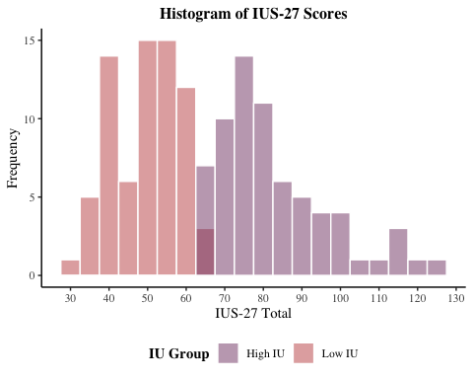

# save plot to file  
ggsave(filename = "graphs/histograms/hist_ius_total.png",   
 plot = hist_ius_total,   
 width = 20,   
 height = 10,   
 dpi = 300,   
 units = "cm")  
  
########################## check ranges  
range_ius_total <- by(df$ius_total, df$iu_group, range)  
range_ius_total

## df$iu_group: -1  
## [1] 32 64  
## ------------------------------------------------------------   
## df$iu_group: 1  
## [1] 65 125

# for high IU: 65-125  
# for low IU: 32-64  
##### overall: all scores are in range of possible scores, no errors apparent

## *For STICSA Total in Both Groups*

# possible total scores for the STICSA range from 21-84  
  
########################## check distributions   
hist_sticsa_total <- df %>%  
 ggplot(aes(sticsa_total, fill = iu_group)) +  
 geom_histogram(binwidth = 5, colour = "white", alpha = .5, position = "identity") +  
 theme_classic() +  
 theme(text = element_text(family = "serif"),   
 plot.title = element_text(face = "bold", hjust = 0.5, size = 15)) +  
 scale_x_continuous(breaks = seq(20, 90, 10)) +   
 labs(x = "STICSA Total", y = "Frequency") +  
 theme(plot.title = element_text(face = "bold", hjust = 0.5, size = 12)) +  
 ggtitle("Histogram of STICSA Scores") +  
 theme(legend.position = "bottom", legend.title = element_text(face = "bold")) +  
 guides(fill = guide_legend(reverse = TRUE)) +  
 scale_fill_manual(values = c("#c45150", "#824372"), labels = c("Low IU", "High IU")) +  
 labs(fill = "IU Group")   
hist_sticsa_total

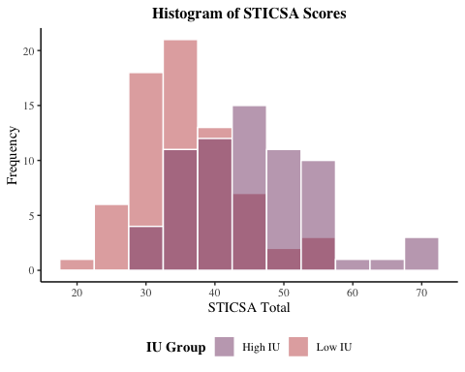

# save plot to file  
ggsave(filename = "graphs/histograms/hist_sticsa_total.png",   
 plot = hist_sticsa_total,   
 width = 20,   
 height = 10,   
 dpi = 300,   
 units = "cm")  
  
########################## check ranges  
range_sticsa_total <- by(df$sticsa_total, df$iu_group, range)  
range_sticsa_total

## df$iu_group: -1  
## [1] 22 57  
## ------------------------------------------------------------   
## df$iu_group: 1  
## [1] 30 69

# for high IU: 30-69  
# for low IU: 22-57  
##### overall: all scores are in range of possible scores, no errors apparent

# **Compute Demographics**

#### for age  
# for all participants  
all_age_table <-   
 describe(df[, "age"])  
  
# for high IU  
high_iu_age_table <-   
 describe(df[df$iu_group =="1", "age"])  
  
# for low IU  
low_iu_age_table <-   
 describe(df[df$iu_group =="-1", "age"])  
  
# combine in a table  
age_table <- rbind(all_age_table, high_iu_age_table, low_iu_age_table)  
  
# re-name rows for easier interpretation  
rownames(age_table) <- c("Age (All Participants","Age (High IU Group)",   
 "Age (Low IU Group)")  
  
### for sex   
sex_table <- xtabs(~ iu_group + sex, data = df)  
sex_table <- prop.table(sex_table) %>%  
 round(digits = 4) * 100  
rownames(sex_table) <- c("Low IU", "High IU")  
sex_table

## sex  
## iu_group Female Male  
## Low IU 26.28 24.82  
## High IU 34.31 14.60

### for sexual orientation  
sexual_orientation_table <- xtabs(~ iu_group + sexual_orientation, data = df)  
sexual_orientation_table <- prop.table(sexual_orientation_table) %>%  
 round(digits = 4) * 100  
rownames(sexual_orientation_table) <- c("Low IU", "High IU")  
sexual_orientation_table

## sexual_orientation  
## iu_group Heterosexual Sexual Minority  
## Low IU 42.15 7.44  
## High IU 42.98 7.44

### for ethnicity  
ethnicity_table <- xtabs(~ iu_group + ethnicity, data = df)  
ethnicity_table <- prop.table(ethnicity_table) %>%  
 round(digits = 4) * 100  
rownames(ethnicity_table) <- c("Low IU", "High IU")  
ethnicity_table

## ethnicity  
## iu_group Asian Black Middle Eastern/ Arab Mixed White  
## Low IU 7.26 1.61 2.42 0.81 37.90  
## High IU 16.13 0.00 0.81 0.81 32.26

#### write each to csv   
# age  
write.csv(age_table, file = "tables/demographics/age_table.csv",  
 row.names = TRUE)  
  
# ethnicity  
write.csv(ethnicity_table, file = "tables/demographics/ethnicity_table.csv",  
 row.names = TRUE)  
  
# sex  
write.csv(sex_table, file = "tables/demographics/sex_table.csv",   
 row.names = TRUE)  
  
# sexual orientation  
write.csv(sexual_orientation_table, file = "tables/demographics/sexual_orientation_table.csv",  
 row.names = TRUE)

# *Check for Difference in Questionnaire Totals Between Groups*

## *Check for Difference in IUS-27 Totals Between Groups*

# t-test to check for intergroup differences in IU total score - there should   
# be a significant difference.   
  
# plot data for both groups using QQ plot  
qqplot_ius_total <- ggqqplot(df, x = "ius_total",  
 color = "iu_group",  
 palette = c("#c45150", "#824372"),  
 title = "Q-Q Plot IUS Total") +  
 theme(plot.title = element_text(face = "bold", hjust = 0.5, size = 12)) +  
 theme(text = element_text(family = "serif"),   
 plot.title = element_text(face = "bold", hjust = 0.5, size = 15))   
# inspect the QQ plots  
qqplot_ius_total

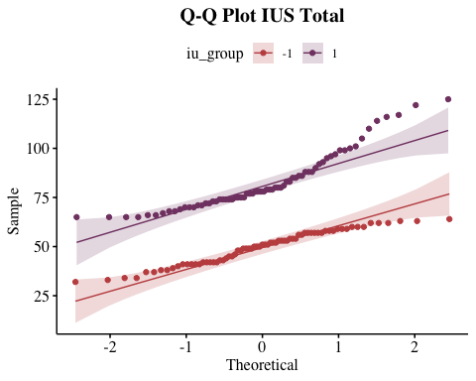

# save plot to file  
ggsave(filename = "graphs/qqplots/qqplot_ius_total.png",   
 plot = qqplot_ius_total,   
 width = 20,   
 height = 10,   
 dpi = 300,   
 units = "cm")  
  
# check significance of data for both groups using Shapiro-Wilk Test  
shapiro_ius_total <- by(df$ius_total, df$iu_group, shapiro.test)  
shapiro_ius_total

## df$iu_group: -1  
##   
## Shapiro-Wilk normality test  
##   
## data: dd[x, ]  
## W = 0.9603, p-value = 0.02444  
##   
## ------------------------------------------------------------   
## df$iu_group: 1  
##   
## Shapiro-Wilk normality test  
##   
## data: dd[x, ]  
## W = 0.88758, p-value = 0.00001673

# high IU: p-value < .05, data violate assumption of normality  
# low IU: p-value < .05, data violate assumption of normality  
  
## check assumption of homogeneity of variances using Bartlett Test ##  
bartlett_ius_total <- bartlett.test(ius_total ~ iu_group, data = df)   
bartlett_ius_total

##   
## Bartlett test of homogeneity of variances  
##   
## data: ius_total by iu_group  
## Bartlett's K-squared = 19.86, df = 1, p-value = 0.000008334

# p-value < .05, data violate assumption of equal variances  
  
## compute independent samples t.test ##  
# as data violate assumption of normality and assumption of equal variances,  
# use non-parametric Mann Whitney U  
  
# compute t.test and assign values to an object  
ius_total_groupdiff <- wilcox.test(ius_total ~ iu_group, data = df, paired = FALSE)  
# obtain t.test values   
ius_total_groupdiff

##   
## Wilcoxon rank sum test with continuity correction  
##   
## data: ius_total by iu_group  
## W = 0, p-value < 0.00000000000000022  
## alternative hypothesis: true location shift is not equal to 0

# p-value < .05, there is a statistical difference in IUS 27 total between groups

## *Check for Difference in STICSA Totals Between Groups*

# t-test to check for intergroup differences in STICSA total score - there should   
# be a significant difference.   
  
# plot data for both groups using QQ plot  
qqplot_sticsa_total <- ggqqplot(df, x = "sticsa_total",  
 color = "iu_group",  
 palette = c("#c45150", "#824372"),  
 title = "Q-Q Plot STICSA Total") +  
 theme(plot.title = element_text(face = "bold", hjust = 0.5, size = 12)) +  
 theme(text = element_text(family = "serif"),   
 plot.title = element_text(face = "bold", hjust = 0.5, size = 15))   
# inspect the QQ plots  
qqplot_sticsa_total

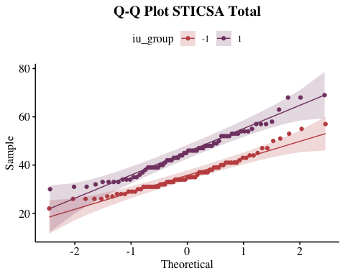

# save plot to file  
ggsave(filename = "graphs/qqplots/qqplot_sticsa_total.png",   
 plot = qqplot_sticsa_total,   
 width = 20,   
 height = 10,   
 dpi = 300,   
 units = "cm")  
  
# check significance of data for both groups using Shapiro-Wilk Test  
shapiro_sticsa_total <- by(df$sticsa_total, df$iu_group, shapiro.test)  
shapiro_sticsa_total

## df$iu_group: -1  
##   
## Shapiro-Wilk normality test  
##   
## data: dd[x, ]  
## W = 0.95514, p-value = 0.01269  
##   
## ------------------------------------------------------------   
## df$iu_group: 1  
##   
## Shapiro-Wilk normality test  
##   
## data: dd[x, ]  
## W = 0.96452, p-value = 0.05002

# high iu: p-value > .05, data meet assumption of normality  
# low iu: p-value < .05, data violate assumption of normality  
  
## check assumption of homogeneity of variances using Bartlett Test ##  
bartlett_sticsa_total <- bartlett.test(sticsa_total ~ iu_group, data = df)   
bartlett_sticsa_total

##   
## Bartlett test of homogeneity of variances  
##   
## data: sticsa_total by iu_group  
## Bartlett's K-squared = 3.8861, df = 1, p-value = 0.04869

# p-value < .05, data violate assumption of equal variances  
  
## compute independent samples t.test ##  
# as data violate assumption of normality and assumption of equal variances,  
# use non-parametric Mann Whitney U  
  
# compute t.test and assign values to an object  
sticsa_total_groupdiff <- wilcox.test(sticsa_total ~ iu_group, data = df, paired = FALSE)  
# obtain t.test values   
sticsa_total_groupdiff

##   
## Wilcoxon rank sum test with continuity correction  
##   
## data: sticsa_total by iu_group  
## W = 1032, p-value = 0.000000005691  
## alternative hypothesis: true location shift is not equal to 0

# p-value < .05, there is a statistical difference in STICSA total between groups

# *Check for Difference in Demographics Between Groups*

## *Check for Difference in Age Between Groups*

# t-test to check for intergroup differences in age  
  
# plot data for both groups using QQ plot  
qqplot_age <- ggqqplot(df, x = "age",  
 color = "iu_group",  
 palette = c("#c45150", "#824372"),  
 title = "Q-Q Plot Age") +  
 theme(plot.title = element_text(face = "bold", hjust = 0.5, size = 12)) +  
 theme(text = element_text(family = "serif"),   
 plot.title = element_text(face = "bold", hjust = 0.5, size = 15))   
# inspect the QQ plots  
qqplot_age

## Warning: Removed 1 rows containing non-finite values (stat_qq).

## Warning: Removed 1 rows containing non-finite values (stat_qq_line).  
  
## Warning: Removed 1 rows containing non-finite values (stat_qq_line).

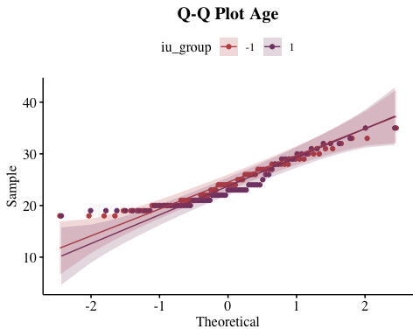

# save plot to file  
ggsave(filename = "graphs/qqplots/qqplot_age.png",   
 plot = qqplot_age,   
 width = 20,   
 height = 10,   
 dpi = 300,   
 units = "cm")

## Warning: Removed 1 rows containing non-finite values (stat_qq).  
  
## Warning: Removed 1 rows containing non-finite values (stat_qq_line).  
  
## Warning: Removed 1 rows containing non-finite values (stat_qq_line).

# check significance of data for both groups using Shapiro-Wilk Test  
shapiro_age <- by(df$age, df$iu_group, shapiro.test)  
shapiro_age

## df$iu_group: -1  
##   
## Shapiro-Wilk normality test  
##   
## data: dd[x, ]  
## W = 0.95698, p-value = 0.016  
##   
## ------------------------------------------------------------   
## df$iu_group: 1  
##   
## Shapiro-Wilk normality test  
##   
## data: dd[x, ]  
## W = 0.88408, p-value = 0.00001422

# high IU: p-value < .05, data violate assumption of normality  
# low IU: p-value < .05, data violate assumption of normality  
  
## check assumption of homogeneity of variances using Bartlett Test ##  
bartlett_age <- bartlett.test(age ~ iu_group, data = df)   
bartlett_age

##   
## Bartlett test of homogeneity of variances  
##   
## data: age by iu_group  
## Bartlett's K-squared = 0.27665, df = 1, p-value = 0.5989

# p-value > .05, data meet assumption of equal variances  
  
## compute independent samples t.test ##  
# as data violate assumption of normality,  
# use non-parametric Mann Whitney U  
  
# compute t.test and assign values to an object  
age_groupdiff <- wilcox.test(age ~ iu_group, data = df, paired = FALSE)  
  
# obtain t.test values   
age_groupdiff

##   
## Wilcoxon rank sum test with continuity correction  
##   
## data: age by iu_group  
## W = 2585.5, p-value = 0.3773  
## alternative hypothesis: true location shift is not equal to 0

# p-value > .05, there is no statistical difference in age between groups

## *Check for Difference in Sex Between Groups*

# compute chi-square of cross-tabulation and save as object   
chi_sex <- chisq.test(table(df$iu_group, df$sex))  
  
# check assumption of chi-square  
chi_sex_expected <- chi_sex$expected   
chi_sex_expected

##   
## Female Male  
## -1 42.40876 27.59124  
## 1 40.59124 26.40876

# no cells less than 5, meets assumptions   
  
# obtain statistic, df and p-value  
chi_sex

##   
## Pearson's Chi-squared test with Yates' continuity correction  
##   
## data: table(df$iu_group, df$sex)  
## X-squared = 4.2708, df = 1, p-value = 0.03877

# p-value < .05, there appears to be a statistical difference in sex between groups  
  
# therefore, obtain observed values  
chi_sex_observed <- chi_sex$observed  
chi_sex_observed

##   
## Female Male  
## -1 36 34  
## 1 47 20

## *Check for Difference in Ethnicity Between Groups*

# compute chi-square of cross-tabulation and save as object   
chi_ethnicity <- chisq.test(table(df$iu_group, df$ethnicity))

## Warning in chisq.test(table(df$iu_group, df$ethnicity)): Chi-squared  
## approximation may be incorrect

# check assumption of chi-square  
chi_ethnicity$expected

##   
## Asian Black Middle Eastern/ Arab Mixed White  
## -1 14.5 1 2 1 43.5  
## 1 14.5 1 2 1 43.5

# multiple cells with values less than 5, does not meet assumptions  
# and therefore requires Fisher's Exact Test  
  
# obtain statistic and df  
chi_ethnicity

##   
## Pearson's Chi-squared test  
##   
## data: table(df$iu_group, df$ethnicity)  
## X-squared = 7.7356, df = 4, p-value = 0.1018

# obtain corrected p-value   
chi_ethnicity_pval <- fisher.test(df$iu_group, df$ethnicity)   
chi_ethnicity_pval

##   
## Fisher's Exact Test for Count Data  
##   
## data: df$iu_group and df$ethnicity  
## p-value = 0.05899  
## alternative hypothesis: two.sided

# p-value > .05, no evidence of statistical difference in ethnicity between groups

## *Check for Difference in Sexual Orientation Between Groups*

# compute chi-square of cross-tabulation and save as object   
chi_sexual_orientation <- chisq.test(table(df$iu_group, df$sexual_orientation))   
  
# check assumption of chi-square  
chi_sexual_orientation$expected

##   
## Heterosexual Sexual Minority  
## -1 51.07438 8.92562  
## 1 51.92562 9.07438

# no cells with values less than 5, meets assumptions  
  
# obtain statistic and df  
chi_sexual_orientation

##   
## Pearson's Chi-squared test with Yates' continuity correction  
##   
## data: table(df$iu_group, df$sexual_orientation)  
## X-squared = 0, df = 1, p-value = 1

# p-value > .05, no evidence of statistical difference in sexual orientation between groups

# *Distribution Checks of Eye-Movement Variables*

## **Fixation Count**

### *Acquisition CS+*

hist_acq_csp_fix_count <- df %>%  
 ggplot(aes(acq_csp_fix_count, fill = iu_group)) +  
 geom_histogram(binwidth = 1, colour = "white", alpha = .5, position = "identity") +  
 theme_classic() +  
 theme(text = element_text(family = "serif"),   
 plot.title = element_text(face = "bold", hjust = 0.5, size = 15)) +  
 scale_x_continuous(breaks = seq(0, 30, 5)) +  
 labs(x = "Fixation Count", y = "Frequency") +  
 theme(plot.title = element_text(face = "bold", hjust = 0.5, size = 12)) +  
 ggtitle("Histogram Acquisition CS+ Fixation Count") +  
 theme(legend.position = "bottom", legend.title = element_text(face = "bold")) +  
 guides(fill = guide_legend(reverse = TRUE)) +  
 scale_fill_manual(values = c("#c45150", "#824372"), labels = c("Low IU", "High IU")) +  
 labs(fill = "IU Group")   
hist_acq_csp_fix_count

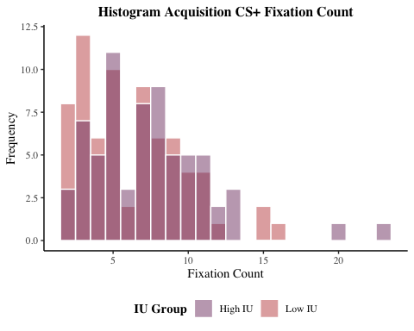

# save plot to file  
ggsave(filename = "graphs/histograms/hist_acq_csp_fix_count.png",   
 plot = hist_acq_csp_fix_count,   
 width = 20,   
 height = 10,   
 dpi = 300,   
 units = "cm")

### *Acquisition CS-*

hist_acq_csm_fix_count <- df %>%  
 ggplot(aes(acq_csm_fix_count, fill = iu_group)) +  
 geom_histogram(binwidth = 1, colour = "white", alpha = .5, position = "identity") +  
 theme_classic() +  
 theme(text = element_text(family = "serif"),   
 plot.title = element_text(face = "bold", hjust = 0.5, size = 15)) +  
 scale_x_continuous(breaks = seq(0, 30, 5)) +  
 labs(x = "Fixation Count", y = "Frequency") +  
 theme(plot.title = element_text(face = "bold", hjust = 0.5, size = 12)) +  
 ggtitle("Histogram Acquisition CS- Fixation Count") +  
 theme(legend.position = "bottom", legend.title = element_text(face = "bold")) +  
 guides(fill = guide_legend(reverse = TRUE)) +  
 scale_fill_manual(values = c("#c45150", "#824372"), labels = c("Low IU", "High IU")) +  
 labs(fill = "IU Group")   
hist_acq_csm_fix_count

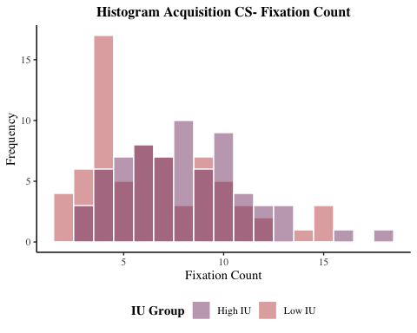

# save plot to file  
ggsave(filename = "graphs/histograms/hist_acq_csm_fix_count.png",   
 plot = hist_acq_csm_fix_count,   
 width = 20,   
 height = 10,   
 dpi = 300,   
 units = "cm")  
  
# combine acquisition fixation count graphs  
hists_acq_fix_count <-   
 grid.arrange(hist_acq_csp_fix_count, hist_acq_csm_fix_count,  
 ncol =2)

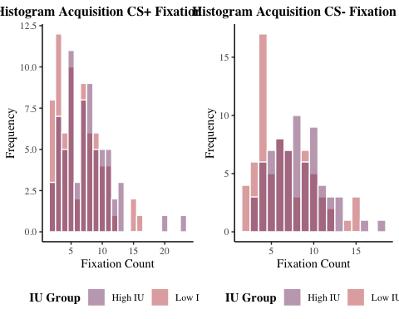

# save plot to file  
ggsave(filename = "graphs/histograms/hists_acq_fix_count.png",   
 plot = hists_acq_fix_count,   
 width = 30,   
 height = 10,   
 dpi = 300,   
 units = "cm")

### *Early Extinction CS+*

hist_e_ext_csp_fix_count <- df %>%  
 ggplot(aes(e_ext_csp_fix_count, fill = iu_group)) +  
 geom_histogram(binwidth = 1, colour = "white", alpha = .5, position = "identity") +  
 theme_classic() +  
 theme(text = element_text(family = "serif"),   
 plot.title = element_text(face = "bold", hjust = 0.5, size = 15)) +  
 scale_x_continuous(breaks = seq(0, 30, 5)) +  
 labs(x = "Fixation Count", y = "Frequency") +  
 theme(plot.title = element_text(face = "bold", hjust = 0.5, size = 12)) +  
 ggtitle("Histogram Early Extinction CS+ Fixation Count") +  
 theme(legend.position = "bottom", legend.title = element_text(face = "bold")) +  
 guides(fill = guide_legend(reverse = TRUE)) +  
 scale_fill_manual(values = c("#c45150", "#824372"), labels = c("Low IU", "High IU")) +  
 labs(fill = "IU Group")   
hist_e_ext_csp_fix_count

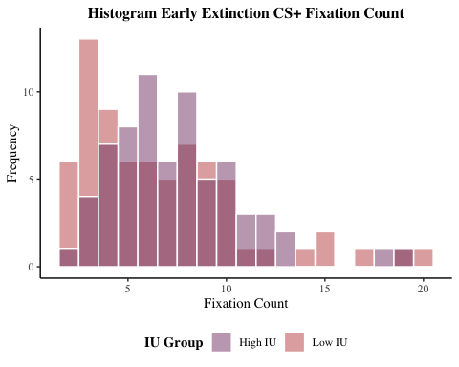

# save plot to file  
ggsave(filename = "graphs/histograms/hist_e_ext_csp_fix_count.png",   
 plot = hist_e_ext_csp_fix_count,   
 width = 20,   
 height = 10,   
 dpi = 300,   
 units = "cm")

### *Early Extinction CS-*

hist_e_ext_csm_fix_count <- df %>%  
 ggplot(aes(e_ext_csm_fix_count, fill = iu_group)) +  
 geom_histogram(binwidth = 1, colour = "white", alpha = .5, position = "identity") +  
 theme_classic() +  
 theme(text = element_text(family = "serif"),   
 plot.title = element_text(face = "bold", hjust = 0.5, size = 15)) +  
 scale_x_continuous(breaks = seq(0, 30, 5)) +  
 labs(x = "Fixation Count", y = "Frequency") +  
 theme(plot.title = element_text(face = "bold", hjust = 0.5, size = 12)) +  
 ggtitle("Histogram Early Extinction CS- Fixation Count") +  
 theme(legend.position = "bottom", legend.title = element_text(face = "bold")) +  
 guides(fill = guide_legend(reverse = TRUE)) +  
 scale_fill_manual(values = c("#c45150", "#824372"), labels = c("Low IU", "High IU")) +  
 labs(fill = "IU Group")   
hist_e_ext_csm_fix_count

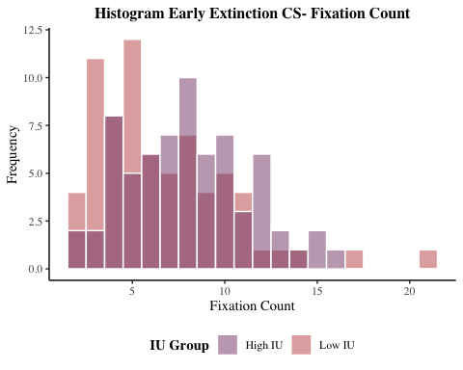

# save plot to file  
ggsave(filename = "graphs/histograms/hist_e_ext_csm_fix_count.png",   
 plot = hist_e_ext_csm_fix_count,   
 width = 20,   
 height = 10,   
 dpi = 300,   
 units = "cm")

### *Late Extinction CS+*

hist_l_ext_csp_fix_count <- df %>%  
 ggplot(aes(l_ext_csp_fix_count, fill = iu_group)) +  
 geom_histogram(binwidth = 1, colour = "white", alpha = .5, position = "identity") +  
 theme_classic() +  
 theme(text = element_text(family = "serif"),   
 plot.title = element_text(face = "bold", hjust = 0.5, size = 15)) +  
 scale_x_continuous(breaks = seq(0, 30, 5)) +  
 labs(x = "Fixation Count", y = "Frequency") +  
 theme(plot.title = element_text(face = "bold", hjust = 0.5, size = 12)) +  
 ggtitle("Histogram Late Extinction CS+ Fixation Count") +  
 theme(legend.position = "bottom", legend.title = element_text(face = "bold")) +  
 guides(fill = guide_legend(reverse = TRUE)) +  
 scale_fill_manual(values = c("#c45150", "#824372"), labels = c("Low IU", "High IU")) +  
 labs(fill = "IU Group")   
hist_l_ext_csp_fix_count

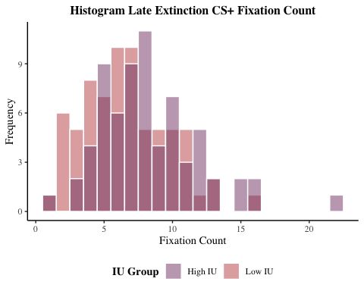

# save plot to file  
ggsave(filename = "graphs/histograms/hist_l_ext_csp_fix_count.png",   
 plot = hist_l_ext_csp_fix_count,   
 width = 20,   
 height = 10,   
 dpi = 300,   
 units = "cm")

### *Late Extinction CS-*

hist_l_ext_csm_fix_count <- df %>%  
 ggplot(aes(l_ext_csm_fix_count, fill = iu_group)) +  
 geom_histogram(binwidth = 1, colour = "white", alpha = .5, position = "identity") +  
 theme_classic() +  
 theme(text = element_text(family = "serif"),   
 plot.title = element_text(face = "bold", hjust = 0.5, size = 15)) +  
 scale_x_continuous(breaks = seq(0, 30, 5)) +  
 labs(x = "Fixation Count", y = "Frequency") +  
 theme(plot.title = element_text(face = "bold", hjust = 0.5, size = 12)) +  
 ggtitle("Histogram Late Extinction CS- Fixation Count") +  
 theme(legend.position = "bottom", legend.title = element_text(face = "bold")) +  
 guides(fill = guide_legend(reverse = TRUE)) +  
 scale_fill_manual(values = c("#c45150", "#824372"), labels = c("Low IU", "High IU")) +  
 labs(fill = "IU Group")   
hist_l_ext_csm_fix_count

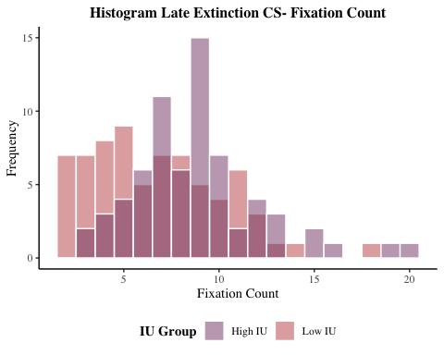

# save plot to file  
ggsave(filename = "graphs/histograms/hist_l_ext_csm_fix_count.png",   
 plot = hist_l_ext_csm_fix_count,   
 width = 20,   
 height = 10,   
 dpi = 300,   
 units = "cm")  
  
# combine extinction fixation count graphs  
hists_ext_fix_count <-   
 grid.arrange(hist_e_ext_csp_fix_count, hist_e_ext_csm_fix_count,  
 hist_l_ext_csp_fix_count, hist_l_ext_csm_fix_count,  
 ncol =2)

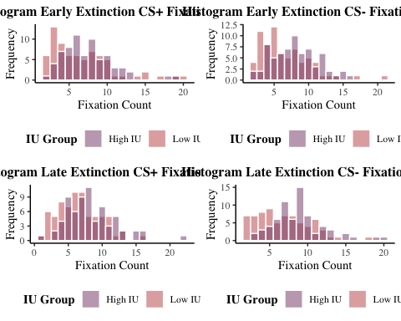

# save plot to file  
ggsave(filename = "graphs/histograms/hists_ext_fix_count.png",   
 plot = hists_ext_fix_count,   
 width = 30,   
 height = 20,   
 dpi = 300,   
 units = "cm")

## **Fixation Duration**

### *Acquisition CS+*

hist_acq_csp_fix_duration <- df %>%  
 ggplot(aes(acq_csp_fix_duration, fill = iu_group)) +  
 geom_histogram(binwidth = 220, colour = "white", alpha = .5, position = "identity") +  
 theme_classic() +  
 theme(text = element_text(family = "serif"),   
 plot.title = element_text(face = "bold", hjust = 0.5, size = 15)) +  
 scale_x_continuous(breaks = seq(0, 6000, 1000)) +  
 labs(x = "Fixation Duration (ms)", y = "Frequency") +  
 theme(plot.title = element_text(face = "bold", hjust = 0.5, size = 12)) +  
 ggtitle("Histogram Acquisition CS+ Fixation Duration") +  
 theme(legend.position = "bottom", legend.title = element_text(face = "bold")) +  
 guides(fill = guide_legend(reverse = TRUE)) +  
 scale_fill_manual(values = c("#c45150", "#824372"), labels = c("Low IU", "High IU")) +  
 labs(fill = "IU Group")   
hist_acq_csp_fix_duration

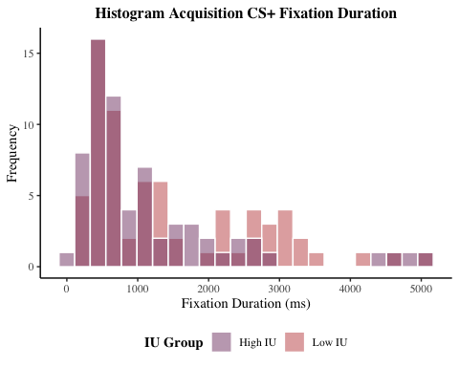

# save plot to file  
ggsave(filename = "graphs/histograms/hist_acq_csp_fix_duration.png",   
 plot = hist_acq_csp_fix_duration,   
 width = 20,   
 height = 10,   
 dpi = 300,   
 units = "cm")

### *Acquisition CS-*

hist_acq_csm_fix_duration <- df %>%  
 ggplot(aes(acq_csm_fix_duration, fill = iu_group)) +  
 geom_histogram(binwidth = 220, colour = "white", alpha = .5, position = "identity") +  
 theme_classic() +  
 theme(text = element_text(family = "serif"),   
 plot.title = element_text(face = "bold", hjust = 0.5, size = 15)) +  
 scale_x_continuous(breaks = seq(0, 6000, 1000)) +  
 labs(x = "Fixation Duration (ms)", y = "Frequency") +  
 theme(plot.title = element_text(face = "bold", hjust = 0.5, size = 12)) +  
 ggtitle("Histogram Acquisition CS- Fixation Duration") +  
 theme(legend.position = "bottom", legend.title = element_text(face = "bold")) +  
 guides(fill = guide_legend(reverse = TRUE)) +  
 scale_fill_manual(values = c("#c45150", "#824372"), labels = c("Low IU", "High IU")) +  
 labs(fill = "IU Group")   
hist_acq_csm_fix_duration

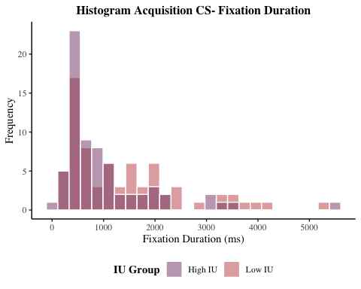

# save plot to file  
ggsave(filename = "graphs/histograms/hist_acq_csm_fix_duration.png",   
 plot = hist_acq_csm_fix_duration,   
 width = 20,   
 height = 10,   
 dpi = 300,   
 units = "cm")  
  
# combine acquisition fixation duration graphs  
hists_acq_fix_duration <-   
 grid.arrange(hist_acq_csp_fix_duration, hist_acq_csm_fix_duration,  
 ncol =2)

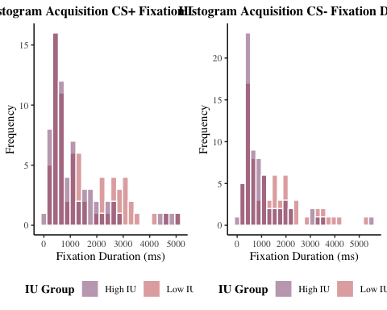

# save plot to file  
ggsave(filename = "graphs/histograms/hists_acq_fix_duration.png",   
 plot = hists_acq_fix_duration,   
 width = 30,   
 height = 10,   
 dpi = 300,   
 units = "cm")

### *Early Extinction CS+*

hist_e_ext_csp_fix_duration <- df %>%  
 ggplot(aes(e_ext_csp_fix_duration, fill = iu_group)) +  
 geom_histogram(binwidth = 220, colour = "white", alpha = .5, position = "identity") +  
 theme_classic() +  
 theme(text = element_text(family = "serif"),   
 plot.title = element_text(face = "bold", hjust = 0.5, size = 15)) +  
 scale_x_continuous(breaks = seq(0, 6000, 1000)) +  
 labs(x = "Fixation Duration (ms)", y = "Frequency") +  
 theme(plot.title = element_text(face = "bold", hjust = 0.5, size = 12)) +  
 ggtitle("Histogram Early Extinction CS+ Fixation Duration") +  
 theme(legend.position = "bottom", legend.title = element_text(face = "bold")) +  
 guides(fill = guide_legend(reverse = TRUE)) +  
 scale_fill_manual(values = c("#c45150", "#824372"), labels = c("Low IU", "High IU")) +  
 labs(fill = "IU Group")   
hist_e_ext_csp_fix_duration

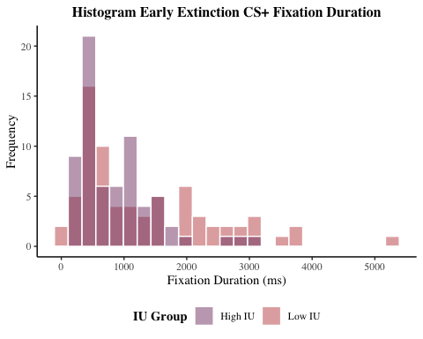

# save plot to file  
ggsave(filename = "graphs/histograms/hist_e_ext_csp_fix_duration.png",   
 plot = hist_e_ext_csp_fix_duration,   
 width = 20,   
 height = 10,   
 dpi = 300,   
 units = "cm")

### *Early Extinction CS-*

hist_e_ext_csm_fix_duration <- df %>%  
 ggplot(aes(e_ext_csm_fix_duration, fill = iu_group)) +  
 geom_histogram(binwidth = 220, colour = "white", alpha = .5, position = "identity") +  
 theme_classic() +  
 theme(text = element_text(family = "serif"),   
 plot.title = element_text(face = "bold", hjust = 0.5, size = 15)) +  
 scale_x_continuous(breaks = seq(0, 6000, 1000)) +  
 labs(x = "Fixation Duration (ms)", y = "Frequency") +  
 theme(plot.title = element_text(face = "bold", hjust = 0.5, size = 12)) +  
 ggtitle("Histogram Early Extinction CS- Fixation Duration") +  
 theme(legend.position = "bottom", legend.title = element_text(face = "bold")) +  
 guides(fill = guide_legend(reverse = TRUE)) +  
 scale_fill_manual(values = c("#c45150", "#824372"), labels = c("Low IU", "High IU")) +  
 labs(fill = "IU Group")   
hist_e_ext_csm_fix_duration

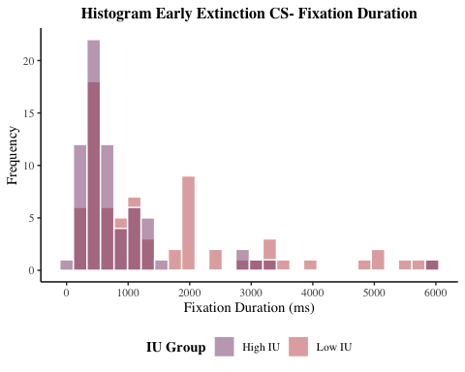

# save plot to file  
ggsave(filename = "graphs/histograms/hist_e_ext_csm_fix_duration.png",   
 plot = hist_e_ext_csm_fix_duration,   
 width = 20,   
 height = 10,   
 dpi = 300,   
 units = "cm")

### *Late Extinction CS+*

hist_l_ext_csp_fix_duration <- df %>%  
 ggplot(aes(l_ext_csp_fix_duration, fill = iu_group)) +  
 geom_histogram(binwidth = 220, colour = "white", alpha = .5, position = "identity") +  
 theme_classic() +  
 theme(text = element_text(family = "serif"),   
 plot.title = element_text(face = "bold", hjust = 0.5, size = 15)) +  
 scale_x_continuous(breaks = seq(0, 6000, 1000)) +  
 labs(x = "Fixation Duration (ms)", y = "Frequency") +  
 theme(plot.title = element_text(face = "bold", hjust = 0.5, size = 12)) +  
 ggtitle("Histogram Late Extinction CS+ Fixation Duration") +  
 theme(legend.position = "bottom", legend.title = element_text(face = "bold")) +  
 guides(fill = guide_legend(reverse = TRUE)) +  
 scale_fill_manual(values = c("#c45150", "#824372"), labels = c("Low IU", "High IU")) +  
 labs(fill = "IU Group")   
hist_l_ext_csp_fix_duration

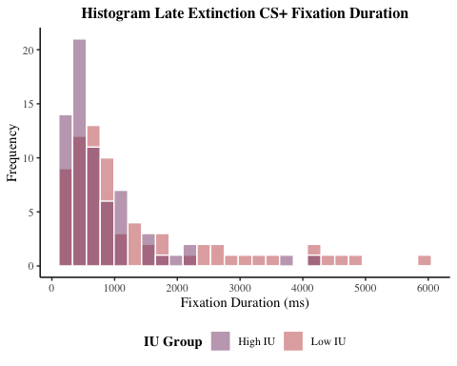

# save plot to file  
ggsave(filename = "graphs/histograms/hist_l_ext_csp_fix_duration.png",   
 plot = hist_l_ext_csp_fix_duration,   
 width = 20,   
 height = 10,   
 dpi = 300,   
 units = "cm")

### *Late Extinction CS-*

hist_l_ext_csm_fix_duration <- df %>%  
 ggplot(aes(l_ext_csm_fix_duration, fill = iu_group)) +  
 geom_histogram(binwidth = 220, colour = "white", alpha = .5, position = "identity") +  
 theme_classic() +  
 theme(text = element_text(family = "serif"),   
 plot.title = element_text(face = "bold", hjust = 0.5, size = 15)) +  
 scale_x_continuous(breaks = seq(0, 6000, 1000)) +  
 labs(x = "Fixation Duration (ms)", y = "Frequency") +  
 theme(plot.title = element_text(face = "bold", hjust = 0.5, size = 12)) +  
 ggtitle("Histogram Late Extinction CS- Fixation Duration") +  
 theme(legend.position = "bottom", legend.title = element_text(face = "bold")) +  
 guides(fill = guide_legend(reverse = TRUE)) +  
 scale_fill_manual(values = c("#c45150", "#824372"), labels = c("Low IU", "High IU")) +  
 labs(fill = "IU Group")   
hist_l_ext_csm_fix_duration

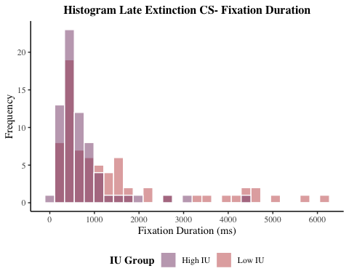

# save plot to file  
ggsave(filename = "graphs/histograms/hist_l_ext_csm_fix_duration.png",   
 plot = hist_l_ext_csm_fix_duration,   
 width = 20,   
 height = 10,   
 dpi = 300,   
 units = "cm")  
  
# combine extinction fixation duration graphs  
hists_ext_fix_duration <-   
 grid.arrange(hist_e_ext_csp_fix_duration, hist_e_ext_csm_fix_duration,  
 hist_l_ext_csp_fix_duration, hist_l_ext_csm_fix_duration,  
 ncol =2)

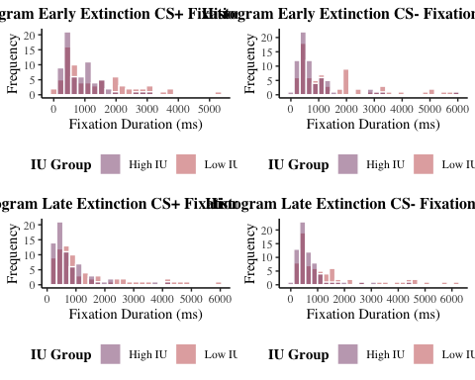

# save plot to file  
ggsave(filename = "graphs/histograms/hists_ext_fix_duration.png",   
 plot = hists_ext_fix_duration,   
 width = 30,   
 height = 20,   
 dpi = 300,   
 units = "cm")

## **Saccade Amplitude**

### *Acquisition CS+*

hist_acq_csp_sacc_amplitude <- df %>%  
 ggplot(aes(acq_csp_sacc_amplitude, fill = iu_group)) +  
 geom_histogram(binwidth = .5, colour = "white", alpha = .5, position = "identity") +  
 theme_classic() +  
 theme(text = element_text(family = "serif"),   
 plot.title = element_text(face = "bold", hjust = 0.5, size = 15)) +  
 scale_x_continuous(breaks = seq(0, 10, 2)) +  
 labs(x = "Saccade Amplitude (deg/ms)", y = "Frequency") +  
 theme(plot.title = element_text(face = "bold", hjust = 0.5, size = 12)) +  
 ggtitle("Histogram Acquisition CS+ Saccade Amplitude") +  
 theme(legend.position = "bottom", legend.title = element_text(face = "bold")) +  
 guides(fill = guide_legend(reverse = TRUE)) +  
 scale_fill_manual(values = c("#c45150", "#824372"), labels = c("Low IU", "High IU")) +  
 labs(fill = "IU Group")   
hist_acq_csp_sacc_amplitude

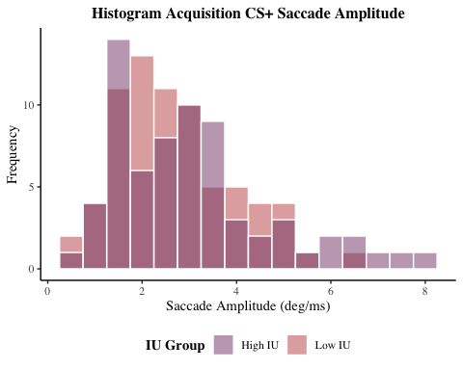

ggsave(filename = "graphs/histograms/hist_acq_csp_sacc_amplitude.png",   
 plot = hist_acq_csp_sacc_amplitude,   
 width = 20,   
 height = 10,   
 dpi = 300,   
 units = "cm")

### *Acquisition CS-*

hist_acq_csm_sacc_amplitude <- df %>%  
 ggplot(aes(acq_csm_sacc_amplitude, fill = iu_group)) +  
 geom_histogram(binwidth = .5, colour = "white", alpha = .5, position = "identity") +  
 theme_classic() +  
 theme(text = element_text(family = "serif"),   
 plot.title = element_text(face = "bold", hjust = 0.5, size = 15)) +  
 scale_x_continuous(breaks = seq(0, 10, 2)) +  
 labs(x = "Saccade Amplitude (deg/ms)", y = "Frequency") +  
 theme(plot.title = element_text(face = "bold", hjust = 0.5, size = 12)) +  
 ggtitle("Histogram Acquisition CS- Saccade Amplitude") +  
 theme(legend.position = "bottom", legend.title = element_text(face = "bold")) +  
 guides(fill = guide_legend(reverse = TRUE)) +  
 scale_fill_manual(values = c("#c45150", "#824372"), labels = c("Low IU", "High IU")) +  
 labs(fill = "IU Group")   
hist_acq_csm_sacc_amplitude

## Warning: Removed 2 rows containing non-finite values (stat_bin).

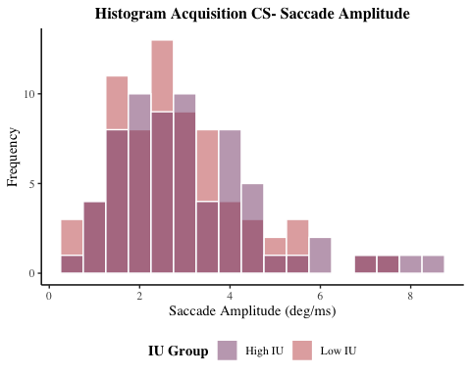

ggsave(filename = "graphs/histograms/hist_acq_csm_sacc_amplitude.png",   
 plot = hist_acq_csm_sacc_amplitude,   
 width = 20,   
 height = 10,   
 dpi = 300,   
 units = "cm")

## Warning: Removed 2 rows containing non-finite values (stat_bin).

# combine acquisition saccade amplitude graphs  
hists_acq_sacc_amplitude <-   
 grid.arrange(hist_acq_csp_sacc_amplitude, hist_acq_csm_sacc_amplitude,  
 ncol =2)

## Warning: Removed 2 rows containing non-finite values (stat_bin).

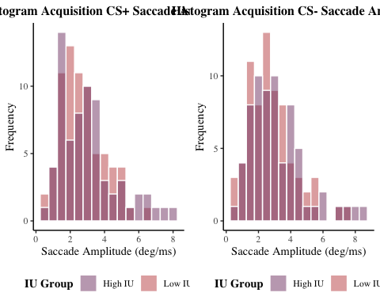

# save plot to file  
ggsave(filename = "graphs/histograms/hists_acq_sacc_amplitude.png",   
 plot = hists_acq_sacc_amplitude,   
 width = 30,   
 height = 10,   
 dpi = 300,   
 units = "cm")

### *Early Extinction CS+*

hist_e_ext_csp_sacc_amplitude <- df %>%  
 ggplot(aes(e_ext_csp_sacc_amplitude, fill = iu_group)) +  
 geom_histogram(binwidth = .5, colour = "white", alpha = .5, position = "identity") +  
 theme_classic() +  
 theme(text = element_text(family = "serif"),   
 plot.title = element_text(face = "bold", hjust = 0.5, size = 15)) +  
 scale_x_continuous(breaks = seq(0, 14, 2)) +  
 labs(x = "Saccade Amplitude (deg/ms)", y = "Frequency") +  
 theme(plot.title = element_text(face = "bold", hjust = 0.5, size = 12)) +  
 ggtitle("Histogram Early Extinction CS+ Saccade Amplitude") +  
 theme(legend.position = "bottom", legend.title = element_text(face = "bold")) +  
 guides(fill = guide_legend(reverse = TRUE)) +  
 scale_fill_manual(values = c("#c45150", "#824372"), labels = c("Low IU", "High IU")) +  
 labs(fill = "IU Group")   
hist_e_ext_csp_sacc_amplitude

## Warning: Removed 1 rows containing non-finite values (stat_bin).

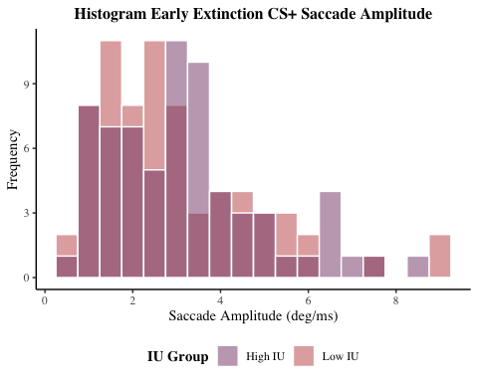

# save plot to file  
ggsave(filename = "graphs/histograms/hist_e_ext_csp_sacc_amplitude.png",   
 plot = hist_e_ext_csp_sacc_amplitude,   
 width = 20,   
 height = 10,   
 dpi = 300,   
 units = "cm")

## Warning: Removed 1 rows containing non-finite values (stat_bin).

### *Early Extinction CS-*

hist_e_ext_csm_sacc_amplitude <- df %>%  
 ggplot(aes(e_ext_csm_sacc_amplitude, fill = iu_group)) +  
 geom_histogram(binwidth = .5, colour = "white", alpha = .5, position = "identity") +  
 theme_classic() +  
 theme(text = element_text(family = "serif"),   
 plot.title = element_text(face = "bold", hjust = 0.5, size = 15)) +  
 scale_x_continuous(breaks = seq(0, 14, 2)) +  
 labs(x = "Saccade Amplitude (deg/ms)", y = "Frequency") +  
 theme(plot.title = element_text(face = "bold", hjust = 0.5, size = 12)) +  
 ggtitle("Histogram Early Extinction CS- Saccade Amplitude") +  
 theme(legend.position = "bottom", legend.title = element_text(face = "bold")) +  
 guides(fill = guide_legend(reverse = TRUE)) +  
 scale_fill_manual(values = c("#c45150", "#824372"), labels = c("Low IU", "High IU")) +  
 labs(fill = "IU Group")   
hist_e_ext_csm_sacc_amplitude

## Warning: Removed 1 rows containing non-finite values (stat_bin).

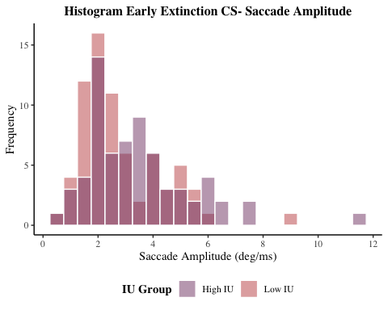

# save plot to file  
ggsave(filename = "graphs/histograms/hist_e_ext_csm_sacc_amplitude.png",   
 plot = hist_e_ext_csm_sacc_amplitude,   
 width = 20,   
 height = 10,   
 dpi = 300,   
 units = "cm")

## Warning: Removed 1 rows containing non-finite values (stat_bin).

### *Late Extinction CS+*

hist_l_ext_csp_sacc_amplitude <- df %>%  
 ggplot(aes(l_ext_csp_sacc_amplitude, fill = iu_group)) +  
 geom_histogram(binwidth = .5, colour = "white", alpha = .5, position = "identity") +  
 theme_classic() +  
 theme(text = element_text(family = "serif"),   
 plot.title = element_text(face = "bold", hjust = 0.5, size = 15)) +  
 scale_x_continuous(breaks = seq(0, 14, 2)) +  
 labs(x = "Saccade Amplitude (deg/ms)", y = "Frequency") +  
 theme(plot.title = element_text(face = "bold", hjust = 0.5, size = 12)) +  
 ggtitle("Histogram Late Extinction CS+ Saccade Amplitude") +  
 theme(legend.position = "bottom", legend.title = element_text(face = "bold")) +  
 guides(fill = guide_legend(reverse = TRUE)) +  
 scale_fill_manual(values = c("#c45150", "#824372"), labels = c("Low IU", "High IU")) +  
 labs(fill = "IU Group")   
hist_l_ext_csp_sacc_amplitude

## Warning: Removed 1 rows containing non-finite values (stat_bin).

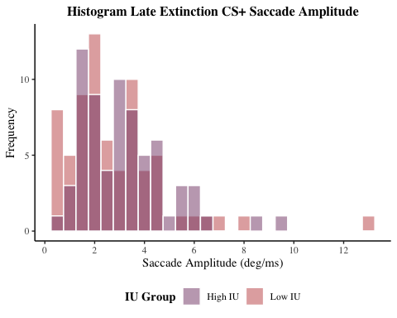

# save plot to file  
ggsave(filename = "graphs/histograms/hist_l_ext_csp_sacc_amplitude.png",   
 plot = hist_l_ext_csp_sacc_amplitude,   
 width = 20,   
 height = 10,   
 dpi = 300,   
 units = "cm")

## Warning: Removed 1 rows containing non-finite values (stat_bin).

### *Late Extinction CS-*

hist_l_ext_csm_sacc_amplitude <- df %>%  
 ggplot(aes(l_ext_csm_sacc_amplitude, fill = iu_group)) +  
 geom_histogram(binwidth = .5, colour = "white", alpha = .5, position = "identity") +  
 theme_classic() +  
 theme(text = element_text(family = "serif"),   
 plot.title = element_text(face = "bold", hjust = 0.5, size = 15)) +  
 scale_x_continuous(breaks = seq(0, 14, 2)) +  
 labs(x = "Saccade Amplitude (deg/ms)", y = "Frequency") +  
 theme(plot.title = element_text(face = "bold", hjust = 0.5, size = 12)) +  
 ggtitle("Histogram Late Extinction CS- Saccade Amplitude") +  
 theme(legend.position = "bottom", legend.title = element_text(face = "bold")) +  
 guides(fill = guide_legend(reverse = TRUE)) +  
 scale_fill_manual(values = c("#c45150", "#824372"), labels = c("Low IU", "High IU")) +  
 labs(fill = "IU Group")   
hist_l_ext_csm_sacc_amplitude

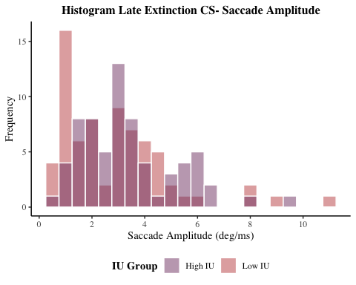

# save plot to file  
ggsave(filename = "graphs/histograms/hist_l_ext_csm_sacc_amplitude.png",   
 plot = hist_l_ext_csm_sacc_amplitude,   
 width = 20,   
 height = 10,   
 dpi = 300,   
 units = "cm")  
  
# combine extinction saccade amplitude graphs  
hists_ext_sacc_amplitude <-   
 grid.arrange(hist_e_ext_csp_sacc_amplitude, hist_e_ext_csm_sacc_amplitude,  
 hist_l_ext_csp_sacc_amplitude, hist_l_ext_csm_sacc_amplitude,  
 ncol =2)

## Warning: Removed 1 rows containing non-finite values (stat_bin).  
  
## Warning: Removed 1 rows containing non-finite values (stat_bin).  
  
## Warning: Removed 1 rows containing non-finite values (stat_bin).

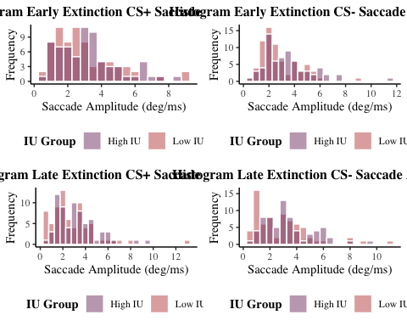

# save plot to file  
ggsave(filename = "graphs/histograms/hists_ext_sacc_amplitude.png",   
 plot = hists_ext_sacc_amplitude,   
 width = 30,   
 height = 20,   
 dpi = 300,   
 units = "cm")

# *Descriptives*

## *Questionnaire Variables*

# for all participants  
descriptives_all_questionnaires <-   
 describe(df[, c("ius_total", "sticsa_total")], na.rm = TRUE)  
  
# for high IU group  
descriptives_high_iu_questionnaires <-   
 describe(df[df$iu_group == "1", c("ius_total", "sticsa_total")], na.rm = TRUE)  
  
# for low IU group  
descriptives_low_iu_questionnaires <-   
 describe(df[df$iu_group == "-1", c("ius_total", "sticsa_total")], na.rm = TRUE)  
  
# combine all into table  
descriptives_questionnaires_table <- round(rbind(descriptives_all_questionnaires,   
 descriptives_high_iu_questionnaires,  
 descriptives_low_iu_questionnaires), 2)  
  
# rename rows for easier interpretation  
rownames(descriptives_questionnaires_table) <- c("IUS 27 (All Participants)",  
 "STICSA Total (All Participants)",  
 "IUS 27 (High IU Group)",  
 "STICSA Total (High IU Group)",  
 "IUS 27 (Low IU Group)",  
 "STICSA Total (Low IU Group)")  
  
descriptives_questionnaires_table

## vars n mean sd median trimmed mad min  
## IUS 27 (All Participants) 1 139 65.82 20.39 63.0 64.27 20.76 32  
## STICSA Total (All Participants) 2 139 40.54 9.54 39.0 39.93 10.38 22  
## IUS 27 (High IU Group) 1 68 82.65 14.77 78.0 80.79 11.86 65  
## STICSA Total (High IU Group) 2 68 45.29 9.30 45.5 44.77 9.64 30  
## IUS 27 (Low IU Group) 1 71 49.70 8.51 51.0 49.96 10.38 32  
## STICSA Total (Low IU Group) 2 71 35.99 7.32 35.0 35.35 5.93 22  
## max range skew kurtosis se  
## IUS 27 (All Participants) 125 93 0.64 0.00 1.73  
## STICSA Total (All Participants) 69 47 0.65 0.06 0.81  
## IUS 27 (High IU Group) 125 60 1.11 0.53 1.79  
## STICSA Total (High IU Group) 69 39 0.47 -0.19 1.13  
## IUS 27 (Low IU Group) 64 32 -0.23 -1.05 1.01  
## STICSA Total (Low IU Group) 57 35 0.76 0.30 0.87

# write to csv  
write.csv(descriptives_questionnaires_table, file = "tables/descriptives/descriptives_questionnaires_table.csv",  
 row.names = TRUE)

## *Eye Movement Variables*

### *Fixation Count*

# for all participants  
descriptives_all_fix_count <-   
 describe(df[, c("acq_csp_fix_count","acq_csm_fix_count",   
 "e_ext_csp_fix_count", "e_ext_csm_fix_count",  
 "l_ext_csp_fix_count", "l_ext_csm_fix_count")],   
 na.rm = TRUE)  
   
# for high IU group  
descriptives_high_iu_fix_count <-   
 describe(df[df$iu_group == "1", c("acq_csp_fix_count","acq_csm_fix_count",   
 "e_ext_csp_fix_count", "e_ext_csm_fix_count",  
 "l_ext_csp_fix_count", "l_ext_csm_fix_count")],   
 na.rm = TRUE)  
   
# for low IU group  
descriptives_low_iu_fix_count <-   
 describe(df[df$iu_group == "-1", c("acq_csp_fix_count","acq_csm_fix_count",   
 "e_ext_csp_fix_count", "e_ext_csm_fix_count",  
 "l_ext_csp_fix_count", "l_ext_csm_fix_count")],   
 na.rm = TRUE)  
  
# combine all into table  
descriptives_fix_count_table <- round(rbind(descriptives_all_fix_count,   
 descriptives_high_iu_fix_count,  
 descriptives_low_iu_fix_count), 2)  
  
# rename rows for easier interpretation  
rownames(descriptives_fix_count_table) <- c("Acquisition CS+ Fix Count (All Participants)",   
 "Acquisition CS- Fix Count (All Participants)",   
 "Early Extinction CS+ Fix Count (All Participants)",   
 "Early Extinction CS- Fix Count (All Participants)",  
 "Late Extinction CS+ Fix Count (All Participants)",   
 "Late Extinction CS- Fix Count (All Participants)",  
 "Acquisition CS+ Fix Count (High IU Group)",   
 "Acquisition CS- Fix Count (High IU Group)",   
 "Early Extinction CS+ Fix Count (High IU Group)",   
 "Early Extinction CS- Fix Count (High IU Group)",  
 "Late Extinction CS+ Fix Count (High IU Group)",   
 "Late Extinction CS- Fix Count (High IU Group)",  
 "Acquisition CS+ Fix Count (Low IU Group)",   
 "Acquisition CS- Fix Count (Low IU Group)",   
 "Early Extinction CS+ Fix Count (Low IU Group)",   
 "Early Extinction CS- Fix Count (Low IU Group)",  
 "Late Extinction CS+ Fix Count (Low IU Group)",   
 "Late Extinction CS- Fix Count (Low IU Group)")  
  
descriptives_fix_count_table

## vars n mean sd median  
## Acquisition CS+ Fix Count (All Participants) 1 139 6.90 3.65 6.67  
## Acquisition CS- Fix Count (All Participants) 2 139 7.31 3.25 6.75  
## Early Extinction CS+ Fix Count (All Participants) 3 139 7.16 3.70 6.50  
## Early Extinction CS- Fix Count (All Participants) 4 139 7.40 3.53 6.75  
## Late Extinction CS+ Fix Count (All Participants) 5 139 7.55 3.49 7.25  
## Late Extinction CS- Fix Count (All Participants) 6 139 7.86 3.52 7.75  
## Acquisition CS+ Fix Count (High IU Group) 1 68 7.51 3.84 7.08  
## Acquisition CS- Fix Count (High IU Group) 2 68 7.97 3.07 7.79  
## Early Extinction CS+ Fix Count (High IU Group) 3 68 7.54 3.26 6.75  
## Early Extinction CS- Fix Count (High IU Group) 4 68 8.14 3.26 7.88  
## Late Extinction CS+ Fix Count (High IU Group) 5 68 8.41 3.63 7.75  
## Late Extinction CS- Fix Count (High IU Group) 6 68 8.89 3.33 8.75  
## Acquisition CS+ Fix Count (Low IU Group) 1 71 6.33 3.38 5.50  
## Acquisition CS- Fix Count (Low IU Group) 2 71 6.67 3.31 5.92  
## Early Extinction CS+ Fix Count (Low IU Group) 3 71 6.80 4.06 6.00  
## Early Extinction CS- Fix Count (Low IU Group) 4 71 6.70 3.66 5.75  
## Late Extinction CS+ Fix Count (Low IU Group) 5 71 6.72 3.15 6.50  
## Late Extinction CS- Fix Count (Low IU Group) 6 71 6.87 3.43 6.50  
## trimmed mad min max range  
## Acquisition CS+ Fix Count (All Participants) 6.57 3.71 1.50 23.17 21.67  
## Acquisition CS- Fix Count (All Participants) 7.06 3.71 1.92 18.33 16.42  
## Early Extinction CS+ Fix Count (All Participants) 6.75 3.71 1.50 20.50 19.00  
## Early Extinction CS- Fix Count (All Participants) 7.14 3.71 1.50 21.50 20.00  
## Late Extinction CS+ Fix Count (All Participants) 7.33 3.34 1.00 22.00 21.00  
## Late Extinction CS- Fix Count (All Participants) 7.65 3.34 1.50 20.00 18.50  
## Acquisition CS+ Fix Count (High IU Group) 7.14 3.46 2.00 23.17 21.17  
## Acquisition CS- Fix Count (High IU Group) 7.78 3.21 2.92 18.33 15.42  
## Early Extinction CS+ Fix Count (High IU Group) 7.26 2.97 2.25 19.25 17.00  
## Early Extinction CS- Fix Count (High IU Group) 8.00 3.34 2.00 16.50 14.50  
## Late Extinction CS+ Fix Count (High IU Group) 8.11 3.71 1.50 22.00 20.50  
## Late Extinction CS- Fix Count (High IU Group) 8.61 2.41 3.25 20.00 16.75  
## Acquisition CS+ Fix Count (Low IU Group) 6.02 3.71 1.50 15.67 14.17  
## Acquisition CS- Fix Count (Low IU Group) 6.35 3.21 1.92 15.50 13.58  
## Early Extinction CS+ Fix Count (Low IU Group) 6.22 3.71 1.50 20.50 19.00  
## Early Extinction CS- Fix Count (Low IU Group) 6.31 3.34 1.50 21.50 20.00  
## Late Extinction CS+ Fix Count (Low IU Group) 6.57 3.34 1.00 16.00 15.00  
## Late Extinction CS- Fix Count (Low IU Group) 6.68 3.71 1.50 17.75 16.25  
## skew kurtosis se  
## Acquisition CS+ Fix Count (All Participants) 1.18 2.52 0.31  
## Acquisition CS- Fix Count (All Participants) 0.69 0.19 0.28  
## Early Extinction CS+ Fix Count (All Participants) 1.18 1.74 0.31  
## Early Extinction CS- Fix Count (All Participants) 0.82 0.96 0.30  
## Late Extinction CS+ Fix Count (All Participants) 0.83 1.34 0.30  
## Late Extinction CS- Fix Count (All Participants) 0.68 0.81 0.30  
## Acquisition CS+ Fix Count (High IU Group) 1.43 3.48 0.47  
## Acquisition CS- Fix Count (High IU Group) 0.74 0.76 0.37  
## Early Extinction CS+ Fix Count (High IU Group) 1.09 1.81 0.40  
## Early Extinction CS- Fix Count (High IU Group) 0.36 -0.42 0.39  
## Late Extinction CS+ Fix Count (High IU Group) 1.00 1.61 0.44  
## Late Extinction CS- Fix Count (High IU Group) 1.03 1.59 0.40  
## Acquisition CS+ Fix Count (Low IU Group) 0.75 -0.01 0.40  
## Acquisition CS- Fix Count (Low IU Group) 0.79 -0.13 0.39  
## Early Extinction CS+ Fix Count (Low IU Group) 1.30 1.65 0.48  
## Early Extinction CS- Fix Count (Low IU Group) 1.32 2.59 0.43  
## Late Extinction CS+ Fix Count (Low IU Group) 0.47 -0.15 0.37  
## Late Extinction CS- Fix Count (Low IU Group) 0.59 -0.05 0.41

# write to csv  
write.csv(descriptives_fix_count_table, file = "tables/descriptives/descriptives_fix_count_table.csv",  
 row.names = TRUE)

### *Fixation Duration*

# for all participants  
descriptives_all_fix_duration <-   
 describe(df[, c("acq_csp_fix_duration","acq_csm_fix_duration",   
 "e_ext_csp_fix_duration", "e_ext_csm_fix_duration",  
 "l_ext_csp_fix_duration", "l_ext_csm_fix_duration")],   
 na.rm = TRUE)  
   
# for high IU group  
descriptives_high_iu_fix_duration <-   
 describe(df[df$iu_group == "1", c("acq_csp_fix_duration","acq_csm_fix_duration",   
 "e_ext_csp_fix_duration", "e_ext_csm_fix_duration",   
 "l_ext_csp_fix_duration", "l_ext_csm_fix_duration")],   
 na.rm = TRUE)  
   
# for low IU group  
descriptives_low_iu_fix_duration <-   
 describe(df[df$iu_group == "-1", c("acq_csp_fix_duration","acq_csm_fix_duration",   
 "e_ext_csp_fix_duration", "e_ext_csm_fix_duration",  
 "l_ext_csp_fix_duration", "l_ext_csm_fix_duration")],   
 na.rm = TRUE)  
  
# combine all in a table  
descriptives_fix_duration_table <- round(rbind(descriptives_all_fix_duration,   
 descriptives_high_iu_fix_duration,  
 descriptives_low_iu_fix_duration), 2)  
  
# rename rows for easier interpretation  
rownames(descriptives_fix_duration_table) <- c("Acquisition CS+ Fix Duration (All Participants)",   
 "Acquisition CS- Fix Duration (All Participants)",   
 "Early Extinction CS+ Fix Duration (All Participants)",   
 "Early Extinction CS- Fix Duration (All Participants)",  
 "Late Extinction CS+ Fix Duration (All Participants)",   
 "Late Extinction CS- Fix Duration (All Participants)",  
 "Acquisition CS+ Fix Duration (High IU Group)",   
 "Acquisition CS- Fix Duration (High IU Group)",   
 "Early Extinction CS+ Fix Duration (High IU Group)",   
 "Early Extinction CS- Fix Duration (High IU Group)",  
 "Late Extinction CS+ Fix Duration (High IU Group)",   
 "Late Extinction CS- Fix Duration (High IU Group)",  
 "Acquisition CS+ Fix Duration (Low IU Group)",   
 "Acquisition CS- Fix Duration (Low IU Group)",   
 "Early Extinction CS+ Fix Duration (Low IU Group)",   
 "Early Extinction CS- Fix Duration (Low IU Group)",  
 "Late Extinction CS+ Fix Duration (Low IU Group)",   
 "Late Extinction CS- Fix Duration (Low IU Group)")  
  
descriptives_fix_duration_table

## vars n mean sd  
## Acquisition CS+ Fix Duration (All Participants) 1 139 1309.36 1173.03  
## Acquisition CS- Fix Duration (All Participants) 2 139 1200.18 1048.80  
## Early Extinction CS+ Fix Duration (All Participants) 3 139 1104.04 930.02  
## Early Extinction CS- Fix Duration (All Participants) 4 139 1203.66 1288.87  
## Late Extinction CS+ Fix Duration (All Participants) 5 139 1066.13 1094.12  
## Late Extinction CS- Fix Duration (All Participants) 6 139 1068.60 1204.27  
## Acquisition CS+ Fix Duration (High IU Group) 1 68 1153.24 1126.41  
## Acquisition CS- Fix Duration (High IU Group) 2 68 1003.87 938.91  
## Early Extinction CS+ Fix Duration (High IU Group) 3 68 869.88 621.12  
## Early Extinction CS- Fix Duration (High IU Group) 4 68 833.27 912.11  
## Late Extinction CS+ Fix Duration (High IU Group) 5 68 799.03 732.10  
## Late Extinction CS- Fix Duration (High IU Group) 6 68 719.91 687.99  
## Acquisition CS+ Fix Duration (Low IU Group) 1 71 1458.89 1204.96  
## Acquisition CS- Fix Duration (Low IU Group) 2 71 1388.19 1118.70  
## Early Extinction CS+ Fix Duration (Low IU Group) 3 71 1328.31 1109.79  
## Early Extinction CS- Fix Duration (Low IU Group) 4 71 1558.41 1489.19  
## Late Extinction CS+ Fix Duration (Low IU Group) 5 71 1321.94 1308.18  
## Late Extinction CS- Fix Duration (Low IU Group) 6 71 1402.56 1474.73  
## median trimmed mad  
## Acquisition CS+ Fix Duration (All Participants) 789.44 1121.85 639.02  
## Acquisition CS- Fix Duration (All Participants) 778.02 1017.24 606.82  
## Early Extinction CS+ Fix Duration (All Participants) 786.25 958.21 611.53  
## Early Extinction CS- Fix Duration (All Participants) 674.06 937.16 519.93  
## Late Extinction CS+ Fix Duration (All Participants) 657.98 830.55 472.15  
## Late Extinction CS- Fix Duration (All Participants) 578.00 786.22 397.29  
## Acquisition CS+ Fix Duration (High IU Group) 666.40 943.03 510.01  
## Acquisition CS- Fix Duration (High IU Group) 649.90 830.74 412.10  
## Early Extinction CS+ Fix Duration (High IU Group) 716.65 780.80 516.83  
## Early Extinction CS- Fix Duration (High IU Group) 533.31 641.57 308.46  
## Late Extinction CS+ Fix Duration (High IU Group) 541.37 664.26 334.40  
## Late Extinction CS- Fix Duration (High IU Group) 510.20 585.21 306.25  
## Acquisition CS+ Fix Duration (Low IU Group) 1002.75 1309.89 888.32  
## Acquisition CS- Fix Duration (Low IU Group) 1081.07 1216.87 977.62  
## Early Extinction CS+ Fix Duration (Low IU Group) 931.86 1181.94 830.29  
## Early Extinction CS- Fix Duration (Low IU Group) 1017.70 1282.48 964.06  
## Late Extinction CS+ Fix Duration (Low IU Group) 781.46 1064.33 638.13  
## Late Extinction CS- Fix Duration (Low IU Group) 845.97 1102.87 689.98  
## min max range  
## Acquisition CS+ Fix Duration (All Participants) 87.39 5083.82 4996.43  
## Acquisition CS- Fix Duration (All Participants) 88.43 5446.78 5358.35  
## Early Extinction CS+ Fix Duration (All Participants) 79.01 5346.50 5267.49  
## Early Extinction CS- Fix Duration (All Participants) 65.23 6015.75 5950.52  
## Late Extinction CS+ Fix Duration (All Participants) 121.30 5923.00 5801.70  
## Late Extinction CS- Fix Duration (All Participants) 109.30 6086.56 5977.26  
## Acquisition CS+ Fix Duration (High IU Group) 87.39 5083.82 4996.43  
## Acquisition CS- Fix Duration (High IU Group) 88.43 5446.78 5358.35  
## Early Extinction CS+ Fix Duration (High IU Group) 110.04 3044.00 2933.96  
## Early Extinction CS- Fix Duration (High IU Group) 65.23 6015.75 5950.52  
## Late Extinction CS+ Fix Duration (High IU Group) 121.84 4252.33 4130.49  
## Late Extinction CS- Fix Duration (High IU Group) 109.30 4299.36 4190.06  
## Acquisition CS+ Fix Duration (Low IU Group) 129.50 4985.33 4855.84  
## Acquisition CS- Fix Duration (Low IU Group) 180.65 5219.17 5038.51  
## Early Extinction CS+ Fix Duration (Low IU Group) 79.01 5346.50 5267.49  
## Early Extinction CS- Fix Duration (Low IU Group) 119.97 5954.83 5834.86  
## Late Extinction CS+ Fix Duration (Low IU Group) 121.30 5923.00 5801.70  
## Late Extinction CS- Fix Duration (Low IU Group) 203.15 6086.56 5883.41  
## skew kurtosis se  
## Acquisition CS+ Fix Duration (All Participants) 1.41 1.29 99.50  
## Acquisition CS- Fix Duration (All Participants) 1.65 2.73 88.96  
## Early Extinction CS+ Fix Duration (All Participants) 1.58 2.76 78.88  
## Early Extinction CS- Fix Duration (All Participants) 2.05 3.83 109.32  
## Late Extinction CS+ Fix Duration (All Participants) 2.17 4.52 92.80  
## Late Extinction CS- Fix Duration (All Participants) 2.31 4.85 102.14  
## Acquisition CS+ Fix Duration (High IU Group) 1.94 3.43 136.60  
## Acquisition CS- Fix Duration (High IU Group) 2.30 6.41 113.86  
## Early Extinction CS+ Fix Duration (High IU Group) 1.50 2.47 75.32  
## Early Extinction CS- Fix Duration (High IU Group) 3.41 14.24 110.61  
## Late Extinction CS+ Fix Duration (High IU Group) 2.66 8.49 88.78  
## Late Extinction CS- Fix Duration (High IU Group) 3.05 10.94 83.43  
## Acquisition CS+ Fix Duration (Low IU Group) 0.98 -0.04 143.00  
## Acquisition CS- Fix Duration (Low IU Group) 1.21 1.01 132.77  
## Early Extinction CS+ Fix Duration (Low IU Group) 1.16 1.00 131.71  
## Early Extinction CS- Fix Duration (Low IU Group) 1.41 1.11 176.73  
## Late Extinction CS+ Fix Duration (Low IU Group) 1.64 1.90 155.25  
## Late Extinction CS- Fix Duration (Low IU Group) 1.64 1.62 175.02

# write to csv  
write.csv(descriptives_fix_duration_table, file = "tables/descriptives/descriptives_fix_duration_table.csv",   
 row.names = TRUE)

### *Saccade Amplitude*

# for all participants  
descriptives_all_sacc_amplitude <-   
 describe(df[, c("acq_csp_sacc_amplitude","acq_csm_sacc_amplitude",   
 "e_ext_csp_sacc_amplitude", "e_ext_csm_sacc_amplitude",  
 "l_ext_csp_sacc_amplitude", "l_ext_csm_sacc_amplitude")],   
 na.rm = TRUE)  
   
# for high IU group  
descriptives_high_iu_sacc_amplitude <-   
 describe(df[df$iu_group == "1", c("acq_csp_sacc_amplitude","acq_csm_sacc_amplitude",  
 "e_ext_csp_sacc_amplitude", "e_ext_csm_sacc_amplitude",  
 "l_ext_csp_sacc_amplitude", "l_ext_csm_sacc_amplitude")],   
 na.rm = TRUE)  
   
# for low IU group  
descriptives_low_iu_sacc_amplitude <-   
 describe(df[df$iu_group == "-1", c("acq_csp_sacc_amplitude","acq_csm_sacc_amplitude",   
 "e_ext_csp_sacc_amplitude", "e_ext_csm_sacc_amplitude",  
 "l_ext_csp_sacc_amplitude", "l_ext_csm_sacc_amplitude")],   
 na.rm = TRUE)  
  
# combine all into one table  
descriptives_sacc_amplitude_table <- round(rbind(descriptives_all_sacc_amplitude,   
 descriptives_high_iu_sacc_amplitude,  
 descriptives_low_iu_sacc_amplitude), 2)  
  
# rename rows for easier interpretation  
rownames(descriptives_sacc_amplitude_table) <- c("Acquisition CS+ Sacc Amplitude (All Participants)",   
 "Acquisition CS- Sacc Amplitude (All Participants)",   
 "Early Extinction CS+ Sacc Amplitude (All Participants)",   
 "Early Extinction CS- Sacc Amplitude (All Participants)",  
 "Late Extinction CS+ Sacc Amplitude (All Participants)",   
 "Late Extinction CS- Sacc Amplitude (All Participants)",  
 "Acquisition CS+ Sacc Amplitude (High IU Group)",   
 "Acquisition CS- Sacc Amplitude (High IU Group)",   
 "Early Extinction CS+ Sacc Amplitude (High IU Group)",   
 "Early Extinction CS- Sacc Amplitude (High IU Group)",  
 "Late Extinction CS+ Sacc Amplitude (High IU Group)",   
 "Late Extinction CS- Sacc Amplitude (High IU Group)",  
 "Acquisition CS+ Sacc Amplitude (Low IU Group)",   
 "Acquisition CS- Sacc Amplitude (Low IU Group)",   
 "Early Extinction CS+ Sacc Amplitude (Low IU Group)",   
 "Early Extinction CS- Sacc Amplitude (Low IU Group)",  
 "Late Extinction CS+ Sacc Amplitude (Low IU Group)",   
 "Late Extinction CS- Sacc Amplitude (Low IU Group)")  
  
descriptives_sacc_amplitude_table

## vars n mean sd  
## Acquisition CS+ Sacc Amplitude (All Participants) 1 139 2.88 1.51  
## Acquisition CS- Sacc Amplitude (All Participants) 2 137 2.98 1.57  
## Early Extinction CS+ Sacc Amplitude (All Participants) 3 138 3.07 1.81  
## Early Extinction CS- Sacc Amplitude (All Participants) 4 138 3.13 1.73  
## Late Extinction CS+ Sacc Amplitude (All Participants) 5 138 3.00 1.92  
## Late Extinction CS- Sacc Amplitude (All Participants) 6 139 3.10 1.97  
## Acquisition CS+ Sacc Amplitude (High IU Group) 1 68 3.10 1.71  
## Acquisition CS- Sacc Amplitude (High IU Group) 2 67 3.16 1.70  
## Early Extinction CS+ Sacc Amplitude (High IU Group) 3 68 3.21 1.80  
## Early Extinction CS- Sacc Amplitude (High IU Group) 4 67 3.46 1.88  
## Late Extinction CS+ Sacc Amplitude (High IU Group) 5 68 3.21 1.78  
## Late Extinction CS- Sacc Amplitude (High IU Group) 6 68 3.37 1.85  
## Acquisition CS+ Sacc Amplitude (Low IU Group) 1 71 2.66 1.27  
## Acquisition CS- Sacc Amplitude (Low IU Group) 2 70 2.80 1.43  
## Early Extinction CS+ Sacc Amplitude (Low IU Group) 3 70 2.95 1.83  
## Early Extinction CS- Sacc Amplitude (Low IU Group) 4 71 2.81 1.53  
## Late Extinction CS+ Sacc Amplitude (Low IU Group) 5 70 2.79 2.03  
## Late Extinction CS- Sacc Amplitude (Low IU Group) 6 71 2.84 2.06  
## median trimmed mad min  
## Acquisition CS+ Sacc Amplitude (All Participants) 2.64 2.71 1.35 0.43  
## Acquisition CS- Sacc Amplitude (All Participants) 2.65 2.81 1.25 0.54  
## Early Extinction CS+ Sacc Amplitude (All Participants) 2.78 2.85 1.65 0.58  
## Early Extinction CS- Sacc Amplitude (All Participants) 2.66 2.94 1.35 0.42  
## Late Extinction CS+ Sacc Amplitude (All Participants) 2.69 2.78 1.61 0.38  
## Late Extinction CS- Sacc Amplitude (All Participants) 2.90 2.86 1.89 0.42  
## Acquisition CS+ Sacc Amplitude (High IU Group) 2.99 2.92 1.74 0.43  
## Acquisition CS- Sacc Amplitude (High IU Group) 2.86 2.96 1.49 0.54  
## Early Extinction CS+ Sacc Amplitude (High IU Group) 3.08 3.02 1.75 0.64  
## Early Extinction CS- Sacc Amplitude (High IU Group) 3.18 3.28 1.74 0.69  
## Late Extinction CS+ Sacc Amplitude (High IU Group) 2.90 3.03 1.78 0.38  
## Late Extinction CS- Sacc Amplitude (High IU Group) 3.13 3.22 1.90 0.61  
## Acquisition CS+ Sacc Amplitude (Low IU Group) 2.52 2.56 1.17 0.59  
## Acquisition CS- Sacc Amplitude (Low IU Group) 2.60 2.66 1.23 0.59  
## Early Extinction CS+ Sacc Amplitude (Low IU Group) 2.48 2.70 1.52 0.58  
## Early Extinction CS- Sacc Amplitude (Low IU Group) 2.34 2.65 1.07 0.42  
## Late Extinction CS+ Sacc Amplitude (Low IU Group) 2.25 2.52 1.69 0.43  
## Late Extinction CS- Sacc Amplitude (Low IU Group) 2.63 2.53 1.93 0.42  
## max range skew  
## Acquisition CS+ Sacc Amplitude (All Participants) 8.15 7.72 1.01  
## Acquisition CS- Sacc Amplitude (All Participants) 8.57 8.04 1.12  
## Early Extinction CS+ Sacc Amplitude (All Participants) 9.18 8.59 1.14  
## Early Extinction CS- Sacc Amplitude (All Participants) 11.42 11.00 1.44  
## Late Extinction CS+ Sacc Amplitude (All Participants) 13.11 12.73 1.72  
## Late Extinction CS- Sacc Amplitude (All Participants) 10.95 10.53 1.25  
## Acquisition CS+ Sacc Amplitude (High IU Group) 8.15 7.72 0.96  
## Acquisition CS- Sacc Amplitude (High IU Group) 8.57 8.04 1.14  
## Early Extinction CS+ Sacc Amplitude (High IU Group) 8.65 8.01 0.89  
## Early Extinction CS- Sacc Amplitude (High IU Group) 11.42 10.73 1.38  
## Late Extinction CS+ Sacc Amplitude (High IU Group) 9.62 9.24 1.11  
## Late Extinction CS- Sacc Amplitude (High IU Group) 9.74 9.13 0.93  
## Acquisition CS+ Sacc Amplitude (Low IU Group) 6.35 5.76 0.68  
## Acquisition CS- Sacc Amplitude (Low IU Group) 7.37 6.78 0.93  
## Early Extinction CS+ Sacc Amplitude (Low IU Group) 9.18 8.59 1.37  
## Early Extinction CS- Sacc Amplitude (Low IU Group) 9.11 8.69 1.33  
## Late Extinction CS+ Sacc Amplitude (Low IU Group) 13.11 12.68 2.20  
## Late Extinction CS- Sacc Amplitude (Low IU Group) 10.95 10.53 1.57  
## kurtosis se  
## Acquisition CS+ Sacc Amplitude (All Participants) 0.86 0.13  
## Acquisition CS- Sacc Amplitude (All Participants) 1.35 0.13  
## Early Extinction CS+ Sacc Amplitude (All Participants) 1.13 0.15  
## Early Extinction CS- Sacc Amplitude (All Participants) 3.30 0.15  
## Late Extinction CS+ Sacc Amplitude (All Participants) 5.31 0.16  
## Late Extinction CS- Sacc Amplitude (All Participants) 1.95 0.17  
## Acquisition CS+ Sacc Amplitude (High IU Group) 0.40 0.21  
## Acquisition CS- Sacc Amplitude (High IU Group) 1.13 0.21  
## Early Extinction CS+ Sacc Amplitude (High IU Group) 0.32 0.22  
## Early Extinction CS- Sacc Amplitude (High IU Group) 3.07 0.23  
## Late Extinction CS+ Sacc Amplitude (High IU Group) 1.55 0.22  
## Late Extinction CS- Sacc Amplitude (High IU Group) 0.76 0.22  
## Acquisition CS+ Sacc Amplitude (Low IU Group) -0.16 0.15  
## Acquisition CS- Sacc Amplitude (Low IU Group) 0.81 0.17  
## Early Extinction CS+ Sacc Amplitude (Low IU Group) 1.92 0.22  
## Early Extinction CS- Sacc Amplitude (Low IU Group) 2.40 0.18  
## Late Extinction CS+ Sacc Amplitude (Low IU Group) 7.87 0.24  
## Late Extinction CS- Sacc Amplitude (Low IU Group) 3.05 0.25

# write to csv  
write.csv(descriptives_sacc_amplitude_table, file = "tables/descriptives/descriptives_sacc_amplitude_table.csv",   
 row.names = TRUE)

# *Data Transformation*

## *Log-Transformation of Fixation Duration*

# as fixation duration had high skew (>3) in high IU group for early and late   
# extinction CS-, fixation duration will be log-transformed for each condition  
  
# for acquisition CS+  
df$acq_csp_fix_duration_log <- log(df$acq_csp_fix_duration)  
  
# for acquisition CS-  
df$acq_csm_fix_duration_log <- log(df$acq_csm_fix_duration)  
  
# for early extinction CS+  
df$e_ext_csp_fix_duration_log <- log(df$e_ext_csp_fix_duration)  
  
# for early extinction CS-  
df$e_ext_csm_fix_duration_log <- log(df$e_ext_csm_fix_duration)  
  
# for late extinction CS+  
df$l_ext_csp_fix_duration_log <- log(df$l_ext_csp_fix_duration)  
  
# for late extinction CS-  
df$l_ext_csm_fix_duration_log <- log(df$l_ext_csm_fix_duration)

## *Check Descriptives of Fixation Duration Following Log-Transformation*

# re-compute descriptives for fixation duration following log transformation  
  
# for all participants  
descriptives_all_fix_duration_log <-   
 describe(df[, c("acq_csp_fix_duration_log","acq_csm_fix_duration_log",   
 "e_ext_csp_fix_duration_log", "e_ext_csm_fix_duration_log",  
 "l_ext_csp_fix_duration_log", "l_ext_csm_fix_duration_log")],   
 na.rm = TRUE)  
   
# for high IU group  
descriptives_high_iu_fix_duration_log <-   
 describe(df[df$iu_group == "1", c("acq_csp_fix_duration_log","acq_csm_fix_duration_log",   
 "e_ext_csp_fix_duration_log", "e_ext_csm_fix_duration_log",   
 "l_ext_csp_fix_duration_log", "l_ext_csm_fix_duration_log")],   
 na.rm = TRUE)  
   
# for low IU group  
descriptives_low_iu_fix_duration_log <-   
 describe(df[df$iu_group == "-1", c("acq_csp_fix_duration_log","acq_csm_fix_duration_log",   
 "e_ext_csp_fix_duration_log", "e_ext_csm_fix_duration_log",  
 "l_ext_csp_fix_duration_log", "l_ext_csm_fix_duration_log")],   
 na.rm = TRUE)  
  
# combine all to table  
descriptives_fix_duration_table_log <- round(rbind(descriptives_all_fix_duration_log,   
 descriptives_high_iu_fix_duration_log,  
 descriptives_low_iu_fix_duration_log), 2)  
  
# rename rows for easier interpretation  
rownames(descriptives_fix_duration_table_log) <- c("Acquisition CS+ Fix Duration (All Participants)",   
 "Acquisition CS- Fix Duration (All Participants)",   
 "Early Extinction CS+ Fix Duration (All Participants)",   
 "Early Extinction CS- Fix Duration (All Participants)",  
 "Late Extinction CS+ Fix Duration (All Participants)",   
 "Late Extinction CS- Fix Duration (All Participants)",  
 "Acquisition CS+ Fix Duration (High IU Group)",   
 "Acquisition CS- Fix Duration (High IU Group)",   
 "Early Extinction CS+ Fix Duration (High IU Group)",   
 "Early Extinction CS- Fix Duration (High IU Group)",  
 "Late Extinction CS+ Fix Duration (High IU Group)",   
 "Late Extinction CS- Fix Duration (High IU Group)",  
 "Acquisition CS+ Fix Duration (Low IU Group)",   
 "Acquisition CS- Fix Duration (Low IU Group)",   
 "Early Extinction CS+ Fix Duration (Low IU Group)",   
 "Early Extinction CS- Fix Duration (Low IU Group)",  
 "Late Extinction CS+ Fix Duration (Low IU Group)",   
 "Late Extinction CS- Fix Duration (Low IU Group)")  
  
descriptives_fix_duration_table_log

## vars n mean sd median  
## Acquisition CS+ Fix Duration (All Participants) 1 139 6.80 0.89 6.67  
## Acquisition CS- Fix Duration (All Participants) 2 139 6.76 0.83 6.66  
## Early Extinction CS+ Fix Duration (All Participants) 3 139 6.68 0.84 6.67  
## Early Extinction CS- Fix Duration (All Participants) 4 139 6.67 0.90 6.51  
## Late Extinction CS+ Fix Duration (All Participants) 5 139 6.60 0.83 6.49  
## Late Extinction CS- Fix Duration (All Participants) 6 139 6.56 0.85 6.36  
## Acquisition CS+ Fix Duration (High IU Group) 1 68 6.68 0.87 6.50  
## Acquisition CS- Fix Duration (High IU Group) 2 68 6.60 0.78 6.48  
## Early Extinction CS+ Fix Duration (High IU Group) 3 68 6.54 0.70 6.57  
## Early Extinction CS- Fix Duration (High IU Group) 4 68 6.40 0.75 6.28  
## Late Extinction CS+ Fix Duration (High IU Group) 5 68 6.41 0.72 6.29  
## Late Extinction CS- Fix Duration (High IU Group) 6 68 6.31 0.71 6.23  
## Acquisition CS+ Fix Duration (Low IU Group) 1 71 6.92 0.89 6.91  
## Acquisition CS- Fix Duration (Low IU Group) 2 71 6.91 0.85 6.99  
## Early Extinction CS+ Fix Duration (Low IU Group) 3 71 6.81 0.94 6.84  
## Early Extinction CS- Fix Duration (Low IU Group) 4 71 6.92 0.96 6.93  
## Late Extinction CS+ Fix Duration (Low IU Group) 5 71 6.79 0.89 6.66  
## Late Extinction CS- Fix Duration (Low IU Group) 6 71 6.81 0.91 6.74  
## trimmed mad min max  
## Acquisition CS+ Fix Duration (All Participants) 6.80 0.94 4.47 8.53  
## Acquisition CS- Fix Duration (All Participants) 6.74 0.97 4.48 8.60  
## Early Extinction CS+ Fix Duration (All Participants) 6.69 0.93 4.37 8.58  
## Early Extinction CS- Fix Duration (All Participants) 6.63 0.84 4.18 8.70  
## Late Extinction CS+ Fix Duration (All Participants) 6.55 0.86 4.80 8.69  
## Late Extinction CS- Fix Duration (All Participants) 6.50 0.71 4.69 8.71  
## Acquisition CS+ Fix Duration (High IU Group) 6.67 0.79 4.47 8.53  
## Acquisition CS- Fix Duration (High IU Group) 6.57 0.74 4.48 8.60  
## Early Extinction CS+ Fix Duration (High IU Group) 6.54 0.77 4.70 8.02  
## Early Extinction CS- Fix Duration (High IU Group) 6.35 0.67 4.18 8.70  
## Late Extinction CS+ Fix Duration (High IU Group) 6.38 0.75 4.80 8.36  
## Late Extinction CS- Fix Duration (High IU Group) 6.29 0.61 4.69 8.37  
## Acquisition CS+ Fix Duration (Low IU Group) 6.94 1.15 4.86 8.51  
## Acquisition CS- Fix Duration (Low IU Group) 6.91 1.01 5.20 8.56  
## Early Extinction CS+ Fix Duration (Low IU Group) 6.86 1.15 4.37 8.58  
## Early Extinction CS- Fix Duration (Low IU Group) 6.91 1.14 4.79 8.69  
## Late Extinction CS+ Fix Duration (Low IU Group) 6.75 0.91 4.80 8.69  
## Late Extinction CS- Fix Duration (Low IU Group) 6.75 0.96 5.31 8.71  
## range skew kurtosis se  
## Acquisition CS+ Fix Duration (All Participants) 4.06 0.02 -0.64 0.08  
## Acquisition CS- Fix Duration (All Participants) 4.12 0.11 -0.65 0.07  
## Early Extinction CS+ Fix Duration (All Participants) 4.21 -0.11 -0.40 0.07  
## Early Extinction CS- Fix Duration (All Participants) 4.52 0.34 -0.31 0.08  
## Late Extinction CS+ Fix Duration (All Participants) 3.89 0.45 -0.27 0.07  
## Late Extinction CS- Fix Duration (All Participants) 4.02 0.59 -0.02 0.07  
## Acquisition CS+ Fix Duration (High IU Group) 4.06 0.09 -0.21 0.11  
## Acquisition CS- Fix Duration (High IU Group) 4.12 0.25 -0.01 0.09  
## Early Extinction CS+ Fix Duration (High IU Group) 3.32 -0.08 -0.48 0.08  
## Early Extinction CS- Fix Duration (High IU Group) 4.52 0.48 1.07 0.09  
## Late Extinction CS+ Fix Duration (High IU Group) 3.55 0.41 -0.03 0.09  
## Late Extinction CS- Fix Duration (High IU Group) 3.67 0.35 0.66 0.09  
## Acquisition CS+ Fix Duration (Low IU Group) 3.65 -0.07 -1.03 0.11  
## Acquisition CS- Fix Duration (Low IU Group) 3.36 -0.07 -1.05 0.10  
## Early Extinction CS+ Fix Duration (Low IU Group) 4.21 -0.32 -0.53 0.11  
## Early Extinction CS- Fix Duration (Low IU Group) 3.90 0.03 -0.87 0.11  
## Late Extinction CS+ Fix Duration (Low IU Group) 3.89 0.29 -0.67 0.11  
## Late Extinction CS- Fix Duration (Low IU Group) 3.40 0.47 -0.83 0.11

# write to csv  
write.csv(descriptives_fix_duration_table_log, file = "tables/descriptives/descriptives_fix_duration_table_log.csv",   
 row.names = TRUE)  
  
### there are no longer any skew values of +/- 3.

## *Check Histograms of Fixation Duration Following Log-Transformation*

### *Acquisition CS+*

########## pre-log-transformation  
hist_acq_csp_fix_duration



########## post-log-transformation  
hist_acq_csp_fix_duration_log <- df %>%  
 ggplot(aes(acq_csp_fix_duration_log, fill = iu_group)) +  
 geom_histogram(binwidth = .2, colour = "white", alpha = .5, position = "identity") +  
 theme_classic() +  
 theme(text = element_text(family = "serif"),   
 plot.title = element_text(face = "bold", hjust = 0.5, size = 15)) +  
 scale_x_continuous(breaks = seq(0, 12, 2)) +  
 labs(x = "Fixation Duration (ms)", y = "Frequency") +  
 theme(plot.title = element_text(face = "bold", hjust = 0.5, size = 12)) +  
 ggtitle("Histogram Acquisition CS+ Fixation Duration (Log-Transformed)") +  
 theme(legend.position = "bottom", legend.title = element_text(face = "bold")) +  
 guides(fill = guide_legend(reverse = TRUE)) +  
 scale_fill_manual(values = c("#c45150", "#824372"), labels = c("Low IU", "High IU")) +  
 labs(fill = "IU Group")   
hist_acq_csp_fix_duration_log

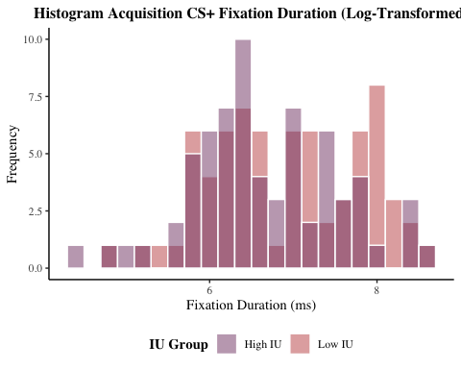

# save plot to file  
ggsave(filename = "graphs/histograms/hist_acq_csp_fix_duration_log.png",   
 plot = hist_acq_csp_fix_duration_log,   
 width = 20,   
 height = 10,   
 dpi = 300,   
 units = "cm")

### *Acquisition CS-*

########## pre-log-transformation  
hist_acq_csp_fix_duration_log



########## post-log-transformation  
hist_acq_csm_fix_duration_log <- df %>%  
 ggplot(aes(acq_csm_fix_duration_log, fill = iu_group)) +  
 geom_histogram(binwidth = .2, colour = "white", alpha = .5, position = "identity") +  
 theme_classic() +  
 theme(text = element_text(family = "serif"),   
 plot.title = element_text(face = "bold", hjust = 0.5, size = 15)) +  
 scale_x_continuous(breaks = seq(0, 12, 2)) +  
 labs(x = "Fixation Duration (ms)", y = "Frequency") +  
 theme(plot.title = element_text(face = "bold", hjust = 0.5, size = 12)) +  
 ggtitle("Histogram Acquisition CS- Fixation Duration (Log-Transformed)") +  
 theme(legend.position = "bottom", legend.title = element_text(face = "bold")) +  
 guides(fill = guide_legend(reverse = TRUE)) +  
 scale_fill_manual(values = c("#c45150", "#824372"), labels = c("Low IU", "High IU")) +  
 labs(fill = "IU Group")   
hist_acq_csm_fix_duration_log

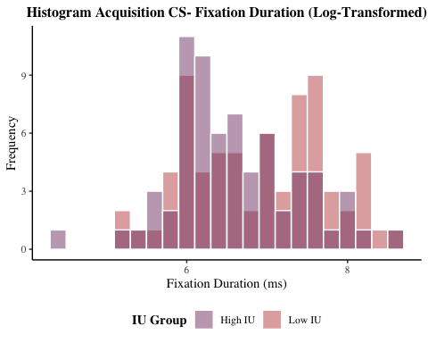

# save plot to file  
ggsave(filename = "graphs/histograms/hist_acq_csm_fix_duration_log.png",   
 plot = hist_acq_csm_fix_duration_log,   
 width = 20,   
 height = 10,   
 dpi = 300,   
 units = "cm")  
  
# combine histograms of acquisition fix duration pre and post log-transformation  
hists_fix_duration_acq_log <- grid.arrange(hist_acq_csp_fix_duration, hist_acq_csm_fix_duration,  
 hist_acq_csp_fix_duration_log, hist_acq_csm_fix_duration_log,  
 ncol = 2)

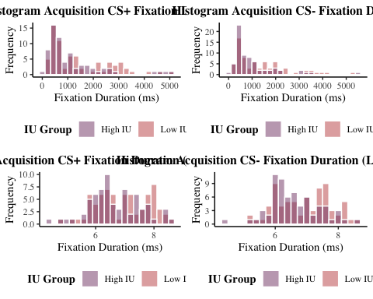

# save plot to file  
ggsave(filename = "graphs/histograms/hists_fix_duration_acq_log.png",   
 plot = hists_fix_duration_acq_log,   
 width = 30,   
 height = 20,   
 dpi = 300,   
 units = "cm")

### *Early Extinction CS+*

########## pre-log-transformation  
hist_e_ext_csp_fix_duration



########## post-log-transformation  
hist_e_ext_csp_fix_duration_log <- df %>%  
 ggplot(aes(e_ext_csp_fix_duration_log, fill = iu_group)) +  
 geom_histogram(binwidth = .2, colour = "white", alpha = .5, position = "identity") +  
 theme_classic() +  
 theme(text = element_text(family = "serif"),   
 plot.title = element_text(face = "bold", hjust = 0.5, size = 15)) +  
 scale_x_continuous(breaks = seq(0, 12, 2)) +  
 labs(x = "Fixation Duration (ms)", y = "Frequency") +  
 theme(plot.title = element_text(face = "bold", hjust = 0.5, size = 12)) +  
 ggtitle("Histogram Early Extinction CS+ Fixation Duration (Log-Transformed)") +  
 theme(legend.position = "bottom", legend.title = element_text(face = "bold")) +  
 guides(fill = guide_legend(reverse = TRUE)) +  
 scale_fill_manual(values = c("#c45150", "#824372"), labels = c("Low IU", "High IU")) +  
 labs(fill = "IU Group")   
hist_e_ext_csp_fix_duration_log

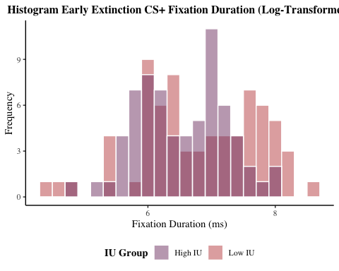

# save plot to file  
ggsave(filename = "graphs/histograms/hist_e_ext_csp_fix_duration_log.png",   
 plot = hist_e_ext_csp_fix_duration_log,   
 width = 20,   
 height = 10,   
 dpi = 300,   
 units = "cm")

### *Early Extinction CS-*

########## pre-log-transformation  
hist_e_ext_csm_fix_duration



########## post-log-transformation  
hist_e_ext_csm_fix_duration_log <- df %>%  
 ggplot(aes(e_ext_csm_fix_duration_log, fill = iu_group)) +  
 geom_histogram(binwidth = .2, colour = "white", alpha = .5, position = "identity") +  
 theme_classic() +  
 theme(text = element_text(family = "serif"),   
 plot.title = element_text(face = "bold", hjust = 0.5, size = 15)) +  
 scale_x_continuous(breaks = seq(0, 12, 2)) +  
 labs(x = "Fixation Duration (ms)", y = "Frequency") +  
 theme(plot.title = element_text(face = "bold", hjust = 0.5, size = 12)) +  
 ggtitle("Histogram Early Extinction CS- Fixation Duration (Log-Transformed)") +  
 theme(legend.position = "bottom", legend.title = element_text(face = "bold")) +  
 guides(fill = guide_legend(reverse = TRUE)) +  
 scale_fill_manual(values = c("#c45150", "#824372"), labels = c("Low IU", "High IU")) +  
 labs(fill = "IU Group")   
hist_e_ext_csm_fix_duration_log

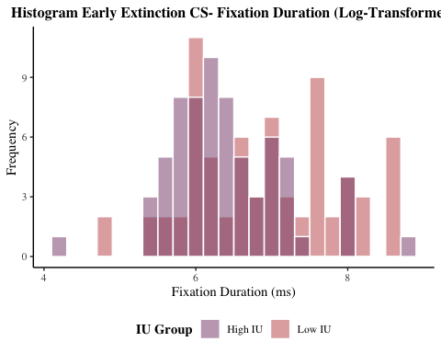

# save plot to file  
ggsave(filename = "graphs/histograms/hist_e_ext_csm_fix_duration_log.png",   
 plot = hist_e_ext_csm_fix_duration_log,   
 width = 20,   
 height = 10,   
 dpi = 300,   
 units = "cm")  
  
# combine histograms of early extinction fix duration pre and post log-transformation  
hists_fix_duration_e_ext_log <- grid.arrange(hist_e_ext_csp_fix_duration, hist_e_ext_csm_fix_duration,  
 hist_e_ext_csp_fix_duration_log, hist_e_ext_csm_fix_duration_log,  
 ncol = 2)

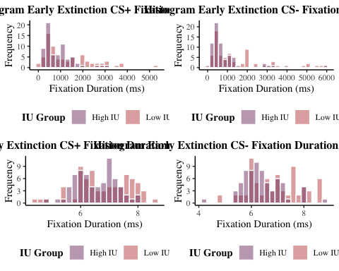

# save plot to file  
ggsave(filename = "graphs/histograms/hists_fix_duration_e_ext_log.png",   
 plot = hists_fix_duration_e_ext_log,   
 width = 30,   
 height = 20,   
 dpi = 300,   
 units = "cm")

### *Late Extinction CS+*

########## pre-log-transformation  
hist_l_ext_csp_fix_duration



########## post-log-transformation  
hist_l_ext_csp_fix_duration_log <- df %>%  
 ggplot(aes(l_ext_csp_fix_duration_log, fill = iu_group)) +  
 geom_histogram(binwidth = .2, colour = "white", alpha = .5, position = "identity") +  
 theme_classic() +  
 theme(text = element_text(family = "serif"),   
 plot.title = element_text(face = "bold", hjust = 0.5, size = 15)) +  
 scale_x_continuous(breaks = seq(0, 12, 2)) +  
 labs(x = "Fixation Duration (ms)", y = "Frequency") +  
 theme(plot.title = element_text(face = "bold", hjust = 0.5, size = 12)) +  
 ggtitle("Histogram Late Extinction CS+ Fixation Duration (Log-Transformed)") +  
 theme(legend.position = "bottom", legend.title = element_text(face = "bold")) +  
 guides(fill = guide_legend(reverse = TRUE)) +  
 scale_fill_manual(values = c("#c45150", "#824372"), labels = c("Low IU", "High IU")) +  
 labs(fill = "IU Group")   
hist_l_ext_csp_fix_duration_log

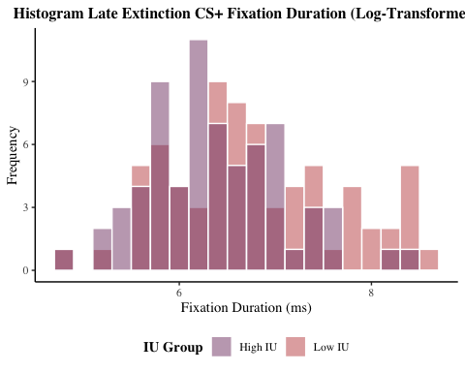

# save plot to file  
ggsave(filename = "graphs/histograms/hist_l_ext_csp_fix_duration_log.png",   
 plot = hist_l_ext_csp_fix_duration_log,   
 width = 20,   
 height = 10,   
 dpi = 300,   
 units = "cm")

### *Late Extinction CS-*

########## pre-log-transformation  
hist_l_ext_csm_fix_duration



########## post-log-transformation  
hist_l_ext_csm_fix_duration_log <- df %>%  
 ggplot(aes(l_ext_csm_fix_duration_log, fill = iu_group)) +  
 geom_histogram(binwidth = .2, colour = "white", alpha = .5, position = "identity") +  
 theme_classic() +  
 theme(text = element_text(family = "serif"),   
 plot.title = element_text(face = "bold", hjust = 0.5, size = 15)) +  
 scale_x_continuous(breaks = seq(0, 12, 2)) +  
 labs(x = "Fixation Duration (ms)", y = "Frequency") +  
 theme(plot.title = element_text(face = "bold", hjust = 0.5, size = 12)) +  
 ggtitle("Histogram Late Extinction CS- Fixation Duration (Log-Transformed)") +  
 theme(legend.position = "bottom", legend.title = element_text(face = "bold")) +  
 guides(fill = guide_legend(reverse = TRUE)) +  
 scale_fill_manual(values = c("#c45150", "#824372"), labels = c("Low IU", "High IU")) +  
 labs(fill = "IU Group")   
hist_l_ext_csm_fix_duration_log

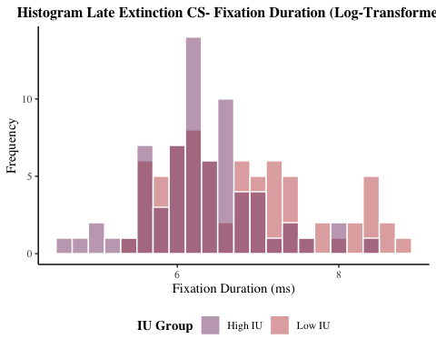

# save plot to file  
ggsave(filename = "graphs/histograms/hist_l_ext_csm_fix_duration_log.png",   
 plot = hist_l_ext_csm_fix_duration_log,   
 width = 20,   
 height = 10,   
 dpi = 300,   
 units = "cm")  
  
# combine histograms of late extinction fix duration pre and post log-transformation  
hists_fix_duration_l_ext_log <- grid.arrange(hist_l_ext_csp_fix_duration, hist_l_ext_csm_fix_duration,  
 hist_l_ext_csp_fix_duration_log, hist_l_ext_csm_fix_duration_log,  
 ncol = 2)

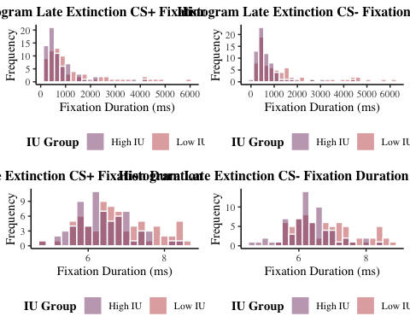

# save plot to file  
ggsave(filename = "graphs/histograms/hists_fix_duration_l_ext_log.png",   
 plot = hists_fix_duration_l_ext_log,   
 width = 30,   
 height = 20,   
 dpi = 300,   
 units = "cm")

# *ANOVAs*

## *ANOVA Acquisition Fixation Count*

# transform wide format data into long format for mixed ANOVA   
df_long_acq_fix_count <- melt(df, id = c("id", "iu_group"),   
 measure.vars = c("acq_csp_fix_count",   
 "acq_csm_fix_count"))  
  
# rename columns for easier interpretation  
colnames(df_long_acq_fix_count) = c("id", "iu_group", "condition", "fix_count")  
  
# create column to code stimulus as CS+ (1) and CS- (-1)  
df_long_acq_fix_count$stimulus <-   
 factor(ifelse(df_long_acq_fix_count$condition == "acq_csp_fix_count", 1, -1))  
  
# compute 2(IU: High & Low) x 2 (Stimulus: CS+, CS-) mixed ANOVA,   
# and obtain effect size (partial eta squared)  
acq_fix_count_anova <-   
 anova_test(df_long_acq_fix_count, fix_count ~ iu_group * stimulus + Error(id/stimulus),  
 effect.size = "pes")   
  
# obtain the mixed ANOVA results  
get_anova_table(acq_fix_count_anova)

## ANOVA Table (type III tests)  
##   
## Effect DFn DFd F p p<.05 pes  
## 1 iu_group 1 137 4.806 0.030000 * 0.034  
## 2 stimulus 1 137 11.441 0.000937 * 0.077  
## 3 iu_group:stimulus 1 137 0.258 0.613000 0.002

# results:  
# IU: F(1,137) = 4.81, p = .030*, eta2(partial) = .034  
# Stimulus: F(1,137) = 11.44, p < .001***, eta2(partial) = .077  
# IU * Stimulus: F(1, 137) = 0.26, p = .613, eta2(partial) = .002  
  
# therefore, there is a significant effect of IU & Stimulus on fixation count in acquisition,   
# and no significant IU*Stimulus interaction  
  
# write to csv  
write.csv((get_anova_table(acq_fix_count_anova)),   
 file = "tables/anovas/acq_fix_count_anova.csv")

## *ANOVA Acquisition Fixation Duration (Log Transformed)*

# transform wide format data into long format for mixed ANOVA   
df_long_acq_fix_duration_log <- melt(df, id = c("id", "iu_group"),   
 measure.vars = c("acq_csp_fix_duration_log",   
 "acq_csm_fix_duration_log"))  
  
# the first input for melt command is the df with wide format. Second input  
# is id =, which is where we list ppts with specific variables within wide format  
# df. Here we have ppts ID no's as participant specific variable, and IU   
# group they are assigned to is also specific for each participant. Therefore  
# only need to list the two variables after id =.   
  
# rename columns for easier interpretation  
colnames(df_long_acq_fix_duration_log) = c("id", "iu_group", "condition", "fix_duration_log")  
  
# create column to code stimulus as CS+ (1) and CS- (-1)  
df_long_acq_fix_duration_log$stimulus <-   
 factor(ifelse(df_long_acq_fix_duration_log$condition == "acq_csp_fix_duration_log", 1, -1))  
  
# compute 2(IU: High & Low) x 2 (Stimulus: CS+, CS-) mixed ANOVA,   
# and obtain effect size (partial eta squared)  
acq_fix_duration_anova_log <-   
 anova_test(df_long_acq_fix_duration_log, fix_duration_log ~ iu_group * stimulus + Error(id/stimulus),  
 effect.size = "pes")   
# the error(id/stimulus) variable is unique to repeated-measures ANOVA, and means  
# that the variable 'stimulus' is manipulated within 'id'  
  
# obtain the mixed ANOVA results  
get_anova_table(acq_fix_duration_anova_log)

## ANOVA Table (type III tests)  
##   
## Effect DFn DFd F p p<.05 pes  
## 1 iu_group 1 137 3.907 0.050 0.028  
## 2 stimulus 1 137 2.921 0.090 0.021  
## 3 iu_group:stimulus 1 137 1.271 0.261 0.009

# results:  
# IU: F(1,137) = 3.91, p = .050*, eta2(partial) = .028  
# Stimulus: F(1,137) = 2.92, p = .090, eta2(partial) = .021  
# IU * Stimulus: F(1, 137) = 1.27, p = .261, eta2(partial) = .009  
  
# therefore, there is a sig effect of IU, and no  
# sig effect of stimulus or IU-stimulus interaction   
  
# write to csv  
write.csv((get_anova_table(acq_fix_duration_anova_log)),   
 file = "tables/anovas/acq_fix_duration_anova_log.csv")

## *ANOVA Acquisition Saccade Amplitude*

# transform wide format data into long format for mixed ANOVA   
df_long_acq_sacc_amplitude <- melt(df, id = c("id", "iu_group"),   
 measure.vars = c("acq_csp_sacc_amplitude",   
 "acq_csm_sacc_amplitude"))  
  
# rename columns for easier interpretation  
colnames(df_long_acq_sacc_amplitude) = c("id", "iu_group", "condition", "sacc_amplitude")  
  
# create column to code stimulus as CS+ (1) and CS- (-1)  
df_long_acq_sacc_amplitude$stimulus <-   
 factor(ifelse(df_long_acq_sacc_amplitude$condition == "acq_csp_sacc_amplitude", 1, -1))  
  
# compute 2(IU: High & Low) x 2 (Stimulus: CS+, CS-) mixed ANOVA,   
# and obtain effect size (partial eta squared)  
acq_sacc_amplitude_anova <-   
 anova_test(df_long_acq_sacc_amplitude, sacc_amplitude ~ iu_group * stimulus + Error(id/stimulus),  
 effect.size = "pes")

## Warning: NA detected in rows: 234,259.  
## Removing this rows before the analysis.

# obtain the mixed ANOVA results  
get_anova_table(acq_sacc_amplitude_anova)

## ANOVA Table (type III tests)  
##   
## Effect DFn DFd F p p<.05 pes  
## 1 iu_group 1 135 2.984 0.086 0.022  
## 2 stimulus 1 135 0.950 0.332 0.007  
## 3 iu_group:stimulus 1 135 0.379 0.539 0.003

# results:  
# IU: F(1,135) = 2.98, p = .086, eta2(partial) = .022  
# Stimulus: F(1,135) = 0.95, p = .332, eta2(partial) = .007  
# IU * Stimulus: F(1, 135) = 0.38, p = .539, eta2(partial) = .003  
  
# therefore, there are no significant effects on saccade amplitude in  
# acquisition  
  
# write to csv  
write.csv((get_anova_table(acq_sacc_amplitude_anova)),   
 file = "tables/anovas/acq_sacc_amplitude_anova.csv")

## *ANOVA Extinction Fixation Count*

# transform wide format data into long format for mixed ANOVA   
df_long_ext_fix_count <- melt(df, id = c("id", "iu_group"),   
 measure.vars = c("e_ext_csp_fix_count",   
 "e_ext_csm_fix_count",  
 "l_ext_csp_fix_count",   
 "l_ext_csm_fix_count"))  
  
# rename columns for easier interpretation  
colnames(df_long_ext_fix_count) = c("id", "iu_group", "condition", "fix_count")  
  
# create column to code stimulus as CS+ (1) and CS- (-1)  
df_long_ext_fix_count$stimulus <-   
 factor(ifelse(df_long_ext_fix_count$condition == "e_ext_csp_fix_count" |   
 df_long_ext_fix_count$condition == "l_ext_csp_fix_count", 1, -1))  
  
# create column to code extinction as early (1) and late (-1)  
df_long_ext_fix_count$time <-   
 factor(ifelse(df_long_ext_fix_count$condition == "e_ext_csp_fix_count" |   
 df_long_ext_fix_count$condition == "e_ext_csm_fix_count", 1, -1))  
  
# compute 2(IU: High & Low) x 2 (Stimulus: CS+, CS-) x 2 (Time: Early, Late) mixed ANOVA,   
# and obtain effect size (partial eta squared)  
ext_fix_count_anova <-   
 anova_test(df_long_ext_fix_count,   
 fix_count ~ iu_group * stimulus * time + Error(id/(stimulus*time)),  
 effect.size = "pes")   
  
# obtain the mixed ANOVA results  
get_anova_table(ext_fix_count_anova)

## ANOVA Table (type III tests)  
##   
## Effect DFn DFd F p p<.05 pes  
## 1 iu_group 1 137 7.672 0.006 * 0.053000  
## 2 stimulus 1 137 4.155 0.043 * 0.029000  
## 3 time 1 137 5.733 0.018 * 0.040000  
## 4 iu_group:stimulus 1 137 3.460 0.065 0.025000  
## 5 iu_group:time 1 137 4.572 0.034 * 0.032000  
## 6 stimulus:time 1 137 0.061 0.806 0.000443  
## 7 iu_group:stimulus:time 1 137 0.600 0.440 0.004000

# results:  
# IU: F(1,137) = 7.67, p = .006 ***, eta2(partial) = .053  
# Stimulus: F(1,137) = 4.16, p = .043 *, eta2(partial) = .029  
# Time: F(1,137) = 5.73, p = .018 *, eta2(partial) = .049  
# IU * Stimulus: F(1, 137) = 3.46, p = .065, eta2(partial) = .025  
# IU * Time: F(1,137) = 4.57, p = .034 *, eta2(partial) = . 032  
# Stimulus * Time: F(1,137) = 0.06, p = .806, eta2(partial) < .001  
# IU * Stimulus * Time: F(1,137) = 0.60, p = .440, eta2(partial) = .004  
  
# therefore, there is a significant effect of IU, Stimulus and Time on fixation count in extinction,   
# as well as a significant interaction effect of IU * Time,  
# but no other significant interactions.   
  
# write to csv  
write.csv((get_anova_table(ext_fix_count_anova)),   
 file = "tables/anovas/ext_fix_count_anova.csv")  
  
# as there was a significant IU*Time interaction, conduct simple   
# main effects analysis:  
## obtain effect of IU at each level of time   
simple_effects_ext_fix_count_iu <- df_long_ext_fix_count %>%  
 group_by(time) %>%  
 anova_test(dv = fix_count, wid = id, between = iu_group, within = stimulus, effect.size = "pes") %>%  
 get_anova_table()   
  
# get the output  
simple_effects_ext_fix_count_iu

## # A tibble: 6 × 8  
## time Effect DFn DFd F p `p<.05` pes  
## * <fct> <chr> <dbl> <dbl> <dbl> <dbl> <chr> <dbl>  
## 1 -1 iu_group 1 137 11.4 0.000952 "*" 0.077  
## 2 -1 stimulus 1 137 3.38 0.068 "" 0.024  
## 3 -1 iu_group:stimulus 1 137 0.864 0.354 "" 0.006  
## 4 1 iu_group 1 137 3.63 0.059 "" 0.026  
## 5 1 stimulus 1 137 1.50 0.222 "" 0.011  
## 6 1 iu_group:stimulus 1 137 3.04 0.084 "" 0.022

# results:   
# The effect of IU group at early extinction was not significant [F(1,137) = 3.63, p = .059, pes = .026]  
# the effect of IU group at late extinction was significant [F(1,137) = 11.41, p < .001, pes = .077]

## *ANOVA Extinction Fixation Duration (Log Transformed)*

# transform wide format data into long format for mixed ANOVA   
df_long_ext_fix_duration_log <- melt(df, id = c("id", "iu_group"),   
 measure.vars = c("e_ext_csp_fix_duration_log",   
 "e_ext_csm_fix_duration_log",  
 "l_ext_csp_fix_duration_log",   
 "l_ext_csm_fix_duration_log"))  
  
# rename columns for easier interpretation  
colnames(df_long_ext_fix_duration_log) = c("id", "iu_group", "condition", "fix_duration_log")  
  
# create column to code stimulus as CS+ (1) and CS- (-1)  
df_long_ext_fix_duration_log$stimulus <-   
 factor(ifelse(df_long_ext_fix_duration_log$condition == "e_ext_csp_fix_duration_log" |   
 df_long_ext_fix_duration_log$condition == "l_ext_csp_fix_duration_log", 1, -1))  
  
# create column to code extinction as early (1) and late (-1)  
df_long_ext_fix_duration_log$time <-   
 factor(ifelse(df_long_ext_fix_duration_log$condition == "e_ext_csp_fix_duration_log" |   
 df_long_ext_fix_duration_log$condition == "e_ext_csm_fix_duration_log", 1, -1))  
  
# compute 2(IU: High & Low) x 2 (Stimulus: CS+, CS-) x 2 (Time: Early, Late) mixed ANOVA,   
# and obtain effect size (partial eta squared)  
ext_fix_duration_anova_log <-   
 anova_test(df_long_ext_fix_duration_log,   
 fix_duration_log ~ iu_group * stimulus * time + Error(id/(stimulus*time)),  
 effect.size = "pes")   
  
# obtain the mixed ANOVA results  
get_anova_table(ext_fix_duration_anova_log)

## ANOVA Table (type III tests)  
##   
## Effect DFn DFd F p p<.05 pes  
## 1 iu_group 1 137 11.213 0.001 * 0.076  
## 2 stimulus 1 137 0.510 0.477 0.004  
## 3 time 1 137 4.351 0.039 * 0.031  
## 4 iu_group:stimulus 1 137 5.823 0.017 * 0.041  
## 5 iu_group:time 1 137 0.241 0.624 0.002  
## 6 stimulus:time 1 137 0.171 0.680 0.001  
## 7 iu_group:stimulus:time 1 137 0.946 0.333 0.007

# results:  
# IU: F(1,137) = 11.21, p < .001 *, eta2(partial) = .076  
# Stimulus: F(1,137) = 0.51, p = .477, eta2(partial) = .004  
# Time: F(1,137) = 4.35, p = .039*, eta2(partial) = .031  
# IU * Stimulus: F(1, 137) = 5.82, p = .017*, eta2(partial) = .041  
# IU * Time: F(1,137) = 0.24, p = .624, eta2(partial) = .002  
# Stimulus * Time: F(1,137) = 0.17, p = 680, eta2(partial) = .001  
# IU * Stimulus * Time: F(1,137) = 0.95, p = .333, eta2(partial) = .007  
  
# therefore, there is a significant effect of IU, Time and IU-Stimulus  
# interaction on fixation duration in extinction,   
# and no other significant effects or interactions.   
  
# write to csv  
write.csv((get_anova_table(ext_fix_duration_anova_log)),   
 file = "tables/anovas/ext_fix_duration_anova_log.csv")  
  
# as there was a significant IU*Stimulus interaction, conduct simple   
# main effects analysis:  
## obtain effect of IU at each level of stimulus   
simple_effects_ext_fix_duration_log_iu <- df_long_ext_fix_duration_log %>%  
 group_by(stimulus) %>%  
 anova_test(dv = fix_duration_log, wid = id, between = iu_group, within = time, effect.size = "pes") %>%  
 get_anova_table()   
  
# get the output  
simple_effects_ext_fix_duration_log_iu

## # A tibble: 6 × 8  
## stimulus Effect DFn DFd F p `p<.05` pes  
## * <fct> <chr> <dbl> <dbl> <dbl> <dbl> <chr> <dbl>  
## 1 -1 iu_group 1 137 14.4 0.000218 "*" 0.095   
## 2 -1 time 1 137 4.34 0.039 "*" 0.031   
## 3 -1 iu_group:time 1 137 0.026 0.871 "" 0.000192  
## 4 1 iu_group 1 137 6.70 0.011 "*" 0.047   
## 5 1 time 1 137 1.94 0.166 "" 0.014   
## 6 1 iu_group:time 1 137 0.816 0.368 "" 0.006

# results:   
# The effect of IU group in response to CS+ was significant [F(1,137) = 6.70, p = .011, pes = .047]  
# the effect of IU group in response to CS- was also significant [F(1,137) = 14.43, p < .001, pes = .095]

## *ANOVA Extinction Saccade Amplitude*

# transform wide format data into long format for mixed ANOVA   
df_long_ext_sacc_amplitude <- melt(df, id = c("id", "iu_group"),   
 measure.vars = c("e_ext_csp_sacc_amplitude",   
 "e_ext_csm_sacc_amplitude",  
 "l_ext_csp_sacc_amplitude",   
 "l_ext_csm_sacc_amplitude"))  
  
# rename columns for easier interpretation  
colnames(df_long_ext_sacc_amplitude) = c("id", "iu_group", "condition", "sacc_amplitude")  
  
# create column to code stimulus as CS+ (1) and CS- (-1)  
df_long_ext_sacc_amplitude$stimulus <-   
 factor(ifelse(df_long_ext_sacc_amplitude$condition == "e_ext_csp_sacc_amplitude" |   
 df_long_ext_sacc_amplitude$condition == "l_ext_csp_sacc_amplitude", 1, -1))  
  
# create column to code extinction as early (1) and late (-1)  
df_long_ext_sacc_amplitude$time <-   
 factor(ifelse(df_long_ext_sacc_amplitude$condition == "e_ext_csp_sacc_amplitude" |   
 df_long_ext_sacc_amplitude$condition == "e_ext_csm_sacc_amplitude", 1, -1))  
  
# compute 2(IU: High & Low) x 2 (Stimulus: CS+, CS-) x 2 (Time: Early, Late) mixed ANOVA,   
# and obtain effect size (partial eta squared)  
ext_sacc_amplitude_anova <-   
 anova_test(df_long_ext_sacc_amplitude,   
 sacc_amplitude ~ iu_group * stimulus * time + Error(id/(stimulus*time)),  
 effect.size = "pes")

## Warning: NA detected in rows: 116,181,301.  
## Removing this rows before the analysis.

# obtain the mixed ANOVA results  
get_anova_table(ext_sacc_amplitude_anova)

## ANOVA Table (type III tests)  
##   
## Effect DFn DFd F p p<.05 pes  
## 1 iu_group 1 134 3.170 0.077 0.023000  
## 2 stimulus 1 134 0.740 0.391 0.005000  
## 3 time 1 134 0.275 0.601 0.002000  
## 4 iu_group:stimulus 1 134 1.687 0.196 0.012000  
## 5 iu_group:time 1 134 0.131 0.718 0.000977  
## 6 stimulus:time 1 134 0.077 0.781 0.000577  
## 7 iu_group:stimulus:time 1 134 0.609 0.437 0.005000

# results:  
# IU: F(1,134) = 3.17, p = .077, eta2(partial) = .023  
# Stimulus: F(1,134) = 0.74, p = .391, eta2(partial) = .005  
# Time: F(1,134) = 0.28, p = .601, eta2(partial) = .002  
# IU * Stimulus: F(1, 134) = 1.69, p = .196, eta2(partial) = .012  
# IU * Time: F(1,134) = 0.13, p = .718, eta2(partial) < .001  
# Stimulus * Time: F(1,134) = 0.08, p = .781, eta2(partial) < .001  
# IU * Stimulus * Time: F(1,134) = .61, p = .437, eta2(partial) < .001  
  
# therefore, there are no significant effects or interactions   
# on saccade amplitude throughout extinction   
  
# write to csv  
write.csv((get_anova_table(ext_sacc_amplitude_anova)),   
 file = "tables/anovas/ext_sacc_amplitude_anova.csv")

# *Bar Graphs*

## *Fixation Count*

### *Acquisition*

# obtain mean fix count for each group at each stimulus type and save as vector   
mean_acq_fix_count_high_iu_csp <-   
 mean(df$acq_csp_fix_count[df_long_acq_fix_count$iu_group == "1"], na.rm = TRUE) # high IU CS+  
mean_acq_fix_count_low_iu_csp <-   
 mean(df$acq_csp_fix_count[df_long_acq_fix_count$iu_group == "-1"], na.rm = TRUE) # low IU CS+  
mean_acq_fix_count_high_iu_csm <-   
 mean(df$acq_csm_fix_count[df_long_acq_fix_count$iu_group == "1"], na.rm = TRUE) # high IU CS-  
mean_acq_fix_count_low_iu_csm <-   
 mean(df$acq_csm_fix_count[df_long_acq_fix_count$iu_group == "-1"], na.rm = TRUE) # low IU CS-  
  
# combine into single variable called   
all_mean_acq_fix_count <-   
 c(mean_acq_fix_count_high_iu_csp, mean_acq_fix_count_low_iu_csp,   
 mean_acq_fix_count_high_iu_csm, mean_acq_fix_count_low_iu_csm)  
  
# obtain SD fix count for each group at each stimulus type and save as vector   
sd_acq_fix_count_high_iu_csp <-   
 sd(df$acq_csp_fix_count[df_long_acq_fix_count$iu_group == "1"], na.rm = TRUE) # high IU CS+  
sd_acq_fix_count_low_iu_csp <-   
 sd(df$acq_csp_fix_count[df_long_acq_fix_count$iu_group == "-1"], na.rm = TRUE) # low IU CS+  
sd_acq_fix_count_high_iu_csm <-   
 sd(df$acq_csm_fix_count[df_long_acq_fix_count$iu_group == "1"], na.rm = TRUE) # high IU CS-  
sd_acq_fix_count_low_iu_csm <-   
 sd(df$acq_csm_fix_count[df_long_acq_fix_count$iu_group == "-1"], na.rm = TRUE) # low IU CS-  
  
# obtain SE:  
se_acq_fix_count_high_iu_csp <- sd_acq_fix_count_high_iu_csp/sqrt(length(df$id))  
se_acq_fix_count_low_iu_csp <- sd_acq_fix_count_low_iu_csp/sqrt(length(df$id))  
se_acq_fix_count_high_iu_csm <- sd_acq_fix_count_high_iu_csm/sqrt(length(df$id))  
se_acq_fix_count_low_iu_csm <- sd_acq_fix_count_low_iu_csm/sqrt(length(df$id))  
  
# Combine all into single variable called all_se  
all_se_acq_fix_count <- c(se_acq_fix_count_high_iu_csp, se_acq_fix_count_low_iu_csp,  
 se_acq_fix_count_high_iu_csm, se_acq_fix_count_low_iu_csm)  
  
### Create new data frame for figures  
# Which includes mean and SE for each condition  
df_fig_acquisition_fix_count <- data.frame(all_mean_acq_fix_count, all_se_acq_fix_count)  
  
### add labels   
# add two more variables to indicate IU group and stimulus type.   
# for IU group  
df_fig_acquisition_fix_count$iu_group[1] <- "High IU"  
df_fig_acquisition_fix_count$iu_group[2] <- "Low IU"  
df_fig_acquisition_fix_count$iu_group[3] <- "High IU"  
df_fig_acquisition_fix_count$iu_group[4] <- "Low IU"  
  
# for stimulus  
df_fig_acquisition_fix_count$stimulus[1] <- "CS+"  
df_fig_acquisition_fix_count$stimulus[2] <- "CS+"  
df_fig_acquisition_fix_count$stimulus[3] <- "CS-"  
df_fig_acquisition_fix_count$stimulus[4] <- "CS-"  
  
# and re-order levels of stimulus factor so that CS+ appears on left in the graph  
df_fig_acquisition_fix_count$stimulus <-   
 factor(df_fig_acquisition_fix_count$stimulus,levels=c("CS+","CS-"))  
  
  
### Create figure  
 fig_acquisition_fix_count <- ggplot(df_fig_acquisition_fix_count,   
 aes(x = iu_group, y = all_mean_acq_fix_count,   
 fill = stimulus)) +   
 geom_bar(stat = "identity", position = position_dodge(.6), width = .5, alpha = .85) +  
 scale_y_continuous(limits = c(0, 10), expand = c(0,0)) +  
 theme_classic() +   
 theme(text = element_text(family = "serif"),   
 plot.title = element_text(face = "bold", hjust = 0.5, size = 15)) +  
 theme(axis.text.y = element_text(size = 10),axis.ticks.y = element_line(size = 1),   
 axis.line.y = element_line(colour = "black")) +  
 theme(axis.text.x = element_text(colour = "black"), axis.ticks.x = element_blank(),  
 axis.line.x = element_line(colour = "black")) +  
 theme(legend.position = "bottom", legend.title = element_blank()) +  
 scale_fill_manual(values = c("#c45150", "#824372")) +  
 ggtitle("Acquisition") +  
 labs(y = "Mean Fixation Count", x = "Intolerance of Uncertainty") +  
 geom_errorbar(aes(ymin = all_mean_acq_fix_count - all_se_acq_fix_count,   
 ymax = all_mean_acq_fix_count + all_se_acq_fix_count),   
 width = .15, position = position_dodge(.6), colour = "#090707", size = .3)   
  
print(fig_acquisition_fix_count)

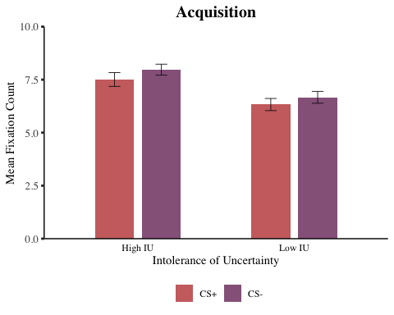

ggsave(filename = "graphs/bar_plots/acquisition_fix_count.png",   
 plot = fig_acquisition_fix_count,   
 width = 20,   
 height = 10,   
 dpi = 300,   
 units = "cm")

### *Extinction*

# obtain mean fix count for each group at each stimulus type and save as vector   
mean_e_ext_fix_count_high_iu_csp <-   
 mean(df$e_ext_csp_fix_count[df_long_ext_fix_count$iu_group == "1"], na.rm = TRUE) # high IU CS+ early  
mean_e_ext_fix_count_low_iu_csp <-   
 mean(df$e_ext_csp_fix_count[df_long_ext_fix_count$iu_group == "-1"], na.rm = TRUE) # low IU CS+ early  
mean_e_ext_fix_count_high_iu_csm <-   
 mean(df$e_ext_csm_fix_count[df_long_ext_fix_count$iu_group == "1"], na.rm = TRUE) # high IU CS- early  
mean_e_ext_fix_count_low_iu_csm <-   
 mean(df$e_ext_csm_fix_count[df_long_ext_fix_count$iu_group == "-1"], na.rm = TRUE) # low IU CS- early  
mean_l_ext_fix_count_high_iu_csp <-   
 mean(df$l_ext_csp_fix_count[df_long_ext_fix_count$iu_group == "1"], na.rm = TRUE) # high IU CS+ late  
mean_l_ext_fix_count_low_iu_csp <-   
 mean(df$l_ext_csp_fix_count[df_long_ext_fix_count$iu_group == "-1"], na.rm = TRUE) # low IU CS+ late  
mean_l_ext_fix_count_high_iu_csm <-   
 mean(df$l_ext_csm_fix_count[df_long_ext_fix_count$iu_group == "1"], na.rm = TRUE) # high IU CS- late  
mean_l_ext_fix_count_low_iu_csm <-   
 mean(df$l_ext_csm_fix_count[df_long_ext_fix_count$iu_group == "-1"], na.rm = TRUE) # low IU CS- late  
  
# combine into single variable called   
all_mean_ext_fix_count <-   
 c(mean_e_ext_fix_count_high_iu_csp, mean_e_ext_fix_count_low_iu_csp,   
 mean_e_ext_fix_count_high_iu_csm, mean_e_ext_fix_count_low_iu_csm,  
 mean_l_ext_fix_count_high_iu_csp, mean_l_ext_fix_count_low_iu_csp,   
 mean_l_ext_fix_count_high_iu_csm, mean_l_ext_fix_count_low_iu_csm)  
  
# obtain SD fix count for each group at each stimulus type and save as vector   
sd_e_ext_fix_count_high_iu_csp <-   
 sd(df$e_ext_csp_fix_count[df_long_ext_fix_count$iu_group == "1"], na.rm = TRUE) # high IU CS+ early  
sd_e_ext_fix_count_low_iu_csp <-   
 sd(df$e_ext_csp_fix_count[df_long_ext_fix_count$iu_group == "-1"], na.rm = TRUE) # low IU CS+ early  
sd_e_ext_fix_count_high_iu_csm <-   
 sd(df$e_ext_csm_fix_count[df_long_ext_fix_count$iu_group == "1"], na.rm = TRUE) # high IU CS- early  
sd_e_ext_fix_count_low_iu_csm <-   
 sd(df$e_ext_csm_fix_count[df_long_ext_fix_count$iu_group == "-1"], na.rm = TRUE) # low IU CS- early  
sd_l_ext_fix_count_high_iu_csp <-   
 sd(df$l_ext_csp_fix_count[df_long_ext_fix_count$iu_group == "1"], na.rm = TRUE) # high IU CS+ late  
sd_l_ext_fix_count_low_iu_csp <-   
 sd(df$l_ext_csp_fix_count[df_long_ext_fix_count$iu_group == "-1"], na.rm = TRUE) # low IU CS+ late  
sd_l_ext_fix_count_high_iu_csm <-   
 sd(df$l_ext_csm_fix_count[df_long_ext_fix_count$iu_group == "1"], na.rm = TRUE) # high IU CS- late  
sd_l_ext_fix_count_low_iu_csm <-   
 sd(df$l_ext_csm_fix_count[df_long_ext_fix_count$iu_group == "-1"], na.rm = TRUE) # low IU CS- late  
  
# obtain SE:  
se_e_ext_fix_count_high_iu_csp <- sd_e_ext_fix_count_high_iu_csp/sqrt(length(df$id))  
se_e_ext_fix_count_low_iu_csp <- sd_e_ext_fix_count_low_iu_csp/sqrt(length(df$id))  
se_e_ext_fix_count_high_iu_csm <- sd_e_ext_fix_count_high_iu_csm/sqrt(length(df$id))  
se_e_ext_fix_count_low_iu_csm <- sd_e_ext_fix_count_low_iu_csm/sqrt(length(df$id))  
se_l_ext_fix_count_high_iu_csp <- sd_l_ext_fix_count_high_iu_csp/sqrt(length(df$id))  
se_l_ext_fix_count_low_iu_csp <- sd_l_ext_fix_count_low_iu_csp/sqrt(length(df$id))  
se_l_ext_fix_count_high_iu_csm <- sd_l_ext_fix_count_high_iu_csm/sqrt(length(df$id))  
se_l_ext_fix_count_low_iu_csm <- sd_l_ext_fix_count_low_iu_csm/sqrt(length(df$id))  
  
# Combine all into single variable called all_se  
all_se_ext_fix_count <- c(se_e_ext_fix_count_high_iu_csp, se_e_ext_fix_count_low_iu_csp,  
 se_e_ext_fix_count_high_iu_csm, se_e_ext_fix_count_low_iu_csm,  
 se_l_ext_fix_count_high_iu_csp, se_l_ext_fix_count_low_iu_csp,   
 se_l_ext_fix_count_high_iu_csm, se_l_ext_fix_count_low_iu_csm)  
  
### Create new data frame for figures  
# Which includes mean and SE for each condition  
df_fig_extinction_fix_count <- data.frame(all_mean_ext_fix_count, all_se_ext_fix_count)  
  
### add labels   
# add two more variables to indicate IU group and stimulus type.   
# for IU group  
df_fig_extinction_fix_count$iu_group[1] <- "High IU"  
df_fig_extinction_fix_count$iu_group[2] <- "Low IU"  
df_fig_extinction_fix_count$iu_group[3] <- "High IU"  
df_fig_extinction_fix_count$iu_group[4] <- "Low IU"  
df_fig_extinction_fix_count$iu_group[5] <- "High IU"  
df_fig_extinction_fix_count$iu_group[6] <- "Low IU"  
df_fig_extinction_fix_count$iu_group[7] <- "High IU"  
df_fig_extinction_fix_count$iu_group[8] <- "Low IU"  
  
# for stimulus  
df_fig_extinction_fix_count$stimulus[1] <- "CS+"  
df_fig_extinction_fix_count$stimulus[2] <- "CS+"  
df_fig_extinction_fix_count$stimulus[3] <- "CS-"  
df_fig_extinction_fix_count$stimulus[4] <- "CS-"  
df_fig_extinction_fix_count$stimulus[5] <- "CS+"  
df_fig_extinction_fix_count$stimulus[6] <- "CS+"  
df_fig_extinction_fix_count$stimulus[7] <- "CS-"  
df_fig_extinction_fix_count$stimulus[8] <- "CS-"  
  
# and re-order levels of stimulus factor so that CS+ appears on left in the graph  
df_fig_extinction_fix_count$stimulus <-   
 factor(df_fig_extinction_fix_count$stimulus,levels=c("CS+","CS-"))  
  
# for early / late extinction  
df_fig_extinction_fix_count$time[1] <- "Early"  
df_fig_extinction_fix_count$time[2] <- "Early"  
df_fig_extinction_fix_count$time[3] <- "Early"  
df_fig_extinction_fix_count$time[4] <- "Early"  
df_fig_extinction_fix_count$time[5] <- "Late"  
df_fig_extinction_fix_count$time[6] <- "Late"  
df_fig_extinction_fix_count$time[7] <- "Late"  
df_fig_extinction_fix_count$time[8] <- "Late"  
  
### create figure  
 fig_extinction_fix_count <- ggplot(df_fig_extinction_fix_count,   
 aes(x = iu_group, y = all_mean_ext_fix_count,   
 fill = stimulus)) +   
 geom_bar(stat = "identity", position = position_dodge(.6), width = .5, alpha = .85) +  
 scale_y_continuous(limits = c(0, 10), expand = c(0,0)) +  
 facet_wrap(~ time) +  
 theme_classic() +   
 theme(text = element_text(family = "serif"),   
 plot.title = element_text(face = "bold", hjust = 0.5, size = 15)) +  
 theme(axis.text.y = element_text(size = 10),axis.ticks.y = element_line(size = 1),   
 axis.line.y = element_line(colour = "black")) +  
 theme(axis.text.x = element_text(colour = "black"), axis.ticks.x = element_blank(),  
 axis.line.x = element_line(colour = "black")) +  
 theme(legend.position = "bottom", legend.title = element_blank()) +  
 scale_fill_manual(values = c("#c45150", "#824372")) +  
 ggtitle("Extinction") +  
 labs(y = "Mean Fixation Count", x = "Intolerance of Uncertainty") +  
 geom_errorbar(aes(ymin = all_mean_ext_fix_count - all_se_ext_fix_count,   
 ymax = all_mean_ext_fix_count + all_se_ext_fix_count),   
 width = .15, position = position_dodge(.6), colour = "#090707", size = .3) +  
 theme(strip.background = element_blank()) +  
 theme(strip.text = element_text(size = 12))   
  
 # obtain and check figure   
print(fig_extinction_fix_count)

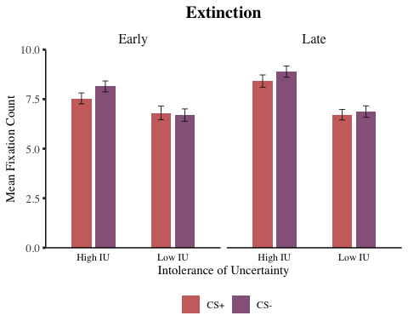

# save figure to files  
ggsave(filename = "graphs/bar_plots/extinction_fix_count.png",   
 plot = fig_extinction_fix_count,   
 width = 20,   
 height = 10,   
 dpi = 300,   
 units = "cm")

## *Fixation Duration (Log Transformed)*

### *Acquisition*

# obtain mean fix duration for each group at each stimulus type and save as vector   
mean_acq_fix_duration_high_iu_csp_log <-   
 mean(df$acq_csp_fix_duration_log[df_long_acq_fix_duration_log$iu_group == "1"], na.rm = TRUE) # high IU CS+  
mean_acq_fix_duration_low_iu_csp_log <-   
 mean(df$acq_csp_fix_duration_log[df_long_acq_fix_duration_log$iu_group == "-1"], na.rm = TRUE) # low IU CS+  
mean_acq_fix_duration_high_iu_csm_log <-   
 mean(df$acq_csm_fix_duration_log[df_long_acq_fix_duration_log$iu_group == "1"], na.rm = TRUE) # high IU CS-  
mean_acq_fix_duration_low_iu_csm_log <-   
 mean(df$acq_csm_fix_duration_log[df_long_acq_fix_duration_log$iu_group == "-1"], na.rm = TRUE) # low IU CS-  
  
# combine into single variable called   
all_mean_acq_fix_duration_log <-   
 c(mean_acq_fix_duration_high_iu_csp_log, mean_acq_fix_duration_low_iu_csp_log,   
 mean_acq_fix_duration_high_iu_csm_log, mean_acq_fix_duration_low_iu_csm_log)  
  
# obtain SD fix duration for each group at each stimulus type and save as vector   
sd_acq_fix_duration_high_iu_csp_log <-   
 sd(df$acq_csp_fix_duration_log[df_long_acq_fix_duration_log$iu_group == "1"], na.rm = TRUE) # high IU CS+  
sd_acq_fix_duration_low_iu_csp_log <-   
 sd(df$acq_csp_fix_duration_log[df_long_acq_fix_duration_log$iu_group == "-1"], na.rm = TRUE) # low IU CS+  
sd_acq_fix_duration_high_iu_csm_log <-   
 sd(df$acq_csm_fix_duration_log[df_long_acq_fix_duration_log$iu_group == "1"], na.rm = TRUE) # high IU CS-  
sd_acq_fix_duration_low_iu_csm_log <-   
 sd(df$acq_csm_fix_duration_log[df_long_acq_fix_duration_log$iu_group == "-1"], na.rm = TRUE) # low IU CS-  
  
# obtain SE:  
se_acq_fix_duration_high_iu_csp_log <- sd_acq_fix_duration_high_iu_csp_log/sqrt(length(df$id))  
se_acq_fix_duration_low_iu_csp_log <- sd_acq_fix_duration_low_iu_csp_log/sqrt(length(df$id))  
se_acq_fix_duration_high_iu_csm_log <- sd_acq_fix_duration_high_iu_csm_log/sqrt(length(df$id))  
se_acq_fix_duration_low_iu_csm_log <- sd_acq_fix_duration_low_iu_csm_log/sqrt(length(df$id))  
  
# combine all into single variable called all_se  
all_se_acq_fix_duration_log <- c(se_acq_fix_duration_high_iu_csp_log, se_acq_fix_duration_low_iu_csp_log,  
 se_acq_fix_duration_high_iu_csm_log, se_acq_fix_duration_low_iu_csm_log)  
  
# create new data frame for figures, which includes mean and se   
# for each condition   
df_fig_acquisition_fix_duration_log <- data.frame(all_mean_acq_fix_duration_log, all_se_acq_fix_duration_log)  
  
# add labels - add two more variables to indicate IU group and stimulus type.   
# for IU group  
df_fig_acquisition_fix_duration_log$iu_group[1] <- "High IU"  
df_fig_acquisition_fix_duration_log$iu_group[2] <- "Low IU"  
df_fig_acquisition_fix_duration_log$iu_group[3] <- "High IU"  
df_fig_acquisition_fix_duration_log$iu_group[4] <- "Low IU"  
  
# for stimulus  
df_fig_acquisition_fix_duration_log$stimulus[1] <- "CS+"  
df_fig_acquisition_fix_duration_log$stimulus[2] <- "CS+"  
df_fig_acquisition_fix_duration_log$stimulus[3] <- "CS-"  
df_fig_acquisition_fix_duration_log$stimulus[4] <- "CS-"  
  
# and re-order levels of stimulus factor so that CS+ appears on left in the graph  
df_fig_acquisition_fix_duration_log$stimulus <-   
 factor(df_fig_acquisition_fix_duration_log$stimulus,levels = c("CS+","CS-"))  
  
# create figure  
 fig_acquisition_fix_duration_log <- ggplot(df_fig_acquisition_fix_duration_log,   
 aes(x = iu_group, y = all_mean_acq_fix_duration_log,   
 fill = stimulus)) +   
 geom_bar(stat = "identity", position = position_dodge(.6), width = .5, alpha = .85) +  
 scale_y_continuous(limits = c(0, 7.2), expand = c(0,0)) +  
 theme_classic() +   
 theme(text = element_text(family = "serif"),   
 plot.title = element_text(face = "bold", hjust = 0.5, size = 15)) +  
 theme(axis.text.y = element_text(size = 10),axis.ticks.y = element_line(size = 1),   
 axis.line.y = element_line(colour = "black")) +  
 theme(axis.text.x = element_text(colour = "black"), axis.ticks.x = element_blank(),  
 axis.line.x = element_line(colour = "black")) +  
 theme(legend.position = "bottom", legend.title = element_blank()) +  
 scale_fill_manual(values = c("#c45150", "#824372")) +  
 ggtitle("Acquisition") +  
 labs(y = "Mean Fixation Duration (ms) (Log Transformed)", x = "Intolerance of Uncertainty") +  
 geom_errorbar(aes(ymin = all_mean_acq_fix_duration_log - all_se_acq_fix_duration_log,   
 ymax = all_mean_acq_fix_duration_log + all_se_acq_fix_duration_log),   
 width = .15, position = position_dodge(.6), colour = "#090707", size = .3)   
  
 # obtain and check figure   
print(fig_acquisition_fix_duration_log)

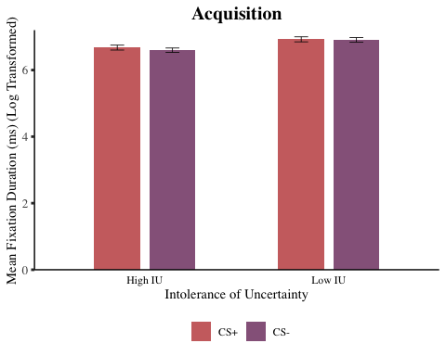

# save figure to file   
ggsave(filename = "graphs/bar_plots/acquisition_fix_duration_log.png",   
 plot = fig_acquisition_fix_duration_log,   
 width = 20,   
 height = 10,   
 dpi = 300,   
 units = "cm")

### *Extinction*

# obtain mean fix duration for each group at each stimulus type and save as vector   
# high IU CS+ early  
mean_e_ext_fix_duration_high_iu_csp_log <-   
 mean(df$e_ext_csp_fix_duration_log[df_long_ext_fix_duration_log$iu_group == "1"], na.rm = TRUE)   
  
# low IU CS+ early  
mean_e_ext_fix_duration_low_iu_csp_log <-   
 mean(df$e_ext_csp_fix_duration_log[df_long_ext_fix_duration_log$iu_group == "-1"], na.rm = TRUE)   
  
# high IU CS- early  
mean_e_ext_fix_duration_high_iu_csm_log <-   
 mean(df$e_ext_csm_fix_duration_log[df_long_ext_fix_duration_log$iu_group == "1"], na.rm = TRUE)   
  
# low IU CS- early  
mean_e_ext_fix_duration_low_iu_csm_log <-   
 mean(df$e_ext_csm_fix_duration_log[df_long_ext_fix_duration_log$iu_group == "-1"], na.rm = TRUE)   
  
# high IU CS+ late  
mean_l_ext_fix_duration_high_iu_csp_log <-   
 mean(df$l_ext_csp_fix_duration_log[df_long_ext_fix_duration_log$iu_group == "1"], na.rm = TRUE)   
  
# low IU CS+ late  
mean_l_ext_fix_duration_low_iu_csp_log <-   
 mean(df$l_ext_csp_fix_duration_log[df_long_ext_fix_duration_log$iu_group == "-1"], na.rm = TRUE)   
  
# high IU CS- late  
mean_l_ext_fix_duration_high_iu_csm_log <-   
 mean(df$l_ext_csm_fix_duration_log[df_long_ext_fix_duration_log$iu_group == "1"], na.rm = TRUE)   
  
# low IU CS- late  
mean_l_ext_fix_duration_low_iu_csm_log <-   
 mean(df$l_ext_csm_fix_duration_log[df_long_ext_fix_duration_log$iu_group == "-1"], na.rm = TRUE)   
  
# combine into single variable called   
all_mean_ext_fix_duration_log <-   
 c(mean_e_ext_fix_duration_high_iu_csp_log, mean_e_ext_fix_duration_low_iu_csp_log,   
 mean_e_ext_fix_duration_high_iu_csm_log, mean_e_ext_fix_duration_low_iu_csm_log,  
 mean_l_ext_fix_duration_high_iu_csp_log, mean_l_ext_fix_duration_low_iu_csp_log,   
 mean_l_ext_fix_duration_high_iu_csm_log, mean_l_ext_fix_duration_low_iu_csm_log)  
  
# obtain SD fix duration for each group at each stimulus type and save as vector   
# high IU CS+ early  
sd_e_ext_fix_duration_high_iu_csp_log <-   
 sd(df$e_ext_csp_fix_duration_log[df_long_ext_fix_duration_log$iu_group == "1"], na.rm = TRUE)   
  
# low IU CS+ early  
sd_e_ext_fix_duration_low_iu_csp_log <-   
 sd(df$e_ext_csp_fix_duration_log[df_long_ext_fix_duration_log$iu_group == "-1"], na.rm = TRUE)   
  
# high IU CS- early  
sd_e_ext_fix_duration_high_iu_csm_log <-   
 sd(df$e_ext_csm_fix_duration_log[df_long_ext_fix_duration_log$iu_group == "1"], na.rm = TRUE)   
  
# low IU CS- early  
sd_e_ext_fix_duration_low_iu_csm_log <-   
 sd(df$e_ext_csm_fix_duration_log[df_long_ext_fix_duration_log$iu_group == "-1"], na.rm = TRUE)   
  
# high IU CS+ late  
sd_l_ext_fix_duration_high_iu_csp_log <-   
 sd(df$l_ext_csp_fix_duration_log[df_long_ext_fix_duration_log$iu_group == "1"], na.rm = TRUE)   
  
# low IU CS+ late  
sd_l_ext_fix_duration_low_iu_csp_log <-   
 sd(df$l_ext_csp_fix_duration_log[df_long_ext_fix_duration_log$iu_group == "-1"], na.rm = TRUE)   
  
# high IU CS- late  
sd_l_ext_fix_duration_high_iu_csm_log <-   
 sd(df$l_ext_csm_fix_duration_log[df_long_ext_fix_duration_log$iu_group == "1"], na.rm = TRUE)   
  
# low IU CS- late  
sd_l_ext_fix_duration_low_iu_csm_log <-   
 sd(df$l_ext_csm_fix_duration_log[df_long_ext_fix_duration_log$iu_group == "-1"], na.rm = TRUE)   
  
# obtain SE:  
se_e_ext_fix_duration_high_iu_csp_log <- sd_e_ext_fix_duration_high_iu_csp_log/sqrt(length(df$id))  
se_e_ext_fix_duration_low_iu_csp_log <- sd_e_ext_fix_duration_low_iu_csp_log/sqrt(length(df$id))  
se_e_ext_fix_duration_high_iu_csm_log <- sd_e_ext_fix_duration_high_iu_csm_log/sqrt(length(df$id))  
se_e_ext_fix_duration_low_iu_csm_log <- sd_e_ext_fix_duration_low_iu_csm_log/sqrt(length(df$id))  
se_l_ext_fix_duration_high_iu_csp_log <- sd_l_ext_fix_duration_high_iu_csp_log/sqrt(length(df$id))  
se_l_ext_fix_duration_low_iu_csp_log <- sd_l_ext_fix_duration_low_iu_csp_log/sqrt(length(df$id))  
se_l_ext_fix_duration_high_iu_csm_log <- sd_l_ext_fix_duration_high_iu_csm_log/sqrt(length(df$id))  
se_l_ext_fix_duration_low_iu_csm_log <- sd_l_ext_fix_duration_low_iu_csm_log/sqrt(length(df$id))  
  
# combine all into single variable   
all_se_ext_fix_duration_log <- c(se_e_ext_fix_duration_high_iu_csp_log, se_e_ext_fix_duration_low_iu_csp_log,  
 se_e_ext_fix_duration_high_iu_csm_log, se_e_ext_fix_duration_low_iu_csm_log,  
 se_l_ext_fix_duration_high_iu_csp_log, se_l_ext_fix_duration_low_iu_csp_log,   
 se_l_ext_fix_duration_high_iu_csm_log, se_l_ext_fix_duration_low_iu_csm_log)  
  
# create new data frame for figures which includes mean and SE for each condition  
df_fig_extinction_fix_duration_log <- data.frame(all_mean_ext_fix_duration_log, all_se_ext_fix_duration_log)  
  
# add labels - add two more variables to indicate IU group, stimulus type and extinction time   
# for IU group  
df_fig_extinction_fix_duration_log$iu_group[1] <- "High IU"  
df_fig_extinction_fix_duration_log$iu_group[2] <- "Low IU"  
df_fig_extinction_fix_duration_log$iu_group[3] <- "High IU"  
df_fig_extinction_fix_duration_log$iu_group[4] <- "Low IU"  
df_fig_extinction_fix_duration_log$iu_group[5] <- "High IU"  
df_fig_extinction_fix_duration_log$iu_group[6] <- "Low IU"  
df_fig_extinction_fix_duration_log$iu_group[7] <- "High IU"  
df_fig_extinction_fix_duration_log$iu_group[8] <- "Low IU"  
  
# for stimulus  
df_fig_extinction_fix_duration_log$stimulus[1] <- "CS+"  
df_fig_extinction_fix_duration_log$stimulus[2] <- "CS+"  
df_fig_extinction_fix_duration_log$stimulus[3] <- "CS-"  
df_fig_extinction_fix_duration_log$stimulus[4] <- "CS-"  
df_fig_extinction_fix_duration_log$stimulus[5] <- "CS+"  
df_fig_extinction_fix_duration_log$stimulus[6] <- "CS+"  
df_fig_extinction_fix_duration_log$stimulus[7] <- "CS-"  
df_fig_extinction_fix_duration_log$stimulus[8] <- "CS-"  
  
# and re-order levels of stimulus factor so that CS+ appears on left in the graph  
df_fig_extinction_fix_duration_log$stimulus <-   
 factor(df_fig_extinction_fix_duration_log$stimulus,levels=c("CS+","CS-"))  
  
# for early / late extinction  
df_fig_extinction_fix_duration_log$time[1] <- "Early"  
df_fig_extinction_fix_duration_log$time[2] <- "Early"  
df_fig_extinction_fix_duration_log$time[3] <- "Early"  
df_fig_extinction_fix_duration_log$time[4] <- "Early"  
df_fig_extinction_fix_duration_log$time[5] <- "Late"  
df_fig_extinction_fix_duration_log$time[6] <- "Late"  
df_fig_extinction_fix_duration_log$time[7] <- "Late"  
df_fig_extinction_fix_duration_log$time[8] <- "Late"  
  
# create figure  
fig_extinction_fix_duration_log <- ggplot(df_fig_extinction_fix_duration_log,   
 aes(x = iu_group, y = all_mean_ext_fix_duration_log,   
 fill = stimulus)) +   
 geom_bar(stat = "identity", position = position_dodge(.6), width = .5, alpha = .85) +  
 scale_y_continuous(limits = c(0, 7.2), expand = c(0,0)) +  
 facet_wrap(~ time) +  
 theme_classic() +   
 theme(text = element_text(family = "serif"),   
 plot.title = element_text(face = "bold", hjust = 0.5, size = 15)) +  
 theme(axis.text.y = element_text(size = 10),axis.ticks.y = element_line(size = 1),   
 axis.line.y = element_line(colour = "black")) +  
 theme(axis.text.x = element_text(colour = "black"), axis.ticks.x = element_blank(),  
 axis.line.x = element_line(colour = "black")) +  
 theme(legend.position = "bottom", legend.title = element_blank()) +  
 scale_fill_manual(values = c("#c45150", "#824372")) +  
 ggtitle("Extinction") +  
 labs(y = "Mean Fixation Duration (ms) (Log Transformed)", x = "Intolerance of Uncertainty") +  
 geom_errorbar(aes(ymin = all_mean_ext_fix_duration_log - all_se_ext_fix_duration_log,   
 ymax = all_mean_ext_fix_duration_log + all_se_ext_fix_duration_log),   
 width = .15, position = position_dodge(.6), colour = "#090707", size = .3) +  
 theme(strip.background = element_blank()) +  
 theme(strip.text = element_text(size = 12))  
  
# obtain and check figure   
print(fig_extinction_fix_duration_log)

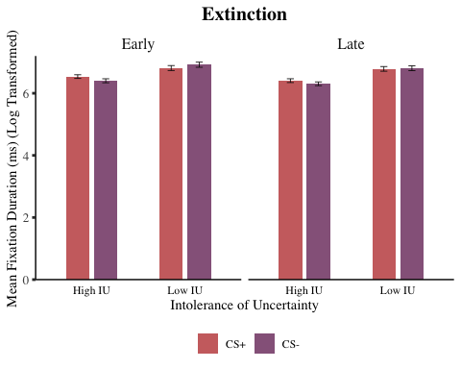

# save figure to files  
ggsave(filename = "graphs/bar_plots/extinction_fix_duration_log.png",   
 plot = fig_extinction_fix_duration_log,   
 width = 20,   
 height = 10,   
 dpi = 300,   
 units = "cm")

## *Saccade Amplitude*

### *Acquisition*

# obtain mean sacc amplitude for each group at each stimulus type and save as vector   
mean_acq_sacc_amplitude_high_iu_csp <-   
 mean(df$acq_csp_sacc_amplitude[df_long_acq_sacc_amplitude$iu_group == "1"], na.rm = TRUE) # high IU CS+  
mean_acq_sacc_amplitude_low_iu_csp <-   
 mean(df$acq_csp_sacc_amplitude[df_long_acq_sacc_amplitude$iu_group == "-1"], na.rm = TRUE) # low IU CS+  
mean_acq_sacc_amplitude_high_iu_csm <-   
 mean(df$acq_csm_sacc_amplitude[df_long_acq_sacc_amplitude$iu_group == "1"], na.rm = TRUE) # high IU CS-  
mean_acq_sacc_amplitude_low_iu_csm <-   
 mean(df$acq_csm_sacc_amplitude[df_long_acq_sacc_amplitude$iu_group == "-1"], na.rm = TRUE) # low IU CS-  
  
# combine into single variable called   
all_mean_acq_sacc_amplitude <-   
 c(mean_acq_sacc_amplitude_high_iu_csp, mean_acq_sacc_amplitude_low_iu_csp,   
 mean_acq_sacc_amplitude_high_iu_csm, mean_acq_sacc_amplitude_low_iu_csm)  
  
# obtain SD sacc amplitude for each group at each stimulus type and save as vector   
sd_acq_sacc_amplitude_high_iu_csp <-   
 sd(df$acq_csp_sacc_amplitude[df_long_acq_sacc_amplitude$iu_group == "1"], na.rm = TRUE) # high IU CS+  
sd_acq_sacc_amplitude_low_iu_csp <-   
 sd(df$acq_csp_sacc_amplitude[df_long_acq_sacc_amplitude$iu_group == "-1"], na.rm = TRUE) # low IU CS+  
sd_acq_sacc_amplitude_high_iu_csm <-   
 sd(df$acq_csm_sacc_amplitude[df_long_acq_sacc_amplitude$iu_group == "1"], na.rm = TRUE) # high IU CS-  
sd_acq_sacc_amplitude_low_iu_csm <-   
 sd(df$acq_csm_sacc_amplitude[df_long_acq_sacc_amplitude$iu_group == "-1"], na.rm = TRUE) # low IU CS-  
  
# obtain SE:  
se_acq_sacc_amplitude_high_iu_csp <- sd_acq_sacc_amplitude_high_iu_csp/sqrt(length(df$id))  
se_acq_sacc_amplitude_low_iu_csp <- sd_acq_sacc_amplitude_low_iu_csp/sqrt(length(df$id))  
se_acq_sacc_amplitude_high_iu_csm <- sd_acq_sacc_amplitude_high_iu_csm/sqrt(length(df$id))  
se_acq_sacc_amplitude_low_iu_csm <- sd_acq_sacc_amplitude_low_iu_csm/sqrt(length(df$id))  
  
# combine all into single variable called all_se  
all_se_acq_sacc_amplitude <- c(se_acq_sacc_amplitude_high_iu_csp, se_acq_sacc_amplitude_low_iu_csp,  
 se_acq_sacc_amplitude_high_iu_csm, se_acq_sacc_amplitude_low_iu_csm)  
  
# create new data frame for figures, which includes mean and se   
# for each condition   
df_fig_acquisition_sacc_amplitude <- data.frame(all_mean_acq_sacc_amplitude, all_se_acq_sacc_amplitude)  
  
# add labels - add two more variables to indicate IU group and stimulus type.   
# for IU group  
df_fig_acquisition_sacc_amplitude$iu_group[1] <- "High IU"  
df_fig_acquisition_sacc_amplitude$iu_group[2] <- "Low IU"  
df_fig_acquisition_sacc_amplitude$iu_group[3] <- "High IU"  
df_fig_acquisition_sacc_amplitude$iu_group[4] <- "Low IU"  
  
# for stimulus  
df_fig_acquisition_sacc_amplitude$stimulus[1] <- "CS+"  
df_fig_acquisition_sacc_amplitude$stimulus[2] <- "CS+"  
df_fig_acquisition_sacc_amplitude$stimulus[3] <- "CS-"  
df_fig_acquisition_sacc_amplitude$stimulus[4] <- "CS-"  
  
# and re-order levels of stimulus factor so that CS+ appears on left in the graph  
df_fig_acquisition_sacc_amplitude$stimulus <-   
 factor(df_fig_acquisition_sacc_amplitude$stimulus,levels=c("CS+","CS-"))  
  
# create figure  
fig_acquisition_sacc_amplitude <- ggplot(df_fig_acquisition_sacc_amplitude,   
 aes(x = iu_group, y = all_mean_acq_sacc_amplitude,   
 fill = stimulus)) +   
 geom_bar(stat = "identity", position = position_dodge(.6), width = .5, alpha = .85) +  
 scale_y_continuous(limits = c(0, 4), expand = c(0,0)) +  
 theme_classic() +   
 theme(text = element_text(family = "serif"),   
 plot.title = element_text(face = "bold", hjust = 0.5, size = 15)) +  
 theme(axis.text.y = element_text(size = 10),axis.ticks.y = element_line(size = 1),   
 axis.line.y = element_line(colour = "black")) +  
 theme(axis.text.x = element_text(colour = "black"), axis.ticks.x = element_blank(),  
 axis.line.x = element_line(colour = "black")) +  
 theme(legend.position = "bottom", legend.title = element_blank()) +  
 scale_fill_manual(values = c("#c45150", "#824372")) +  
 ggtitle("Acquisition") +  
 labs(y = "Mean Saccade Amplitude (degrees/ms)", x = "Intolerance of Uncertainty") +  
 geom_errorbar(aes(ymin = all_mean_acq_sacc_amplitude - all_se_acq_sacc_amplitude,   
 ymax = all_mean_acq_sacc_amplitude + all_se_acq_sacc_amplitude),   
 width = .15, position = position_dodge(.6), colour = "#090707", size = .3)   
  
# obtain and check figure   
print(fig_acquisition_sacc_amplitude)

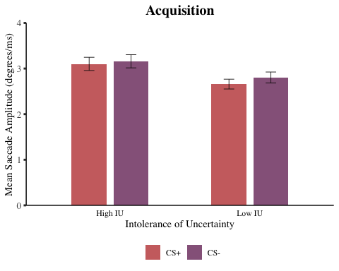

# save figure to file   
ggsave(filename = "graphs/bar_plots/acquisition_sacc_amplitude.png",   
 plot = fig_acquisition_sacc_amplitude,   
 width = 20,   
 height = 10,   
 dpi = 300,   
 units = "cm")

### *Extinction*

# obtain mean sacc amplitude for each group at each stimulus type and save as vector   
# high IU CS+ early  
mean_e_ext_sacc_amplitude_high_iu_csp <-   
 mean(df$e_ext_csp_sacc_amplitude[df_long_ext_sacc_amplitude$iu_group == "1"], na.rm = TRUE)   
  
# low IU CS+ early  
mean_e_ext_sacc_amplitude_low_iu_csp <-   
 mean(df$e_ext_csp_sacc_amplitude[df_long_ext_sacc_amplitude$iu_group == "-1"], na.rm = TRUE)   
  
# high IU CS- early  
mean_e_ext_sacc_amplitude_high_iu_csm <-   
 mean(df$e_ext_csm_sacc_amplitude[df_long_ext_sacc_amplitude$iu_group == "1"], na.rm = TRUE)   
  
# low IU CS- early  
mean_e_ext_sacc_amplitude_low_iu_csm <-   
 mean(df$e_ext_csm_sacc_amplitude[df_long_ext_sacc_amplitude$iu_group == "-1"], na.rm = TRUE)   
  
# high IU CS+ late  
mean_l_ext_sacc_amplitude_high_iu_csp <-   
 mean(df$l_ext_csp_sacc_amplitude[df_long_ext_sacc_amplitude$iu_group == "1"], na.rm = TRUE)   
  
# low IU CS+ late  
mean_l_ext_sacc_amplitude_low_iu_csp <-   
 mean(df$l_ext_csp_sacc_amplitude[df_long_ext_sacc_amplitude$iu_group == "-1"], na.rm = TRUE)   
  
# high IU CS- late  
mean_l_ext_sacc_amplitude_high_iu_csm <-   
 mean(df$l_ext_csm_sacc_amplitude[df_long_ext_sacc_amplitude$iu_group == "1"], na.rm = TRUE)   
  
# low IU CS- late  
mean_l_ext_sacc_amplitude_low_iu_csm <-   
 mean(df$l_ext_csm_sacc_amplitude[df_long_ext_sacc_amplitude$iu_group == "-1"], na.rm = TRUE)   
  
# combine into single variable called   
all_mean_ext_sacc_amplitude <-   
 c(mean_e_ext_sacc_amplitude_high_iu_csp, mean_e_ext_sacc_amplitude_low_iu_csp,   
 mean_e_ext_sacc_amplitude_high_iu_csm, mean_e_ext_sacc_amplitude_low_iu_csm,  
 mean_l_ext_sacc_amplitude_high_iu_csp, mean_l_ext_sacc_amplitude_low_iu_csp,   
 mean_l_ext_sacc_amplitude_high_iu_csm, mean_l_ext_sacc_amplitude_low_iu_csm)  
  
# obtain SD sacc amplitude for each group at each stimulus type and save as vector   
# high IU CS+ early  
sd_e_ext_sacc_amplitude_high_iu_csp <-   
 sd(df$e_ext_csp_sacc_amplitude[df_long_ext_sacc_amplitude$iu_group == "1"], na.rm = TRUE)   
  
# low IU CS+ early  
sd_e_ext_sacc_amplitude_low_iu_csp <-   
 sd(df$e_ext_csp_sacc_amplitude[df_long_ext_sacc_amplitude$iu_group == "-1"], na.rm = TRUE)   
  
# high IU CS- early  
sd_e_ext_sacc_amplitude_high_iu_csm <-   
 sd(df$e_ext_csm_sacc_amplitude[df_long_ext_sacc_amplitude$iu_group == "1"], na.rm = TRUE)   
  
# low IU CS- early  
sd_e_ext_sacc_amplitude_low_iu_csm <-   
 sd(df$e_ext_csm_sacc_amplitude[df_long_ext_sacc_amplitude$iu_group == "-1"], na.rm = TRUE)   
  
# high IU CS+ late  
sd_l_ext_sacc_amplitude_high_iu_csp <-   
 sd(df$l_ext_csp_sacc_amplitude[df_long_ext_sacc_amplitude$iu_group == "1"], na.rm = TRUE)   
  
# low IU CS+ late  
sd_l_ext_sacc_amplitude_low_iu_csp <-   
 sd(df$l_ext_csp_sacc_amplitude[df_long_ext_sacc_amplitude$iu_group == "-1"], na.rm = TRUE)   
  
# high IU CS- late  
sd_l_ext_sacc_amplitude_high_iu_csm <-   
 sd(df$l_ext_csm_sacc_amplitude[df_long_ext_sacc_amplitude$iu_group == "1"], na.rm = TRUE)   
  
# low IU CS- late  
sd_l_ext_sacc_amplitude_low_iu_csm <-   
 sd(df$l_ext_csm_sacc_amplitude[df_long_ext_sacc_amplitude$iu_group == "-1"], na.rm = TRUE)   
  
# obtain SE:  
se_e_ext_sacc_amplitude_high_iu_csp <- sd_e_ext_sacc_amplitude_high_iu_csp/sqrt(length(df$id))  
se_e_ext_sacc_amplitude_low_iu_csp <- sd_e_ext_sacc_amplitude_low_iu_csp/sqrt(length(df$id))  
se_e_ext_sacc_amplitude_high_iu_csm <- sd_e_ext_sacc_amplitude_high_iu_csm/sqrt(length(df$id))  
se_e_ext_sacc_amplitude_low_iu_csm <- sd_e_ext_sacc_amplitude_low_iu_csm/sqrt(length(df$id))  
se_l_ext_sacc_amplitude_high_iu_csp <- sd_l_ext_sacc_amplitude_high_iu_csp/sqrt(length(df$id))  
se_l_ext_sacc_amplitude_low_iu_csp <- sd_l_ext_sacc_amplitude_low_iu_csp/sqrt(length(df$id))  
se_l_ext_sacc_amplitude_high_iu_csm <- sd_l_ext_sacc_amplitude_high_iu_csm/sqrt(length(df$id))  
se_l_ext_sacc_amplitude_low_iu_csm <- sd_l_ext_sacc_amplitude_low_iu_csm/sqrt(length(df$id))  
  
# combine all into single variable   
all_se_ext_sacc_amplitude <- c(se_e_ext_sacc_amplitude_high_iu_csp, se_e_ext_sacc_amplitude_low_iu_csp,  
 se_e_ext_sacc_amplitude_high_iu_csm, se_e_ext_sacc_amplitude_low_iu_csm,  
 se_l_ext_sacc_amplitude_high_iu_csp, se_l_ext_sacc_amplitude_low_iu_csp,   
 se_l_ext_sacc_amplitude_high_iu_csm, se_l_ext_sacc_amplitude_low_iu_csm)  
  
# create new data frame for figures which includes mean and SE for each condition  
df_fig_extinction_sacc_amplitude <- data.frame(all_mean_ext_sacc_amplitude, all_se_ext_sacc_amplitude)  
  
# add labels - add two more variables to indicate IU group, stimulus type and extinction time   
# for IU group  
df_fig_extinction_sacc_amplitude$iu_group[1] <- "High IU"  
df_fig_extinction_sacc_amplitude$iu_group[2] <- "Low IU"  
df_fig_extinction_sacc_amplitude$iu_group[3] <- "High IU"  
df_fig_extinction_sacc_amplitude$iu_group[4] <- "Low IU"  
df_fig_extinction_sacc_amplitude$iu_group[5] <- "High IU"  
df_fig_extinction_sacc_amplitude$iu_group[6] <- "Low IU"  
df_fig_extinction_sacc_amplitude$iu_group[7] <- "High IU"  
df_fig_extinction_sacc_amplitude$iu_group[8] <- "Low IU"  
  
# for stimulus  
df_fig_extinction_sacc_amplitude$stimulus[1] <- "CS+"  
df_fig_extinction_sacc_amplitude$stimulus[2] <- "CS+"  
df_fig_extinction_sacc_amplitude$stimulus[3] <- "CS-"  
df_fig_extinction_sacc_amplitude$stimulus[4] <- "CS-"  
df_fig_extinction_sacc_amplitude$stimulus[5] <- "CS+"  
df_fig_extinction_sacc_amplitude$stimulus[6] <- "CS+"  
df_fig_extinction_sacc_amplitude$stimulus[7] <- "CS-"  
df_fig_extinction_sacc_amplitude$stimulus[8] <- "CS-"  
  
# and re-order levels of stimulus factor so that CS+ appears on left in the graph  
df_fig_extinction_sacc_amplitude$stimulus <-   
 factor(df_fig_extinction_sacc_amplitude$stimulus,levels=c("CS+","CS-"))  
  
# for early / late extinction  
df_fig_extinction_sacc_amplitude$time[1] <- "Early"  
df_fig_extinction_sacc_amplitude$time[2] <- "Early"  
df_fig_extinction_sacc_amplitude$time[3] <- "Early"  
df_fig_extinction_sacc_amplitude$time[4] <- "Early"  
df_fig_extinction_sacc_amplitude$time[5] <- "Late"  
df_fig_extinction_sacc_amplitude$time[6] <- "Late"  
df_fig_extinction_sacc_amplitude$time[7] <- "Late"  
df_fig_extinction_sacc_amplitude$time[8] <- "Late"  
  
# create figure  
fig_extinction_sacc_amplitude <- ggplot(df_fig_extinction_sacc_amplitude,   
 aes(x = iu_group, y = all_mean_ext_sacc_amplitude,   
 fill = stimulus)) +   
 geom_bar(stat = "identity", position = position_dodge(.6), width = .5, alpha = .85) +  
 scale_y_continuous(limits = c(0, 4), expand = c(0,0)) +  
 facet_wrap(~ time) +  
 theme_classic() +   
 theme(text = element_text(family = "serif"),   
 plot.title = element_text(face = "bold", hjust = 0.5, size = 15)) +  
 theme(axis.text.y = element_text(size = 10),axis.ticks.y = element_line(size = 1),   
 axis.line.y = element_line(colour = "black")) +  
 theme(axis.text.x = element_text(colour = "black"), axis.ticks.x = element_blank(),  
 axis.line.x = element_line(colour = "black")) +  
 theme(legend.position = "bottom", legend.title = element_blank()) +  
 scale_fill_manual(values = c("#c45150", "#824372")) +  
 ggtitle("Extinction") +  
 labs(y = "Mean Saccade Amplitude (degrees/ms)", x = "Intolerance of Uncertainty") +  
 geom_errorbar(aes(ymin = all_mean_ext_sacc_amplitude - all_se_ext_sacc_amplitude,   
 ymax = all_mean_ext_sacc_amplitude + all_se_ext_sacc_amplitude),   
 width = .15, position = position_dodge(.6), colour = "#090707", size = .3) +  
 theme(strip.background = element_blank()) +  
 theme(strip.text = element_text(size = 12))  
  
# obtain and check figure   
print(fig_extinction_sacc_amplitude)

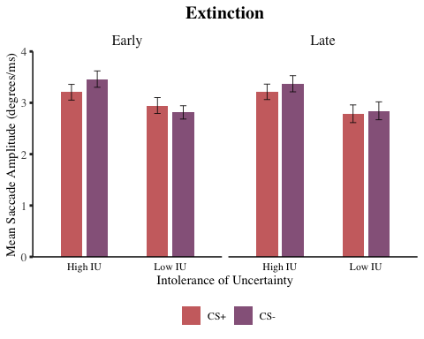

# save figure to files  
ggsave(filename = "graphs/bar_plots/extinction_sacc_amplitude.png",   
 plot = fig_extinction_sacc_amplitude,   
 width = 20,   
 height = 10,   
 dpi = 300,   
 units = "cm")

## *Combine Bar Plots*

all_bar_plots <- grid.arrange(fig_acquisition_fix_count, fig_extinction_fix_count,  
 fig_acquisition_fix_duration_log, fig_extinction_fix_duration_log,  
 fig_acquisition_sacc_amplitude, fig_extinction_sacc_amplitude,   
 ncol = 2)

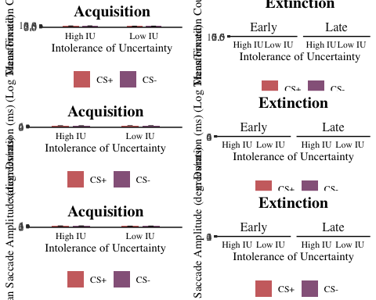

# save figure to files  
ggsave(filename = "graphs/bar_plots/all_bar_plots.png",   
 plot = all_bar_plots,   
 width = 40,   
 height = 30,   
 dpi = 300,   
 units = "cm")

# *ANCOVAs to test Specificity of IU over Trait Anxiety*

## *ANCOVA Acquisition Fixation Count*

# transform wide format data into long format for mixed ANCOVA   
df_long_acq_fix_count <- melt(df, id = c("id", "iu_group", "sticsa_total"),   
 measure.vars = c("acq_csp_fix_count",   
 "acq_csm_fix_count"))  
  
# rename columns for easier interpretation  
colnames(df_long_acq_fix_count) = c("id", "iu_group", "sticsa_total", "condition", "fix_count")  
  
# create column to code stimulus as CS+ (1) and CS- (-1)  
df_long_acq_fix_count$stimulus <-   
 factor(ifelse(df_long_acq_fix_count$condition == "acq_csp_fix_count", 1, -1))  
  
# mean centre continuous covariate (STICSA)  
# to apply mean centring, first obtain average sticsa scores for all participants,   
# and save as a variable  
df_long_acq_fix_count$sticsa_total_avg <- mean(df_long_acq_fix_count$sticsa_total)  
  
# next, subtract this average from all participants' sticsa scores,  
# and save as a variable  
df_long_acq_fix_count$sticsa_total_centred <-   
 df_long_acq_fix_count$sticsa_total - df_long_acq_fix_count$sticsa_total_avg   
# from this we have mean sticsa scores after centring   
  
# compute 2(IU: High & Low) x 2 (Stimulus: CS+, CS-) mixed ANCOVA,   
# with mean-cenred STICSA as covariate  
# and obtain effect size (partial eta squared)  
acq_fix_count_ancova <-   
 anova_test(df_long_acq_fix_count, fix_count ~ iu_group * stimulus + Error(id/stimulus),  
 covariate = sticsa_total_centred, effect.size = "pes")   
  
# obtain the mixed ANCOVA results  
get_anova_table(acq_fix_count_ancova)

## ANOVA Table (type III tests)  
##   
## Effect DFn DFd F p p<.05 pes  
## 1 sticsa_total_centred 1 136 0.059 0.808000 0.000434  
## 2 iu_group 1 136 3.191 0.076000 0.023000  
## 3 stimulus 1 136 11.622 0.000858 * 0.079000  
## 4 sticsa_total_centred:stimulus 1 136 1.845 0.177000 0.013000  
## 5 iu_group:stimulus 1 136 1.230 0.269000 0.009000

# results:  
# STICSA (centred): F(1,136) = 0.06, p = .808, eta2(partial) = < .001  
# IU: F(1,136) = 3.19, p = .076, eta2(partial) = .023  
# Stimulus: F(1,136) = 11.62, p < .001***, eta2(partial) = .079  
# STICSA * Stimulus: F(1,136) = 1.85, p = .177, eta2(partial) = .013  
# IU * Stimulus: F(1, 136) = 1.23, p = .269, eta2(partial) = .009  
  
# therefore, after accounting for trait anxiety, IU no longer has a significant  
# effect on fixation count in acquisition, but stimulus continues to have  
# significant effect. IU*Stimulus interaction also remains non-significant,   
# even after controlling for trait anxiety.  
  
# write to csv  
write.csv((get_anova_table(acq_fix_count_ancova)),   
 file = "tables/ancovas/acq_fix_count_ancova.csv")  
  
# as there was a significant main effect of stimulus, obtain estimated  
# marginal means to be reported (temporarily from SPSS):  
  
emmeans_acq_fix_count_ancova_csp <- 6.92  
emmeans_acq_fix_count_ancova_csm <- 7.32

## *ANCOVA Acquisition Fixation Duration (Log Transformed)*

# transform wide format data into long format for mixed ANCOVA   
df_long_acq_fix_duration_log <- melt(df, id = c("id", "iu_group", "sticsa_total"),   
 measure.vars = c("acq_csp_fix_duration_log",   
 "acq_csm_fix_duration_log"))  
  
# rename columns for easier interpretation  
colnames(df_long_acq_fix_duration_log) = c("id", "iu_group", "sticsa_total", "condition", "fix_duration_log")  
  
# create column to code stimulus as CS+ (1) and CS- (-1)  
df_long_acq_fix_duration_log$stimulus <-   
 factor(ifelse(df_long_acq_fix_duration_log$condition == "acq_csp_fix_duration_log", 1, -1))  
  
# mean centre continuous covariate (STICSA)  
# to apply mean centring, first obtain average sticsa scores for all participants,   
# and save as a variable  
df_long_acq_fix_duration_log$sticsa_total_avg <- mean(df_long_acq_fix_duration_log$sticsa_total)  
  
# next, subtract this average from all participants' sticsa scores,  
# and save as a variable  
df_long_acq_fix_duration_log$sticsa_total_centred <-   
 df_long_acq_fix_duration_log$sticsa_total - df_long_acq_fix_duration_log$sticsa_total_avg   
# from this we have mean sticsa scores after centring   
  
# compute 2(IU: High & Low) x 2 (Stimulus: CS+, CS-) mixed ANCOVA,   
# with mean-cenred STICSA as covariate  
# and obtain effect size (partial eta squared)  
acq_fix_duration_ancova_log <-   
 anova_test(df_long_acq_fix_duration_log, fix_duration_log ~ iu_group * stimulus + Error(id/stimulus),  
 covariate = sticsa_total_centred, effect.size = "pes")   
  
# obtain the mixed ANCOVA results  
get_anova_table(acq_fix_duration_ancova_log)

## ANOVA Table (type III tests)  
##   
## Effect DFn DFd F p p<.05 pes  
## 1 sticsa_total_centred 1 136 0.268 0.606 0.002  
## 2 iu_group 1 136 3.890 0.051 0.028  
## 3 stimulus 1 136 2.935 0.089 0.021  
## 4 sticsa_total_centred:stimulus 1 136 0.409 0.524 0.003  
## 5 iu_group:stimulus 1 136 1.674 0.198 0.012

# results:  
# STICSA (centred): F(1,136) = 0.27, p = .606, eta2(partial) = .002  
# IU: F(1,136) = 3.89, p = .051, eta2(partial) = .028  
# Stimulus: F(1,136) = 2.94, p = .089, eta2(partial) = .021  
# STICSA * Stimulus: F(1,136) = 0.41, p = .524, eta2(partial) = .003  
# IU * Stimulus: F(1, 136) = 1.67, p = .198, eta2(partial) = .012  
  
# there are no significant effects or interactions on fixation duration in acquisition.   
  
# write to csv  
write.csv((get_anova_table(acq_fix_duration_ancova_log)),   
 file = "tables/ancovas/acq_fix_duration_ancova_log.csv")

## *ANCOVA Acquisition Saccade Amplitude*

# transform wide format data into long format for mixed ANCOVA   
df_long_acq_sacc_amplitude <- melt(df, id = c("id", "iu_group", "sticsa_total"),   
 measure.vars = c("acq_csp_sacc_amplitude",   
 "acq_csm_sacc_amplitude"))  
  
# rename columns for easier interpretation  
colnames(df_long_acq_sacc_amplitude) = c("id", "iu_group", "sticsa_total", "condition", "sacc_amplitude")  
  
# create column to code stimulus as CS+ (1) and CS- (-1)  
df_long_acq_sacc_amplitude$stimulus <-   
 factor(ifelse(df_long_acq_sacc_amplitude$condition == "acq_csp_sacc_amplitude", 1, -1))  
  
# mean centre continuous covariate (STICSA)  
# to apply mean centring, first obtain average sticsa scores for all participants,   
# and save as a variable  
df_long_acq_sacc_amplitude$sticsa_total_avg <- mean(df_long_acq_sacc_amplitude$sticsa_total)  
  
# next, subtract this average from all participants' sticsa scores,  
# and save as a variable  
df_long_acq_sacc_amplitude$sticsa_total_centred <-   
 df_long_acq_sacc_amplitude$sticsa_total - df_long_acq_sacc_amplitude$sticsa_total_avg   
# from this we have mean sticsa scores after centring   
  
# compute 2(IU: High & Low) x 2 (Stimulus: CS+, CS-) mixed ANCOVA,   
# with mean-cenred STICSA as covariate  
# and obtain effect size (partial eta squared)  
acq_sacc_amplitude_ancova <-   
 anova_test(df_long_acq_sacc_amplitude, sacc_amplitude ~ iu_group * stimulus + Error(id/stimulus),  
 covariate = sticsa_total_centred, effect.size = "pes")

## Warning: NA detected in rows: 234,259.  
## Removing this rows before the analysis.

# obtain the mixed ANCOVA results  
get_anova_table(acq_sacc_amplitude_ancova)

## ANOVA Table (type III tests)  
##   
## Effect DFn DFd F p p<.05 pes  
## 1 sticsa_total_centred 1 134 0.007 0.935 0.0000503  
## 2 iu_group 1 134 2.128 0.147 0.0160000  
## 3 stimulus 1 134 0.943 0.333 0.0070000  
## 4 sticsa_total_centred:stimulus 1 134 0.643 0.424 0.0050000  
## 5 iu_group:stimulus 1 134 0.864 0.354 0.0060000

# results:  
# STICSA (centred): F(1,134) = 0.01, p = .935, eta2(partial) < .001  
# IU: F(1,134) = 2.13, p = .147, eta2(partial) = .016  
# Stimulus: F(1,134) = 0.94, p = .333, eta2(partial) = .007  
# STICSA * Stimulus: F(1,134) = 0.64, p = .424, eta2(partial) = .005  
# IU * Stimulus: F(1, 134) = 0.86, p = .354, eta2(partial) = .006  
  
# therefore, after accounting for trait anxiety, there continue not  
# to be any significant effects of IU, stimulus, and interaction  
# effects on saccade amplitude in acquisition.   
  
# write to csv  
write.csv((get_anova_table(acq_sacc_amplitude_ancova)),   
 file = "tables/ancovas/acq_sacc_amplitude_ancova.csv")

## *ANCOVA Extinction Fixation Count*

# transform wide format data into long format for mixed ANOVA   
df_long_ext_fix_count <- melt(df, id = c("id", "iu_group", "sticsa_total"),   
 measure.vars = c("e_ext_csp_fix_count",   
 "e_ext_csm_fix_count",  
 "l_ext_csp_fix_count",   
 "l_ext_csm_fix_count"))  
  
# rename columns for easier interpretation  
colnames(df_long_ext_fix_count) = c("id", "iu_group", "sticsa_total", "condition", "fix_count")  
  
# create column to code stimulus as CS+ (1) and CS- (-1)  
df_long_ext_fix_count$stimulus <-   
 factor(ifelse(df_long_ext_fix_count$condition == "e_ext_csp_fix_count" |   
 df_long_ext_fix_count$condition == "l_ext_csp_fix_count", 1, -1))  
  
# create column to code extinction as early (1) and late (-1)  
df_long_ext_fix_count$time <-   
 factor(ifelse(df_long_ext_fix_count$condition == "e_ext_csp_fix_count" |   
 df_long_ext_fix_count$condition == "e_ext_csm_fix_count", 1, -1))  
  
# mean centre continuous covariate (STICSA)  
# to apply mean centring, first obtain average sticsa scores for all participants,   
# and save as a variable  
df_long_ext_fix_count$sticsa_total_avg <- mean(df_long_ext_fix_count$sticsa_total)  
  
# next, subtract this average from all participants' sticsa scores,  
# and save as a variable  
df_long_ext_fix_count$sticsa_total_centred <-   
 df_long_ext_fix_count$sticsa_total - df_long_ext_fix_count$sticsa_total_avg   
# from this we have mean sticsa scores after centring   
  
# compute 2(IU: High & Low) x 2 (Stimulus: CS+, CS-) x 2 (Time: Early, Late) mixed ANOVA,   
# with mean-centred STICSA as covariate,  
# and obtain effect size (partial eta squared)  
ext_fix_count_ancova <-   
 anova_test(df_long_ext_fix_count,   
 fix_count ~ iu_group * stimulus * time + Error(id/(stimulus*time)),  
 covariate = sticsa_total_centred, effect.size = "pes")   
  
# obtain the mixed ANCOVA results  
get_anova_table(ext_fix_count_ancova)

## ANOVA Table (type III tests)  
##   
## Effect DFn DFd F p p<.05 pes  
## 1 sticsa_total_centred 1 136 0.433000 0.512 0.00300000  
## 2 iu_group 1 136 4.361000 0.039 * 0.03100000  
## 3 stimulus 1 136 4.209000 0.042 * 0.03000000  
## 4 time 1 136 5.692000 0.018 * 0.04000000  
## 5 sticsa_total_centred:stimulus 1 136 1.098000 0.297 0.00800000  
## 6 iu_group:stimulus 1 136 4.560000 0.035 * 0.03200000  
## 7 sticsa_total_centred:time 1 136 0.000429 0.984 0.00000316  
## 8 iu_group:time 1 136 3.489000 0.064 0.02500000  
## 9 stimulus:time 1 136 0.066000 0.797 0.00048800  
## 10 sticsa_total_centred:stimulus:time 1 136 0.901000 0.344 0.00700000  
## 11 iu_group:stimulus:time 1 136 0.044000 0.834 0.00032500

# results:  
# STICSA (centred): F(1,136) = 0.43, p = .512, eta2(partial) = .003  
# IU: F(1,136) = 4.36, p = .039*, eta2(partial) = .031  
# Stimulus: F(1,136) = 4.21, p = .042*, eta2(partial) = .030  
# Time: F(1,136) = 5.69, p = .018 *, eta2(partial) = .040  
# STICSA * Stimulus: F(1,136) = 1.10, p = .297, eta2(partial) = .008  
# IU * Stimulus: F(1, 136) = 4.56, p = .035*, eta2(partial) = .032  
# STICSA* Time: F(1,136) = 0.00, p = .982, eta2(partial) < .001  
# IU * Time: F(1,136) = 3.49, p = .064, eta2(partial) = . 025  
# Stimulus * Time: F(1,136) = 0.07, p = .797, eta2(partial) < .001  
# STICSA * Stimulus * Time: F(1,136) = 0.90, p = .344, eta2(partial) = .007  
# IU * Stimulus * Time: F(1,136) = 0.04, p = .834, eta2(partial) < .001  
  
# therefore, after accounting for trait anxiety, IU, Stimulus, and Time   
# continue to have a significant effect on fixation duration in acquisition.   
# there is no longer a significant interaction effect of IU*Time,   
# but there is now a significant interaction effect of IU*stimulus  
  
# write to csv  
write.csv((get_anova_table(ext_fix_count_ancova)),   
 file = "tables/ancovas/ext_fix_count_ancova.csv")  
  
# as there was a significant IU*Stimulus interaction, conduct simple   
# main effects analysis:  
## obtain effect of IU at each level of stimulus   
simple_effects_ext_fix_count_iu_ancova <- df_long_ext_fix_count %>%  
 group_by(stimulus) %>%  
 anova_test(dv = fix_count, wid = id, between = iu_group, within = time,  
 covariate = sticsa_total_centred, effect.size = "pes") %>%  
 get_anova_table()   
  
# get the output  
simple_effects_ext_fix_count_iu_ancova

## # A tibble: 10 × 8  
## stimulus Effect DFn DFd F p `p<.05` pes  
## * <fct> <chr> <dbl> <dbl> <dbl> <dbl> <chr> <dbl>  
## 1 -1 sticsa_total_centred 1 136 0.142 0.707 "" 0.001  
## 2 -1 iu_group 1 136 6.66 0.011 "*" 0.047  
## 3 -1 time 1 136 5.02 0.027 "*" 0.036  
## 4 -1 sticsa_total_centred:time 1 136 0.369 0.545 "" 0.003  
## 5 -1 iu_group:time 1 136 2.25 0.136 "" 0.016  
## 6 1 sticsa_total_centred 1 136 0.796 0.374 "" 0.006  
## 7 1 iu_group 1 136 2.16 0.143 "" 0.016  
## 8 1 time 1 136 2.86 0.093 "" 0.021  
## 9 1 sticsa_total_centred:time 1 136 0.253 0.616 "" 0.002  
## 10 1 iu_group:time 1 136 2.40 0.124 "" 0.017

# results:   
# The effect of IU group on CS+ was not significant [F(1,136) = 2.17, p = .143, pes = .016]  
# the effect of IU group on CS- was significant [F(1,136) = 6.66, p = .011, pes = .047]  
  
# as there were a significant main effects of IU, stimulus and time,   
# as well as a sig IU-STimulus interaction, obtain estimated  
# marginal means to be reported (temporarily from SPSS):  
  
# IU  
emmeans_ext_fix_count_ancova_high_iu <- 8.15  
emmeans_ext_fix_count_ancova_low_iu <- 6.87  
  
# stimulus  
emmeans_ext_fix_count_ancova_csp <- 7.37  
emmeans_ext_fix_count_ancova_csm <- 7.65  
  
# time  
emmeans_ext_fix_count_ancova_early <- 7.29  
emmeans_ext_fix_count_ancova_late <- 7.72  
  
# IU-Stimulus interaction  
emmeans_ext_fix_count_ancova_high_iu_csp <- 7.83  
emmeans_ext_fix_count_ancova_high_iu_csm <- 8.46  
emmeans_ext_fix_count_ancova_low_iu_csp <- 6.90  
emmeans_ext_fix_count_ancova_low_iu_csm <- 6.84

## *ANCOVA Extinction Fixation Duration (Log Transformed)*

# transform wide format data into long format for mixed ANCOVA   
df_long_ext_fix_duration_log <- melt(df, id = c("id", "iu_group", "sticsa_total"),   
 measure.vars = c("e_ext_csp_fix_duration_log",   
 "e_ext_csm_fix_duration_log",  
 "l_ext_csp_fix_duration_log",   
 "l_ext_csm_fix_duration_log"))  
  
# rename columns for easier interpretation  
colnames(df_long_ext_fix_duration_log) = c("id", "iu_group", "sticsa_total", "condition", "fix_duration_log")  
  
# create column to code stimulus as CS+ (1) and CS- (-1)  
df_long_ext_fix_duration_log$stimulus <-   
 factor(ifelse(df_long_ext_fix_duration_log$condition == "e_ext_csp_fix_duration_log" |   
 df_long_ext_fix_duration_log$condition == "l_ext_csp_fix_duration_log", 1, -1))  
  
# create column to code extinction as early (1) and late (-1)  
df_long_ext_fix_duration_log$time <-   
 factor(ifelse(df_long_ext_fix_duration_log$condition == "e_ext_csp_fix_duration_log" |   
 df_long_ext_fix_duration_log$condition == "e_ext_csm_fix_duration_log", 1, -1))  
  
# mean centre continuous covariate (STICSA)  
# to apply mean centring, first obtain average sticsa scores for all participants,   
# and save as a variable  
df_long_ext_fix_duration_log$sticsa_total_avg <- mean(df_long_ext_fix_duration_log$sticsa_total)  
  
# next, subtract this average from all participants' sticsa scores,  
# and save as a variable  
df_long_ext_fix_duration_log$sticsa_total_centred <-   
 df_long_ext_fix_duration_log$sticsa_total - df_long_ext_fix_duration_log$sticsa_total_avg   
# from this we have mean sticsa scores after centring   
  
# compute 2(IU: High & Low) x 2 (Stimulus: CS+, CS-) x 2 (Time: Early, Late) mixed ANOVA,   
# with mean-centred STICSA as covariate,  
# and obtain effect size (partial eta squared)  
ext_fix_duration_ancova_log <-   
 anova_test(df_long_ext_fix_duration_log,   
 fix_duration_log ~ iu_group * stimulus * time + Error(id/(stimulus*time)),  
 covariate = sticsa_total_centred, effect.size = "pes")   
  
# obtain the mixed ANCOVA results  
get_anova_table(ext_fix_duration_ancova_log)

## ANOVA Table (type III tests)  
##   
## Effect DFn DFd F p p<.05 pes  
## 1 sticsa_total_centred 1 136 0.001 0.972 0.00000901  
## 2 iu_group 1 136 8.365 0.004 * 0.05800000  
## 3 stimulus 1 136 0.514 0.475 0.00400000  
## 4 time 1 136 4.358 0.039 * 0.03100000  
## 5 sticsa_total_centred:stimulus 1 136 0.195 0.659 0.00100000  
## 6 iu_group:stimulus 1 136 5.357 0.022 * 0.03800000  
## 7 sticsa_total_centred:time 1 136 0.329 0.567 0.00200000  
## 8 iu_group:time 1 136 0.501 0.480 0.00400000  
## 9 stimulus:time 1 136 0.174 0.677 0.00100000  
## 10 sticsa_total_centred:stimulus:time 1 136 0.221 0.639 0.00200000  
## 11 iu_group:stimulus:time 1 136 0.379 0.539 0.00300000

# results:  
# STICSA (centred): F(1,136) = 0.01, p = .972, eta2(partial) < .001  
# IU: F(1,136) = 8.37, p = .004**, eta2(partial) = .058  
# Stimulus: F(1,136) = 0.51, p = .475, eta2(partial) = .004  
# Time: F(1,136) = 4.36, p = .039*, eta2(partial) = .031  
# STICSA * Stimulus: F(1,136) = 0.20, p = .659, eta2(partial) = .001  
# IU * Stimulus: F(1, 136) = 5.36, p = .022*, eta2(partial) = .038  
# STICSA* Time: F(1,136) = 0.33, p = .567, eta2(partial) = .002  
# IU * Time: F(1,136) = 0.50, p = .480, eta2(partial) = . 004  
# Stimulus * Time: F(1,136) = 0.17, p = .677, eta2(partial) = .001  
# STICSA * Stimulus * Time: F(1,136) = 0.22, p = .639, eta2(partial) = .002  
# IU * Stimulus * Time: F(1,136) = 0.34, p = .539, eta2(partial) = .003  
  
# there were significant main effects of IU, time,  
# and a significant IU-stimulus interaction on fixation duration in extinction,  
# and no further main effects or interactions.   
  
# write to csv  
write.csv((get_anova_table(ext_fix_duration_ancova_log)),   
 file = "tables/ancovas/ext_fix_duration_ancova_log.csv")  
  
# as there was a significant IU*Stimulus interaction, conduct simple   
# main effects analysis:  
## obtain effect of IU at each level of stimulus   
simple_effects_ext_fix_duration_iu_ancova <- df_long_ext_fix_duration_log %>%  
 group_by(stimulus) %>%  
 anova_test(dv = fix_duration_log, wid = id, between = iu_group, within = time,  
 covariate = sticsa_total_centred, effect.size = "pes") %>%  
 get_anova_table()   
  
# get the output  
simple_effects_ext_fix_duration_iu_ancova

## # A tibble: 10 × 8  
## stimulus Effect DFn DFd F p `p<.05` pes  
## * <fct> <chr> <dbl> <dbl> <dbl> <dbl> <chr> <dbl>  
## 1 -1 sticsa_total_centred 1 136 0.008 0.928 "" 0.0000602  
## 2 -1 iu_group 1 136 11.2 0.001 "*" 0.076   
## 3 -1 time 1 136 4.37 0.038 "*" 0.031   
## 4 -1 sticsa_total_centred:time 1 136 0.627 0.43 "" 0.005   
## 5 -1 iu_group:time 1 136 0.061 0.806 "" 0.000445   
## 6 1 sticsa_total_centred 1 136 0.027 0.87 "" 0.000199   
## 7 1 iu_group 1 136 4.70 0.032 "*" 0.033   
## 8 1 time 1 136 1.93 0.167 "" 0.014   
## 9 1 sticsa_total_centred:time 1 136 0.036 0.849 "" 0.000266   
## 10 1 iu_group:time 1 136 0.771 0.381 "" 0.006

# results:   
# The effect of IU group on CS+ was not significant [F(1,136) = 4.70, p = .032, pes = .033]  
# the effect of IU group on CS- was significant [F(1,136) = 11,19, p = .001, pes = .076]  
  
# as there were a significant main effects of IU, time and iu-stimulus interaction,   
# obtain estimated marginal means to be reported (temporarily from SPSS):  
##### NOTE: have not done log-transformed fixation duration on SPSS yet, and  
# so do not have estimated marginal means for fixation duration (log-transformed)  
  
# IU  
emmeans_ext_fix_duration_ancova_high_iu <- 0  
emmeans_ext_fix_duration_ancova_low_iu <- 0  
  
# time  
emmeans_ext_fix_duration_ancova_early <- 0  
emmeans_ext_fix_duration_ancova_late <- 0  
  
# IU-Stimulus interaction  
emmeans_ext_fix_duration_ancova_high_iu_csp <- 0  
emmeans_ext_fix_duration_ancova_high_iu_csm <- 0  
emmeans_ext_fix_duration_ancova_low_iu_csp <- 0  
emmeans_ext_fix_duration_ancova_low_iu_csm <- 0

## *ANCOVA Extinction Saccade Amplitude*

# transform wide format data into long format for mixed ANCOVA   
df_long_ext_sacc_amplitude <- melt(df, id = c("id", "iu_group", "sticsa_total"),   
 measure.vars = c("e_ext_csp_sacc_amplitude",   
 "e_ext_csm_sacc_amplitude",  
 "l_ext_csp_sacc_amplitude",   
 "l_ext_csm_sacc_amplitude"))  
  
# rename columns for easier interpretation  
colnames(df_long_ext_sacc_amplitude) = c("id", "iu_group", "sticsa_total", "condition", "sacc_amplitude")  
  
# create column to code stimulus as CS+ (1) and CS- (-1)  
df_long_ext_sacc_amplitude$stimulus <-   
 factor(ifelse(df_long_ext_sacc_amplitude$condition == "e_ext_csp_sacc_amplitude" |   
 df_long_ext_sacc_amplitude$condition == "l_ext_csp_sacc_amplitude", 1, -1))  
  
# create column to code extinction as early (1) and late (-1)  
df_long_ext_sacc_amplitude$time <-   
 factor(ifelse(df_long_ext_sacc_amplitude$condition == "e_ext_csp_sacc_amplitude" |   
 df_long_ext_sacc_amplitude$condition == "e_ext_csm_sacc_amplitude", 1, -1))  
  
# mean centre continuous covariate (STICSA)  
# to apply mean centring, first obtain average sticsa scores for all participants,   
# and save as a variable  
df_long_ext_sacc_amplitude$sticsa_total_avg <- mean(df_long_ext_sacc_amplitude$sticsa_total)  
  
# next, subtract this average from all participants' sticsa scores,  
# and save as a variable  
df_long_ext_sacc_amplitude$sticsa_total_centred <-   
 df_long_ext_sacc_amplitude$sticsa_total - df_long_ext_sacc_amplitude$sticsa_total_avg   
# from this we have mean sticsa scores after centring   
  
# compute 2(IU: High & Low) x 2 (Stimulus: CS+, CS-) x 2 (Time: Early, Late) mixed ANOVA,   
# with mean-centred STICSA as covariate,  
# and obtain effect size (partial eta squared)  
ext_sacc_amplitude_ancova <-   
 anova_test(df_long_ext_sacc_amplitude,   
 sacc_amplitude ~ iu_group * stimulus * time + Error(id/(stimulus*time)),  
 covariate = sticsa_total_centred, effect.size = "pes")

## Warning: NA detected in rows: 116,181,301.  
## Removing this rows before the analysis.

# obtain the mixed ANCOVA results  
get_anova_table(ext_sacc_amplitude_ancova)

## ANOVA Table (type III tests)  
##   
## Effect DFn DFd F p p<.05 pes  
## 1 sticsa_total_centred 1 133 1.134 0.289 0.008000  
## 2 iu_group 1 133 1.025 0.313 0.008000  
## 3 stimulus 1 133 0.754 0.387 0.006000  
## 4 time 1 133 0.255 0.615 0.002000  
## 5 sticsa_total_centred:stimulus 1 133 0.370 0.544 0.003000  
## 6 iu_group:stimulus 1 133 2.035 0.156 0.015000  
## 7 sticsa_total_centred:time 1 133 1.359 0.246 0.010000  
## 8 iu_group:time 1 133 0.803 0.372 0.006000  
## 9 stimulus:time 1 133 0.071 0.790 0.000533  
## 10 sticsa_total_centred:stimulus:time 1 133 0.421 0.517 0.003000  
## 11 iu_group:stimulus:time 1 133 0.997 0.320 0.007000

# results:  
# STICSA (centred): F(1,133) = 1.13, p = .289, eta2(partial) = .008  
# IU: F(1,133) = 1.03, p = .313, eta2(partial) = .008  
# Stimulus: F(1,133) = 0.75, p = .387, eta2(partial) = .006  
# Time: F(1,133) = 0.26, p = .615, eta2(partial) = .002  
# STICSA * Stimulus: F(1,133) = 0.37, p = .544, eta2(partial) = .003  
# IU * Stimulus: F(1, 133) = 2.04, p = .156, eta2(partial) = .015  
# STICSA* Time: F(1,133) = 1.36, p = .246, eta2(partial) = .010  
# IU * Time: F(1,133) = 0.80, p = .372, eta2(partial) = . 006  
# Stimulus * Time: F(1,133) = 0.07, p = .790, eta2(partial) = .001  
# STICSA * Stimulus * Time: F(1,133) = 0.42, p = .517, eta2(partial) = .003  
# IU * Stimulus * Time: F(1,133) = 0.10, p = .320, eta2(partial) = .007  
  
# therefore, even after accounting for trait anxiety, there continue  
# to be no significant effects or interactions on saccade amplitude  
# in extinction  
  
# write to csv  
write.csv((get_anova_table(ext_sacc_amplitude_ancova)),   
 file = "tables/ancovas/ext_sacc_amplitude_ancova.csv")

# *Assumption Checks*

# assumptions of mixed ANOVA:  
## categorical IVs, interval/ratio DVs  
## residuals approximate normal distribution (for each level of each IV)  
## homogeneity of variances  
## homoscedasticity (plot standardised residuals against predicted values)  
## sphericity (not applicable in this case, as no within-subjects factors with > 3 levels)  
## homogeneity of variance-covariance matrices (this is assumed as sample size for  
##### each group and testing session is roughly equal)  
  
# additional assumptions of ANCOVA:  
## independence of covariate and IVs  
## homogeneity of regression slopes  
## linearity between covariate and outcome variable(s) at each level of grouping  
#### variable(s). check by creating grouped scatterplot  
## outcome variable(s) should be approximately normally distributed  
## no sigifnicant outliers in the groups

## *Linearity Between Covariate and Outcome Variables*

## this is at each level of grouping variable.   
# check by computing grouped scatterplot of covariate and outcome variable   
  
################# linearity   
# linearity between covariate and outcome variable at each level of grouping variable  
# (check using grouped scatterplot of covariate and outcome variable)  
  
### iu group  
scatterplot_acq_fix_count_sticsa_centred_by_iu <- ggplot(df_long_acq_fix_count,   
 aes(x = sticsa_total_centred, y = fix_count,   
 colour = iu_group)) +  
 geom_point() +  
 geom_jitter(width = .5, alpha = .30, size = 2.5) +  
 geom_smooth(method = lm, se = FALSE) +  
 labs(title = "Plot of the Relationship Between Trait Anxiety (Covariate) and   
 Fixation Count in Acquisition by IU Group",  
 x = "STICSA Total (Centred)",   
 y = "Acquisition Fixation Count") +  
 theme_classic() +  
 theme(plot.title = element_text(face = "bold", hjust = 0.5, size = 12)) +  
 theme(text = element_text(family = "serif")) +  
 guides(colour = guide_legend(reverse = TRUE)) +  
 scale_colour_manual(values = c("#c45150", "#824372"), labels = c("Low IU", "High IU")) +  
 labs(colour = "IU Group") +  
 theme(legend.position = "bottom", legend.title = element_text(face = "bold"))   
  
print(scatterplot_acq_fix_count_sticsa_centred_by_iu)

## `geom_smooth()` using formula 'y ~ x'

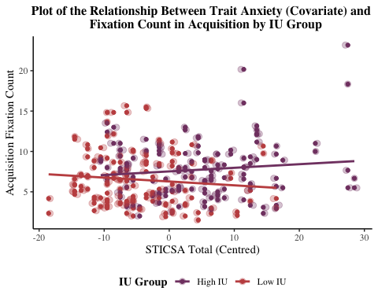

# there appears to be a linear relationship between the covariate (sticsa total centred)  
# and outcome variable (fixation count acquisition) at both levels of the grouping variable (iu group)  
# however, this plot also demonstrates likely heterogeneity of regression slopes, as there is possibly an  
# interaction between the outcome and covariate, and the regression lines do not appear  
# parallel  
  
####### extinctino iu  
### iu group  
scatterplot_ext_fix_count_sticsa_centred_by_iu <- ggplot(df_long_ext_fix_count,   
 aes(x = sticsa_total_centred, y = fix_count,   
 colour = iu_group)) +  
 geom_point() +  
 geom_jitter(width = .5, alpha = .30, size = 2.5) +  
 geom_smooth(method = lm, se = FALSE) +  
 labs(title = "Plot of the Relationship Between Trait Anxiety (Covariate) and   
 Fixation Count in Extinction by IU Group and Time",  
 x = "STICSA Total (Centred)",   
 y = "Extinction Fixation Count") +  
 theme_classic() +  
 theme(plot.title = element_text(face = "bold", hjust = 0.5, size = 12)) +  
 theme(text = element_text(family = "serif")) +  
 guides(colour = guide_legend(reverse = TRUE)) +  
 scale_colour_manual(values = c("#c45150", "#824372"), labels = c("Low IU", "High IU")) +  
 labs(colour = "IU Group") +  
 theme(legend.position = "bottom", legend.title = element_text(face = "bold")) +  
 facet_wrap(~ time, labeller = "label_both")   
  
print(scatterplot_ext_fix_count_sticsa_centred_by_iu)

## `geom_smooth()` using formula 'y ~ x'

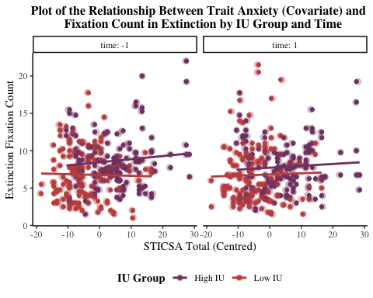

### stimulus  
scatterplot_acq_fix_count_sticsa_centred_by_stimulus <- ggplot(df_long_acq_fix_count,   
 aes(x = sticsa_total_centred, y = fix_count,   
 colour = stimulus)) +  
 geom_point() +  
 geom_jitter(width = .5, alpha = .30, size = 2.5) +  
 geom_smooth(method = lm, se = FALSE) +  
 labs(title = "Plot of the Relationship Between Trait Anxiety (Covariate) and   
 Fixation Count in Extinction by Stimulus",  
 x = "STICSA Total (Centred)",   
 y = "Acquisition Fixation Count") +  
 theme_classic() +  
 theme(plot.title = element_text(face = "bold", hjust = 0.5, size = 12)) +  
 theme(text = element_text(family = "serif")) +  
 guides(colour = guide_legend(reverse = TRUE)) +  
 scale_colour_manual(values = c("#DCECC9", "#076B68"), labels = c("CS-", "CS+")) +  
 labs(colour = "Stimulus") +  
 theme(legend.position = "bottom", legend.title = element_text(face = "bold"))  
  
print(scatterplot_acq_fix_count_sticsa_centred_by_stimulus)

## `geom_smooth()` using formula 'y ~ x'

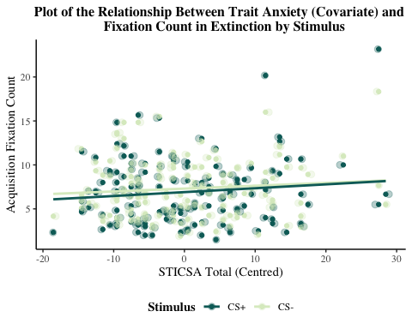

# there appears to be a linear relationship between the covariate (sticsa total centred)  
# and outcome variable (fixation count acquisition) at both levels of the grouping variable (stimulus)  
# this plot also demonstrates homogeneity of regression slopes, as there is no   
# interaction between the outcome and covariate, and the regression lines appear roughly  
# parallel  
  
# this also checks homogeneity of regression slopes:  
# slopes of regression lines should be same for each group (no interaction between  
# covariate and outcome) i.e. the lines should be parallel  
  
## reporting example: There was a linear relationship between pre-test and post-test anxiety score for each training group, as assessed by visual inspection of a scatter plot.

## *Normality*

## acquisition fix count  
df_long_acq_fix_count %>%  
 group_by(iu_group, stimulus) %>%  
 shapiro_test(fix_count)

## # A tibble: 4 × 5  
## iu_group stimulus variable statistic p  
## <fct> <fct> <chr> <dbl> <dbl>  
## 1 -1 -1 fix_count 0.929 0.000611   
## 2 -1 1 fix_count 0.934 0.00108   
## 3 1 -1 fix_count 0.962 0.0364   
## 4 1 1 fix_count 0.895 0.0000312

## extinction fix count  
df_long_ext_fix_count %>%  
 group_by(iu_group, stimulus, time) %>%  
 shapiro_test(fix_count)

## # A tibble: 8 × 6  
## iu_group stimulus time variable statistic p  
## <fct> <fct> <fct> <chr> <dbl> <dbl>  
## 1 -1 -1 -1 fix_count 0.961 0.0263   
## 2 -1 -1 1 fix_count 0.904 0.0000488   
## 3 -1 1 -1 fix_count 0.977 0.228   
## 4 -1 1 1 fix_count 0.881 0.00000681  
## 5 1 -1 -1 fix_count 0.929 0.000810   
## 6 1 -1 1 fix_count 0.981 0.391   
## 7 1 1 -1 fix_count 0.945 0.00457   
## 8 1 1 1 fix_count 0.931 0.000995

# acquisition fix duration log  
df_long_acq_fix_duration_log %>%  
 group_by(iu_group, stimulus) %>%  
 shapiro_test(fix_duration_log)

## # A tibble: 4 × 5  
## iu_group stimulus variable statistic p  
## <fct> <fct> <chr> <dbl> <dbl>  
## 1 -1 -1 fix_duration_log 0.970 0.0814  
## 2 -1 1 fix_duration_log 0.964 0.0398  
## 3 1 -1 fix_duration_log 0.981 0.385   
## 4 1 1 fix_duration_log 0.981 0.408

## extinction fix count  
df_long_ext_fix_duration_log %>%  
 group_by(iu_group, stimulus, time) %>%  
 shapiro_test(fix_duration_log)

## # A tibble: 8 × 6  
## iu_group stimulus time variable statistic p  
## <fct> <fct> <fct> <chr> <dbl> <dbl>  
## 1 -1 -1 -1 fix_duration_log 0.945 0.00364  
## 2 -1 -1 1 fix_duration_log 0.974 0.143   
## 3 -1 1 -1 fix_duration_log 0.972 0.112   
## 4 -1 1 1 fix_duration_log 0.970 0.0913   
## 5 1 -1 -1 fix_duration_log 0.973 0.146   
## 6 1 -1 1 fix_duration_log 0.959 0.0242   
## 7 1 1 -1 fix_duration_log 0.984 0.523   
## 8 1 1 1 fix_duration_log 0.983 0.460

## acquisition sacc amplitude  
df_long_acq_sacc_amplitude %>%  
 group_by(iu_group, stimulus) %>%  
 shapiro_test(sacc_amplitude)

## # A tibble: 4 × 5  
## iu_group stimulus variable statistic p  
## <fct> <fct> <chr> <dbl> <dbl>  
## 1 -1 -1 sacc_amplitude 0.940 0.00227   
## 2 -1 1 sacc_amplitude 0.954 0.0111   
## 3 1 -1 sacc_amplitude 0.913 0.000176  
## 4 1 1 sacc_amplitude 0.918 0.000275

## extinction sacc amplitude  
df_long_ext_sacc_amplitude %>%  
 group_by(iu_group, stimulus, time) %>%  
 shapiro_test(sacc_amplitude)

## # A tibble: 8 × 6  
## iu_group stimulus time variable statistic p  
## <fct> <fct> <fct> <chr> <dbl> <dbl>  
## 1 -1 -1 -1 sacc_amplitude 0.849 0.000000535   
## 2 -1 -1 1 sacc_amplitude 0.889 0.0000125   
## 3 -1 1 -1 sacc_amplitude 0.821 0.0000000925  
## 4 -1 1 1 sacc_amplitude 0.880 0.00000688   
## 5 1 -1 -1 sacc_amplitude 0.930 0.000946   
## 6 1 -1 1 sacc_amplitude 0.902 0.0000659   
## 7 1 1 -1 sacc_amplitude 0.925 0.000514   
## 8 1 1 1 sacc_amplitude 0.926 0.000578

## however, as sample size is greater than 50, normal QQ plot is preferred because  
# at larger sample sizes, Shapiro-Wilk becomes very sensitive to even a minor   
# deviation from normality.   
# (q-q plot draw correlation btw data and the normal distribution)  
  
ggqqplot(df_long_acq_fix_count, "fix_count", ggtheme = theme_classic()) +  
 facet_grid(stimulus ~ iu_group, labeller = "label_both")

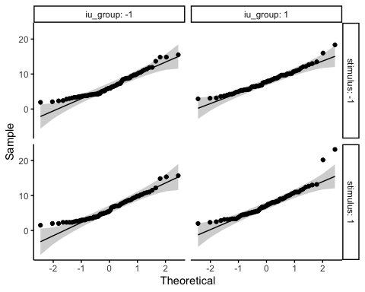

ggqqplot(df_long_ext_fix_count, "fix_count", ggtheme = theme_classic()) +  
 facet_grid(stimulus + time ~ iu_group, labeller = "label_both")

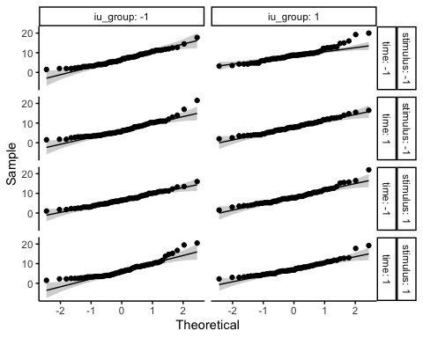

### reporting example:  
# The score were normally distributed (p > 0.05) for each cell, as assessed by Shapiro-Wilk’s test of normality.  
# All the points fall approximately along the reference line, for each cell. So we can assume normality of the data.

## *Normality of Residuals*

# first compute model using lm(). covariate goes first.f  
ancova_lm_model_acq_fix_count <-   
 lm(fix_count ~ sticsa_total_centred + iu_group * stimulus, df_long_acq_fix_count)  
  
# augment data by adding fitted values and residuals  
model_metrics <- augment(ancova_lm_model_acq_fix_count)   
  
# assess normality of residuals using shapiro wilk  
shapiro_test(model_metrics$.resid) # not normally distributed

## # A tibble: 1 × 3  
## variable statistic p.value  
## <chr> <dbl> <dbl>  
## 1 model_metrics$.resid 0.940 0.00000000340

# reporting:  
# The Shapiro Wilk test was not significant (p > 0.05), so we can assume normality of residuals  
  
###### also outliers:  
# examine standardised/studentised residual. observations whose standardised residuals  
# are greater than 3 in absolute value are possible outliers.   
model_metrics %>%  
 filter(abs(.std.resid) > 3) %>%  
 as.data.frame()

## fix_count sticsa_total_centred iu_group stimulus .fitted .resid .hat  
## 1 23.16667 27.46043 1 1 7.697435 15.46923 0.04169528  
## 2 20.16667 11.46043 1 1 7.564182 12.60248 0.01706000  
## 3 18.33333 27.46043 1 -1 8.159690 10.17364 0.04169528  
## .sigma .cooksd .std.resid  
## 1 3.286205 0.18613043 4.624897  
## 2 3.335139 0.04804383 3.720299  
## 3 3.364537 0.08050687 3.041654

# reporting example: There were no outliers in the data, as assessed by no cases with standardized residuals greater than 3 in absolute value.

## *Homogeneity of Variance*

# this will be done using levene's test  
# however, in large samples, levene's test can be sig even when group variances  
# are not very different.  
  
## acquisition fix count  
df_long_acq_fix_count %>%  
 group_by(stimulus) %>%  
 levene_test(fix_count ~ iu_group)

## # A tibble: 2 × 5  
## stimulus df1 df2 statistic p  
## <fct> <int> <int> <dbl> <dbl>  
## 1 -1 1 137 0.477 0.491  
## 2 1 1 137 0.0415 0.839

## extinction fix count  
df_long_ext_fix_count %>%  
 group_by(stimulus, time) %>%  
 levene_test(fix_count ~ iu_group)

## # A tibble: 4 × 6  
## stimulus time df1 df2 statistic p  
## <fct> <fct> <int> <int> <dbl> <dbl>  
## 1 -1 -1 1 137 1.45 0.231  
## 2 -1 1 1 137 0.181 0.671  
## 3 1 -1 1 137 0.264 0.608  
## 4 1 1 1 137 1.86 0.174

# acquisition fix duration log  
df_long_acq_fix_duration_log %>%  
 group_by(stimulus) %>%  
 levene_test(fix_duration_log ~ iu_group)

## # A tibble: 2 × 5  
## stimulus df1 df2 statistic p  
## <fct> <int> <int> <dbl> <dbl>  
## 1 -1 1 137 2.04 0.155  
## 2 1 1 137 0.753 0.387

## extinction fix count  
df_long_ext_fix_duration_log %>%  
 group_by(stimulus, time) %>%  
 levene_test(fix_duration_log ~ iu_group)

## # A tibble: 4 × 6  
## stimulus time df1 df2 statistic p  
## <fct> <fct> <int> <int> <dbl> <dbl>  
## 1 -1 -1 1 137 8.18 0.00490  
## 2 -1 1 1 137 7.74 0.00616  
## 3 1 -1 1 137 2.78 0.0977   
## 4 1 1 1 137 7.14 0.00843

## acquisition sacc amplitude  
df_long_acq_sacc_amplitude %>%  
 group_by(stimulus) %>%  
 levene_test(sacc_amplitude ~ iu_group)

## # A tibble: 2 × 5  
## stimulus df1 df2 statistic p  
## <fct> <int> <int> <dbl> <dbl>  
## 1 -1 1 135 1.03 0.311   
## 2 1 1 137 3.42 0.0665

## extinction sacc amplitude  
df_long_ext_sacc_amplitude %>%  
 group_by(stimulus, time) %>%  
 levene_test(sacc_amplitude ~ iu_group)

## # A tibble: 4 × 6  
## stimulus time df1 df2 statistic p  
## <fct> <fct> <int> <int> <dbl> <dbl>  
## 1 -1 -1 1 137 0.364 0.547  
## 2 -1 1 1 136 1.72 0.191  
## 3 1 -1 1 136 0.0230 0.880  
## 4 1 1 1 136 0.0324 0.857

### reproting: For IUS total, the variances were not similar for the   
# High and Low IU groups, F(1,137) = 6.75, p = .010  
# (i.e. spread of IU scores is different between groups)  
  
# There was homogeneity of variances, as assessed by Levene’s test (p > 0.05).

## *Homoscedasticity*

# aka homogeneity of residuals variance for all groups. the residuals are   
# assumed to have a constant variance (homoscedasticity)

## *Homogeneity of Variance-Covariance Matrices*

# this tests whether covariance matrices are equal across cells formed by  
# between-subjects factor (IU)  
  
# use Box's M (however, this is highly sensitive, so unless p < .001 and sample  
# sizes are unequal, can ignore it)  
  
box_m(df_long_acq_fix_count[, "fix_count", drop = FALSE], df_long_acq_fix_count$iu_group)

## # A tibble: 1 × 4  
## statistic p.value parameter method   
## <dbl> <dbl> <dbl> <chr>   
## 1 0.224 0.636 1 Box's M-test for Homogeneity of Covariance Matric…

box_m(df_long_ext_fix_count[, "fix_count", drop = FALSE], df_long_ext_fix_count$iu_group)

## # A tibble: 1 × 4  
## statistic p.value parameter method   
## <dbl> <dbl> <dbl> <chr>   
## 1 0.753 0.385 1 Box's M-test for Homogeneity of Covariance Matric…

box_m(df_long_acq_fix_duration_log[, "fix_duration_log", drop = FALSE], df_long_acq_fix_duration_log$iu_group)

## # A tibble: 1 × 4  
## statistic p.value parameter method   
## <dbl> <dbl> <dbl> <chr>   
## 1 0.358 0.550 1 Box's M-test for Homogeneity of Covariance Matric…

box_m(df_long_ext_fix_duration_log[, "fix_duration_log", drop = FALSE], df_long_ext_fix_duration_log$iu_group)

## # A tibble: 1 × 4  
## statistic p.value parameter method   
## <dbl> <dbl> <dbl> <chr>   
## 1 16.7 0.0000435 1 Box's M-test for Homogeneity of Covariance Matr…

box_m(df_long_acq_sacc_amplitude[, "sacc_amplitude", drop = FALSE], df_long_acq_sacc_amplitude$iu_group)

## # A tibble: 1 × 4  
## statistic p.value parameter method   
## <dbl> <dbl> <dbl> <chr>   
## 1 NA NA 1 Box's M-test for Homogeneity of Covariance Matric…

box_m(df_long_ext_sacc_amplitude[, "sacc_amplitude", drop = FALSE], df_long_ext_sacc_amplitude$iu_group)

## # A tibble: 1 × 4  
## statistic p.value parameter method   
## <dbl> <dbl> <dbl> <chr>   
## 1 NA NA 1 Box's M-test for Homogeneity of Covariance Matric…

## reporting example: There was homogeneity of covariances, as assessed by Box’s test of equality of covariance matrices (p > 0.001).

## *Independence of Covariate and IVs*

### *Fixation Count*

#### *Acquisition*

# sticsa and iu group  
t_test_independence_sticsa_iu_group_acq_fix_count <-   
 t.test(  
 df_long_acq_fix_count[df_long_acq_fix_count$iu_group == "1", "sticsa_total_centred"],  
 df_long_acq_fix_count[df_long_acq_fix_count$iu_group == "-1", "sticsa_total_centred"],   
 var.equal = TRUE  
 )  
t_test_independence_sticsa_iu_group_acq_fix_count

##   
## Two Sample t-test  
##   
## data: df_long_acq_fix_count[df_long_acq_fix_count$iu_group == "1", "sticsa_total_centred"] and df_long_acq_fix_count[df_long_acq_fix_count$iu_group == "-1", "sticsa_total_centred"]  
## t = 9.3255, df = 276, p-value < 0.00000000000000022  
## alternative hypothesis: true difference in means is not equal to 0  
## 95 percent confidence interval:  
## 7.343247 11.273157  
## sample estimates:  
## mean of x mean of y   
## 4.754549 -4.553653

# p < .05 : sticsa is not independent of iu group   
  
# sticsa and stimulus  
t_test_independence_sticsa_stimulus_acq_fix_count <-   
 t.test(  
 df_long_acq_fix_count[df_long_acq_fix_count$stimulus == "1", "sticsa_total_centred"],  
 df_long_acq_fix_count[df_long_acq_fix_count$stimulus == "-1", "sticsa_total_centred"],   
 var.equal = TRUE  
 )  
t_test_independence_sticsa_stimulus_acq_fix_count

##   
## Two Sample t-test  
##   
## data: df_long_acq_fix_count[df_long_acq_fix_count$stimulus == "1", "sticsa_total_centred"] and df_long_acq_fix_count[df_long_acq_fix_count$stimulus == "-1", "sticsa_total_centred"]  
## t = 0, df = 276, p-value = 1  
## alternative hypothesis: true difference in means is not equal to 0  
## 95 percent confidence interval:  
## -2.252832 2.252832  
## sample estimates:  
## mean of x mean of y   
## -0.000000000000002862893 -0.000000000000002862893

# p > .05 - sticsa is independent of stimulus

#### *Extinction*

# sticsa and iu group  
t_test_independence_sticsa_iu_group_ext_fix_count <-   
 t.test(  
 df_long_ext_fix_count[df_long_ext_fix_count$iu_group == "1", "sticsa_total_centred"],  
 df_long_ext_fix_count[df_long_ext_fix_count$iu_group == "-1", "sticsa_total_centred"],   
 var.equal = TRUE  
 )  
t_test_independence_sticsa_iu_group_ext_fix_count

##   
## Two Sample t-test  
##   
## data: df_long_ext_fix_count[df_long_ext_fix_count$iu_group == "1", "sticsa_total_centred"] and df_long_ext_fix_count[df_long_ext_fix_count$iu_group == "-1", "sticsa_total_centred"]  
## t = 13.212, df = 554, p-value < 0.00000000000000022  
## alternative hypothesis: true difference in means is not equal to 0  
## 95 percent confidence interval:  
## 7.924338 10.692067  
## sample estimates:  
## mean of x mean of y   
## 4.754549 -4.553653

# p < .05 : sticsa is not independent of iu group   
  
# sticsa and stimulus  
t_test_independence_sticsa_stimulus_ext_fix_count <-   
 t.test(  
 df_long_ext_fix_count[df_long_ext_fix_count$stimulus == "1", "sticsa_total_centred"],  
 df_long_ext_fix_count[df_long_ext_fix_count$stimulus == "-1", "sticsa_total_centred"],   
 var.equal = TRUE  
 )  
t_test_independence_sticsa_stimulus_ext_fix_count

##   
## Two Sample t-test  
##   
## data: df_long_ext_fix_count[df_long_ext_fix_count$stimulus == "1", "sticsa_total_centred"] and df_long_ext_fix_count[df_long_ext_fix_count$stimulus == "-1", "sticsa_total_centred"]  
## t = 0, df = 554, p-value = 1  
## alternative hypothesis: true difference in means is not equal to 0  
## 95 percent confidence interval:  
## -1.586608 1.586608  
## sample estimates:  
## mean of x mean of y   
## -0.000000000000002862855 -0.000000000000002862855

# p > .05 - sticsa is independent of stimulus  
  
# sticsa and time  
t_test_independence_sticsa_time_ext_fix_count <-   
 t.test(  
 df_long_ext_fix_count[df_long_ext_fix_count$time == "1", "sticsa_total_centred"],  
 df_long_ext_fix_count[df_long_ext_fix_count$time == "-1", "sticsa_total_centred"],   
 var.equal = TRUE  
 )  
t_test_independence_sticsa_time_ext_fix_count

##   
## Two Sample t-test  
##   
## data: df_long_ext_fix_count[df_long_ext_fix_count$time == "1", "sticsa_total_centred"] and df_long_ext_fix_count[df_long_ext_fix_count$time == "-1", "sticsa_total_centred"]  
## t = 0, df = 554, p-value = 1  
## alternative hypothesis: true difference in means is not equal to 0  
## 95 percent confidence interval:  
## -1.586608 1.586608  
## sample estimates:  
## mean of x mean of y   
## -0.000000000000002862855 -0.000000000000002862855

# p > .05 - sticsa is independent of time

### *Fixation Duration (Log Transformed)*

#### *Acquisition*

# sticsa and iu group  
t_test_independence_sticsa_iu_group_acq_fix_duration_log <-   
 t.test(  
 df_long_acq_fix_duration_log[df_long_acq_fix_duration_log$iu_group == "1", "sticsa_total_centred"],  
 df_long_acq_fix_duration_log[df_long_acq_fix_duration_log$iu_group == "-1", "sticsa_total_centred"],   
 var.equal = TRUE  
 )  
t_test_independence_sticsa_iu_group_acq_fix_duration_log

##   
## Two Sample t-test  
##   
## data: df_long_acq_fix_duration_log[df_long_acq_fix_duration_log$iu_group == "1", "sticsa_total_centred"] and df_long_acq_fix_duration_log[df_long_acq_fix_duration_log$iu_group == "-1", "sticsa_total_centred"]  
## t = 9.3255, df = 276, p-value < 0.00000000000000022  
## alternative hypothesis: true difference in means is not equal to 0  
## 95 percent confidence interval:  
## 7.343247 11.273157  
## sample estimates:  
## mean of x mean of y   
## 4.754549 -4.553653

# p < .05 : sticsa is not independent of iu group   
  
# sticsa and stimulus  
t_test_independence_sticsa_stimulus_acq_fix_duration_log <-   
 t.test(  
 df_long_acq_fix_duration_log[df_long_acq_fix_duration_log$stimulus == "1", "sticsa_total_centred"],  
 df_long_acq_fix_duration_log[df_long_acq_fix_duration_log$stimulus == "-1", "sticsa_total_centred"],   
 var.equal = TRUE  
 )  
t_test_independence_sticsa_stimulus_acq_fix_duration_log

##   
## Two Sample t-test  
##   
## data: df_long_acq_fix_duration_log[df_long_acq_fix_duration_log$stimulus == "1", "sticsa_total_centred"] and df_long_acq_fix_duration_log[df_long_acq_fix_duration_log$stimulus == "-1", "sticsa_total_centred"]  
## t = 0, df = 276, p-value = 1  
## alternative hypothesis: true difference in means is not equal to 0  
## 95 percent confidence interval:  
## -2.252832 2.252832  
## sample estimates:  
## mean of x mean of y   
## -0.000000000000002862893 -0.000000000000002862893

# p > .05 - sticsa is independent of stimulus

#### *Extinction*

# sticsa and iu group  
t_test_independence_sticsa_iu_group_ext_fix_duration_log <-   
 t.test(  
 df_long_ext_fix_duration_log[df_long_ext_fix_duration_log$iu_group == "1", "sticsa_total_centred"],  
 df_long_ext_fix_duration_log[df_long_ext_fix_duration_log$iu_group == "-1", "sticsa_total_centred"],   
 var.equal = TRUE  
 )  
t_test_independence_sticsa_iu_group_ext_fix_duration_log

##   
## Two Sample t-test  
##   
## data: df_long_ext_fix_duration_log[df_long_ext_fix_duration_log$iu_group == "1", "sticsa_total_centred"] and df_long_ext_fix_duration_log[df_long_ext_fix_duration_log$iu_group == "-1", "sticsa_total_centred"]  
## t = 13.212, df = 554, p-value < 0.00000000000000022  
## alternative hypothesis: true difference in means is not equal to 0  
## 95 percent confidence interval:  
## 7.924338 10.692067  
## sample estimates:  
## mean of x mean of y   
## 4.754549 -4.553653

# p < .05 : sticsa is not independent of iu group   
  
# sticsa and stimulus  
t_test_independence_sticsa_stimulus_ext_fix_duration_log <-   
 t.test(  
 df_long_ext_fix_duration_log[df_long_ext_fix_duration_log$stimulus == "1", "sticsa_total_centred"],  
 df_long_ext_fix_duration_log[df_long_ext_fix_duration_log$stimulus == "-1", "sticsa_total_centred"],   
 var.equal = TRUE  
 )  
t_test_independence_sticsa_stimulus_ext_fix_duration_log

##   
## Two Sample t-test  
##   
## data: df_long_ext_fix_duration_log[df_long_ext_fix_duration_log$stimulus == "1", "sticsa_total_centred"] and df_long_ext_fix_duration_log[df_long_ext_fix_duration_log$stimulus == "-1", "sticsa_total_centred"]  
## t = 0, df = 554, p-value = 1  
## alternative hypothesis: true difference in means is not equal to 0  
## 95 percent confidence interval:  
## -1.586608 1.586608  
## sample estimates:  
## mean of x mean of y   
## -0.000000000000002862855 -0.000000000000002862855

# p > .05 - sticsa is independent of stimulus  
  
# sticsa and time  
t_test_independence_sticsa_time_ext_fix_duration <-   
 t.test(  
 df_long_ext_fix_duration_log[df_long_ext_fix_duration_log$time == "1", "sticsa_total_centred"],  
 df_long_ext_fix_duration_log[df_long_ext_fix_duration_log$time == "-1", "sticsa_total_centred"],   
 var.equal = TRUE  
 )  
t_test_independence_sticsa_time_ext_fix_duration

##   
## Two Sample t-test  
##   
## data: df_long_ext_fix_duration_log[df_long_ext_fix_duration_log$time == "1", "sticsa_total_centred"] and df_long_ext_fix_duration_log[df_long_ext_fix_duration_log$time == "-1", "sticsa_total_centred"]  
## t = 0, df = 554, p-value = 1  
## alternative hypothesis: true difference in means is not equal to 0  
## 95 percent confidence interval:  
## -1.586608 1.586608  
## sample estimates:  
## mean of x mean of y   
## -0.000000000000002862855 -0.000000000000002862855

# p > .05 - sticsa is independent of time

### *Saccade Amplitude*

#### *Acquisition*

# sticsa and iu group  
t_test_independence_sticsa_iu_group_acq_sacc_amplitude <-   
 t.test(  
 df_long_acq_sacc_amplitude[df_long_acq_sacc_amplitude$iu_group == "1", "sticsa_total_centred"],  
 df_long_acq_sacc_amplitude[df_long_acq_sacc_amplitude$iu_group == "-1", "sticsa_total_centred"],   
 var.equal = TRUE  
 )  
t_test_independence_sticsa_iu_group_acq_sacc_amplitude

##   
## Two Sample t-test  
##   
## data: df_long_acq_sacc_amplitude[df_long_acq_sacc_amplitude$iu_group == "1", "sticsa_total_centred"] and df_long_acq_sacc_amplitude[df_long_acq_sacc_amplitude$iu_group == "-1", "sticsa_total_centred"]  
## t = 9.3255, df = 276, p-value < 0.00000000000000022  
## alternative hypothesis: true difference in means is not equal to 0  
## 95 percent confidence interval:  
## 7.343247 11.273157  
## sample estimates:  
## mean of x mean of y   
## 4.754549 -4.553653

# p < .05 : sticsa is not independent of iu group   
  
# sticsa and stimulus  
t_test_independence_sticsa_stimulus_acq_sacc_amplitude <-   
 t.test(  
 df_long_acq_sacc_amplitude[df_long_acq_sacc_amplitude$stimulus == "1", "sticsa_total_centred"],  
 df_long_acq_sacc_amplitude[df_long_acq_sacc_amplitude$stimulus == "-1", "sticsa_total_centred"],   
 var.equal = TRUE  
 )  
t_test_independence_sticsa_stimulus_acq_sacc_amplitude

##   
## Two Sample t-test  
##   
## data: df_long_acq_sacc_amplitude[df_long_acq_sacc_amplitude$stimulus == "1", "sticsa_total_centred"] and df_long_acq_sacc_amplitude[df_long_acq_sacc_amplitude$stimulus == "-1", "sticsa_total_centred"]  
## t = 0, df = 276, p-value = 1  
## alternative hypothesis: true difference in means is not equal to 0  
## 95 percent confidence interval:  
## -2.252832 2.252832  
## sample estimates:  
## mean of x mean of y   
## -0.000000000000002862893 -0.000000000000002862893

# p > .05 - sticsa is independent of stimulus

#### *Extinction*

# sticsa and iu group  
t_test_independence_sticsa_iu_group_ext_sacc_amplitude <-   
 t.test(  
 df_long_ext_sacc_amplitude[df_long_ext_sacc_amplitude$iu_group == "1", "sticsa_total_centred"],  
 df_long_ext_sacc_amplitude[df_long_ext_sacc_amplitude$iu_group == "-1", "sticsa_total_centred"],   
 var.equal = TRUE  
 )  
t_test_independence_sticsa_iu_group_ext_sacc_amplitude

##   
## Two Sample t-test  
##   
## data: df_long_ext_sacc_amplitude[df_long_ext_sacc_amplitude$iu_group == "1", "sticsa_total_centred"] and df_long_ext_sacc_amplitude[df_long_ext_sacc_amplitude$iu_group == "-1", "sticsa_total_centred"]  
## t = 13.212, df = 554, p-value < 0.00000000000000022  
## alternative hypothesis: true difference in means is not equal to 0  
## 95 percent confidence interval:  
## 7.924338 10.692067  
## sample estimates:  
## mean of x mean of y   
## 4.754549 -4.553653

# p < .05 : sticsa is not independent of iu group   
  
# sticsa and stimulus  
t_test_independence_sticsa_stimulus_ext_sacc_amplitude <-   
 t.test(  
 df_long_ext_sacc_amplitude[df_long_ext_sacc_amplitude$stimulus == "1", "sticsa_total_centred"],  
 df_long_ext_sacc_amplitude[df_long_ext_sacc_amplitude$stimulus == "-1", "sticsa_total_centred"],   
 var.equal = TRUE  
 )  
t_test_independence_sticsa_stimulus_ext_sacc_amplitude

##   
## Two Sample t-test  
##   
## data: df_long_ext_sacc_amplitude[df_long_ext_sacc_amplitude$stimulus == "1", "sticsa_total_centred"] and df_long_ext_sacc_amplitude[df_long_ext_sacc_amplitude$stimulus == "-1", "sticsa_total_centred"]  
## t = 0, df = 554, p-value = 1  
## alternative hypothesis: true difference in means is not equal to 0  
## 95 percent confidence interval:  
## -1.586608 1.586608  
## sample estimates:  
## mean of x mean of y   
## -0.000000000000002862855 -0.000000000000002862855

# p > .05 - sticsa is independent of stimulus  
  
# sticsa and time  
t_test_independence_sticsa_time_ext_sacc_amplitude <-   
 t.test(  
 df_long_ext_sacc_amplitude[df_long_ext_sacc_amplitude$time == "1", "sticsa_total_centred"],  
 df_long_ext_sacc_amplitude[df_long_ext_sacc_amplitude$time == "-1", "sticsa_total_centred"],   
 var.equal = TRUE  
 )  
t_test_independence_sticsa_time_ext_sacc_amplitude

##   
## Two Sample t-test  
##   
## data: df_long_ext_sacc_amplitude[df_long_ext_sacc_amplitude$time == "1", "sticsa_total_centred"] and df_long_ext_sacc_amplitude[df_long_ext_sacc_amplitude$time == "-1", "sticsa_total_centred"]  
## t = 0, df = 554, p-value = 1  
## alternative hypothesis: true difference in means is not equal to 0  
## 95 percent confidence interval:  
## -1.586608 1.586608  
## sample estimates:  
## mean of x mean of y   
## -0.000000000000002862855 -0.000000000000002862855

# p > .05 - sticsa is independent of time

## *Homogeneity of Regression Slopes*

####### check homogeneity of regression slopes  
  
 df_long_acq_fix_count %>%  
 anova_test(fix_count ~ sticsa_total_centred + iu_group + stimulus + iu_group*stimulus +   
 sticsa_total_centred*iu_group + sticsa_total_centred*stimulus +  
 sticsa_total_centred*iu_group*stimulus)

## Coefficient covariances computed by hccm()

## ANOVA Table (type II tests)  
##   
## Effect DFn DFd F p p<.05 ges  
## 1 sticsa_total_centred 1 270 0.114 0.736 0.0004210  
## 2 iu_group 1 270 6.146 0.014 * 0.0220000  
## 3 stimulus 1 270 0.957 0.329 0.0040000  
## 4 iu_group:stimulus 1 270 0.103 0.749 0.0003810  
## 5 sticsa_total_centred:iu_group 1 270 3.336 0.069 0.0120000  
## 6 sticsa_total_centred:stimulus 1 270 0.154 0.695 0.0005710  
## 7 sticsa_total_centred:iu_group:stimulus 1 270 0.021 0.885 0.0000783

# as the interaction term sticsa_total_centred*iu_group was not sig (p = .067), there  
 # is not an interaction between iu group and sticsa total centred  
   
# as the interaction term sticsa_total_centred*stimulus was not sig (p = .787), there  
 # is not an interaction between stimulus and sticsa total centred  
  
 # There was homogeneity of regression slopes as the interaction terms between   
 # the covariate (STICSA total centred) and grouping variables (iu group  
 # and stimulus), was not statistically significant, p > .05.   
   
# reporting example:  
# There was homogeneity of regression slopes as the interaction term was not statistically significant, F(2, 39) = 0.13, p = 0.88.  
  
  
   
######## check remaining assumptions  
# to check remaining assumptions, first compute lm() version of the model  
ancova_lm_model_acq_fix_count <- lm(fix_count ~ sticsa_total_centred + iu_group * stimulus, df_long_acq_fix_count)  
model_metrics <- augment(ancova_lm_model_acq_fix_count)   
shapiro_test(model_metrics$.resid)

## # A tibble: 1 × 3  
## variable statistic p.value  
## <chr> <dbl> <dbl>  
## 1 model_metrics$.resid 0.940 0.00000000340

summary(ancova_lm_model_acq_fix_count)

##   
## Call:  
## lm(formula = fix_count ~ sticsa_total_centred + iu_group * stimulus,   
## data = df_long_acq_fix_count)  
##   
## Residuals:  
## Min 1Q Median 3Q Max   
## -5.4309 -2.6331 -0.4267 2.0982 15.4692   
##   
## Coefficients:  
## Estimate Std. Error t value Pr(>|t|)   
## (Intercept) 6.706298 0.420831 15.936 <0.0000000000000002 ***  
## sticsa_total_centred 0.008328 0.024721 0.337 0.7365   
## iu_group1 1.224693 0.623745 1.963 0.0506 .   
## stimulus1 -0.341613 0.573457 -0.596 0.5519   
## iu_group1:stimulus1 -0.120642 0.819886 -0.147 0.8831   
## ---  
## Signif. codes: 0 '***' 0.001 '**' 0.01 '*' 0.05 '.' 0.1 ' ' 1  
##   
## Residual standard error: 3.417 on 273 degrees of freedom  
## Multiple R-squared: 0.03625, Adjusted R-squared: 0.02213   
## F-statistic: 2.567 on 4 and 273 DF, p-value: 0.03851

# obtain the assumptions and save as variable   
q1_ancova_assumptions <- check_model(ancova_lm_model_acq_fix_count)  
  
# check the assumptions  
q1_ancova_assumptions

## Registered S3 methods overwritten by 'parameters':  
## method from   
## as.double.parameters_kurtosis datawizard  
## as.double.parameters_skewness datawizard  
## as.double.parameters_smoothness datawizard  
## as.numeric.parameters_kurtosis datawizard  
## as.numeric.parameters_skewness datawizard  
## as.numeric.parameters_smoothness datawizard  
## print.parameters_distribution datawizard  
## print.parameters_kurtosis datawizard  
## print.parameters_skewness datawizard  
## summary.parameters_kurtosis datawizard  
## summary.parameters_skewness datawizard

## Warning: `guides(<scale> = FALSE)` is deprecated. Please use `guides(<scale> =  
## "none")` instead.

## Loading required namespace: qqplotr

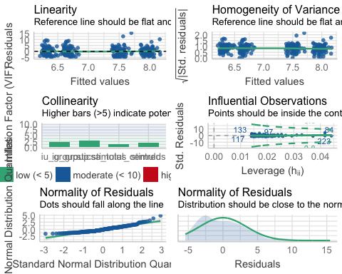

######## normality of residuals  
# panel 2: most data points are roughly plotted along the line, but there do appear  
# to be some possible deviations to assumption of normality   
# panel 3: residuals appear mostly normally distributed,   
# though there are some peaks on both tails  
# assumption violated  
  
###### homoscedasticity   
# panel 4: data-points roughly plotted along horizontal line  
# assumption is met  
  
####### outliers  
# panel 6: no cases exceed Cook's value of 1, so no outliers by influence.  
# assumption is met.

## *Outliers*

## acquisition fix count  
df_long_acq_fix_count %>%  
 group_by(iu_group, stimulus) %>%  
 identify_outliers(fix_count)

## # A tibble: 4 × 10  
## iu_group stimulus id sticsa_total condition fix_count sticsa_total_avg  
## <fct> <fct> <fct> <dbl> <fct> <dbl> <dbl>  
## 1 1 -1 086_1 68 acq_csm_fix_c… 18.3 40.5  
## 2 1 -1 099_1 52 acq_csm_fix_c… 16 40.5  
## 3 1 1 086_1 68 acq_csp_fix_c… 23.2 40.5  
## 4 1 1 099_1 52 acq_csp_fix_c… 20.2 40.5  
## # … with 3 more variables: sticsa_total_centred <dbl>, is.outlier <lgl>,  
## # is.extreme <lgl>

## extinction fix count  
df_long_ext_fix_count %>%  
 group_by(iu_group, stimulus, time) %>%  
 identify_outliers(fix_count)

## # A tibble: 14 × 11  
## iu_group stimulus time id sticsa_total condition fix_count  
## <fct> <fct> <fct> <fct> <dbl> <fct> <dbl>  
## 1 -1 -1 -1 122_1 37 l_ext_csm_fix_count 17.8  
## 2 -1 -1 1 047_1 41 e_ext_csm_fix_count 17   
## 3 -1 -1 1 122_1 37 e_ext_csm_fix_count 21.5  
## 4 -1 1 -1 122_1 37 l_ext_csp_fix_count 16   
## 5 -1 1 1 122_1 37 e_ext_csp_fix_count 20.5  
## 6 -1 1 1 143_1 44 e_ext_csp_fix_count 19.5  
## 7 1 -1 -1 033_1 54 l_ext_csm_fix_count 20   
## 8 1 -1 -1 065_1 33 l_ext_csm_fix_count 14.8  
## 9 1 -1 -1 086_1 68 l_ext_csm_fix_count 19.2  
## 10 1 -1 -1 099_1 52 l_ext_csm_fix_count 16   
## 11 1 -1 -1 113_1 31 l_ext_csm_fix_count 15   
## 12 1 1 -1 086_1 68 l_ext_csp_fix_count 22   
## 13 1 1 1 086_1 68 e_ext_csp_fix_count 19.2  
## 14 1 1 1 113_1 31 e_ext_csp_fix_count 17.8  
## # … with 4 more variables: sticsa_total_avg <dbl>, sticsa_total_centred <dbl>,  
## # is.outlier <lgl>, is.extreme <lgl>

# acquisition fix duration log  
df_long_acq_fix_duration_log %>%  
 group_by(iu_group, stimulus) %>%  
 identify_outliers(fix_duration_log)

## [1] iu_group stimulus id   
## [4] sticsa_total condition fix_duration_log   
## [7] sticsa_total_avg sticsa_total_centred is.outlier   
## [10] is.extreme   
## <0 rows> (or 0-length row.names)

## extinction fix count  
df_long_ext_fix_duration_log %>%  
 group_by(iu_group, stimulus, time) %>%  
 identify_outliers(fix_duration_log)

## # A tibble: 6 × 11  
## iu_group stimulus time id sticsa_total condition fix_duration_log  
## <fct> <fct> <fct> <fct> <dbl> <fct> <dbl>  
## 1 1 -1 -1 009_1 41 l_ext_csm_fix_dur… 8.00  
## 2 1 -1 -1 010_1 43 l_ext_csm_fix_dur… 4.69  
## 3 1 -1 -1 015_1 55 l_ext_csm_fix_dur… 8.37  
## 4 1 -1 -1 044_1 36 l_ext_csm_fix_dur… 7.91  
## 5 1 -1 1 044_1 36 e_ext_csm_fix_dur… 8.70  
## 6 1 -1 1 113_1 31 e_ext_csm_fix_dur… 4.18  
## # … with 4 more variables: sticsa_total_avg <dbl>, sticsa_total_centred <dbl>,  
## # is.outlier <lgl>, is.extreme <lgl>

## acquisition sacc amplitude  
df_long_acq_sacc_amplitude %>%  
 group_by(iu_group, stimulus) %>%  
 identify_outliers(sacc_amplitude)

## # A tibble: 9 × 10  
## iu_group stimulus id sticsa_total condition sacc_amplitude sticsa_total_avg  
## <fct> <fct> <fct> <dbl> <fct> <dbl> <dbl>  
## 1 -1 -1 016_1 26 acq_csm_… 7.37 40.5  
## 2 -1 -1 026_1 55 acq_csm_… 6.87 40.5  
## 3 -1 1 016_1 26 acq_csp_… 6.35 40.5  
## 4 1 -1 017_1 33 acq_csm_… 7.81 40.5  
## 5 1 -1 021_1 54 acq_csm_… 7.50 40.5  
## 6 1 -1 022_1 50 acq_csm_… 8.57 40.5  
## 7 1 1 009_1 41 acq_csp_… 7.47 40.5  
## 8 1 1 043_1 39 acq_csp_… 6.88 40.5  
## 9 1 1 044_1 36 acq_csp_… 8.15 40.5  
## # … with 3 more variables: sticsa_total_centred <dbl>, is.outlier <lgl>,  
## # is.extreme <lgl>

## extinction sacc amplitude  
df_long_ext_sacc_amplitude %>%  
 group_by(iu_group, stimulus, time) %>%  
 identify_outliers(sacc_amplitude)

## # A tibble: 17 × 11  
## iu_group stimulus time id sticsa_total condition sacc_amplitude  
## <fct> <fct> <fct> <fct> <dbl> <fct> <dbl>  
## 1 -1 -1 -1 016_1 26 l_ext_csm_sacc_amp… 10.9   
## 2 -1 -1 -1 075_1 35 l_ext_csm_sacc_amp… 8.98  
## 3 -1 -1 -1 078_1 42 l_ext_csm_sacc_amp… 8.03  
## 4 -1 -1 -1 111_1 41 l_ext_csm_sacc_amp… 8.21  
## 5 -1 -1 1 016_1 26 e_ext_csm_sacc_amp… 9.11  
## 6 -1 1 -1 016_1 26 l_ext_csp_sacc_amp… 13.1   
## 7 -1 1 -1 075_1 35 l_ext_csp_sacc_amp… 7.84  
## 8 -1 1 1 016_1 26 e_ext_csp_sacc_amp… 9.02  
## 9 -1 1 1 051_1 28 e_ext_csp_sacc_amp… 7.40  
## 10 -1 1 1 119_1 43 e_ext_csp_sacc_amp… 9.18  
## 11 1 -1 -1 009_1 41 l_ext_csm_sacc_amp… 8.00  
## 12 1 -1 -1 105_1 33 l_ext_csm_sacc_amp… 9.74  
## 13 1 -1 1 105_1 33 e_ext_csm_sacc_amp… 11.4   
## 14 1 1 -1 009_1 41 l_ext_csp_sacc_amp… 9.62  
## 15 1 1 -1 022_1 50 l_ext_csp_sacc_amp… 8.34  
## 16 1 1 1 009_1 41 e_ext_csp_sacc_amp… 7.67  
## 17 1 1 1 129_1 46 e_ext_csp_sacc_amp… 8.65  
## # … with 4 more variables: sticsa_total_avg <dbl>, sticsa_total_centred <dbl>,  
## # is.outlier <lgl>, is.extreme <lgl>

### reporting:  
# There were no extreme outliers.